**Administrating VPC and EC2 services by launching linux servers under Elastic load balancing rules under defined subnetworks with autoscaling method**

VPC:-

A Virtual Private Cloud (VPC) is a secure, isolated private cloud hosted within a public cloud. It allows organizations to create a virtualized network environment that mimics a traditional physical network, but with the scalability and flexibility of cloud computing.

First creating manual VPC

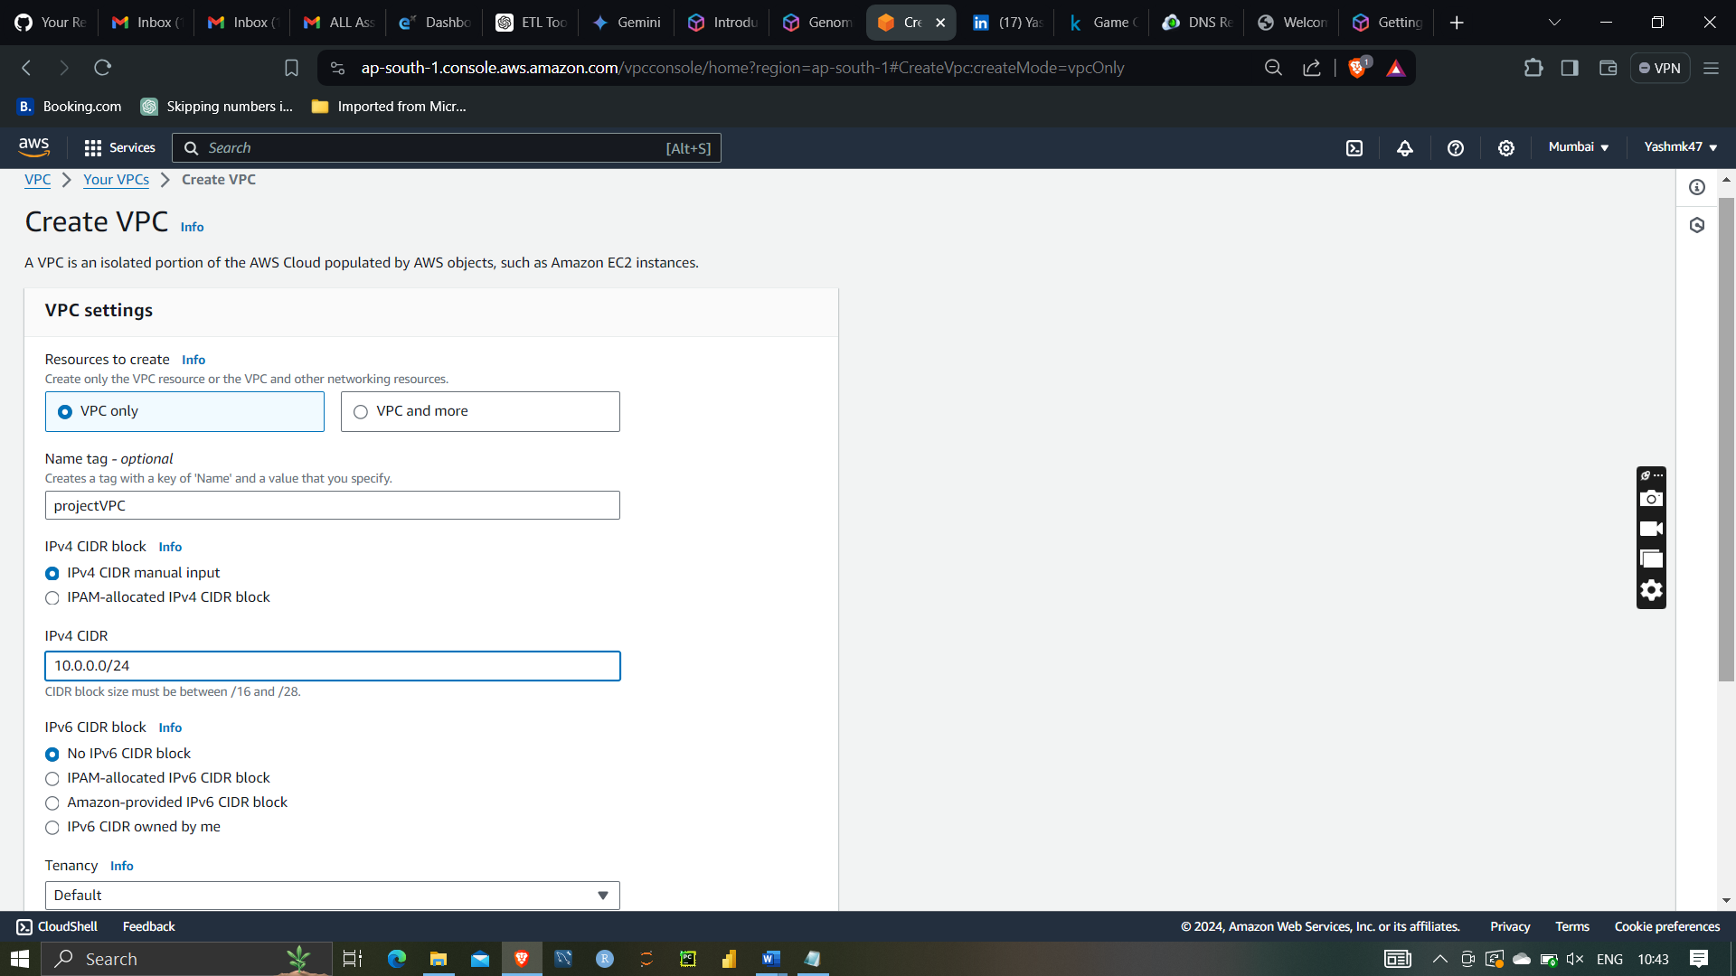

Giving IPv4 CIDR (Classless Inter-Domain Routing)

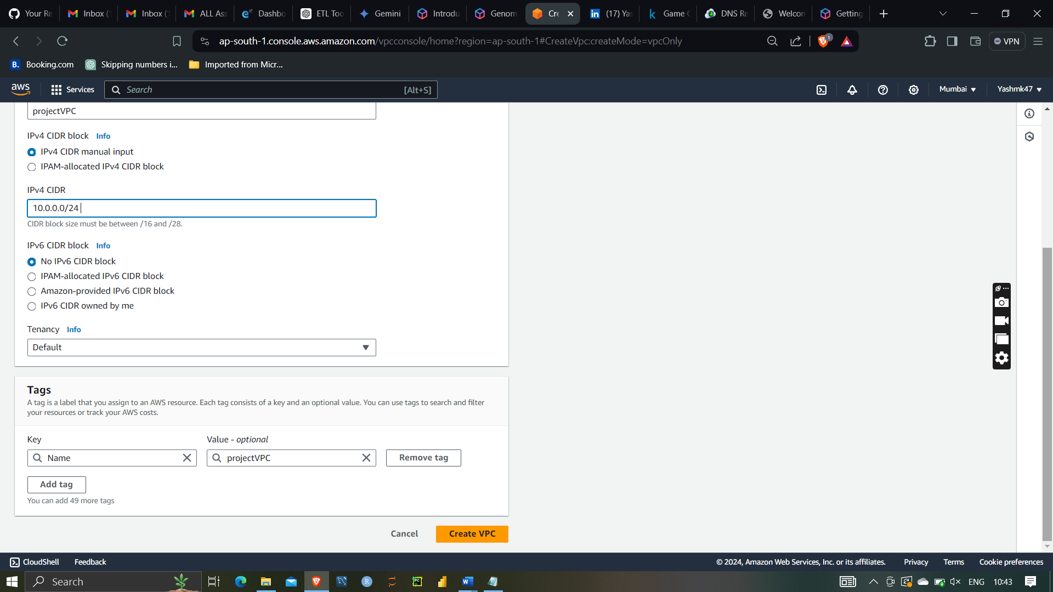

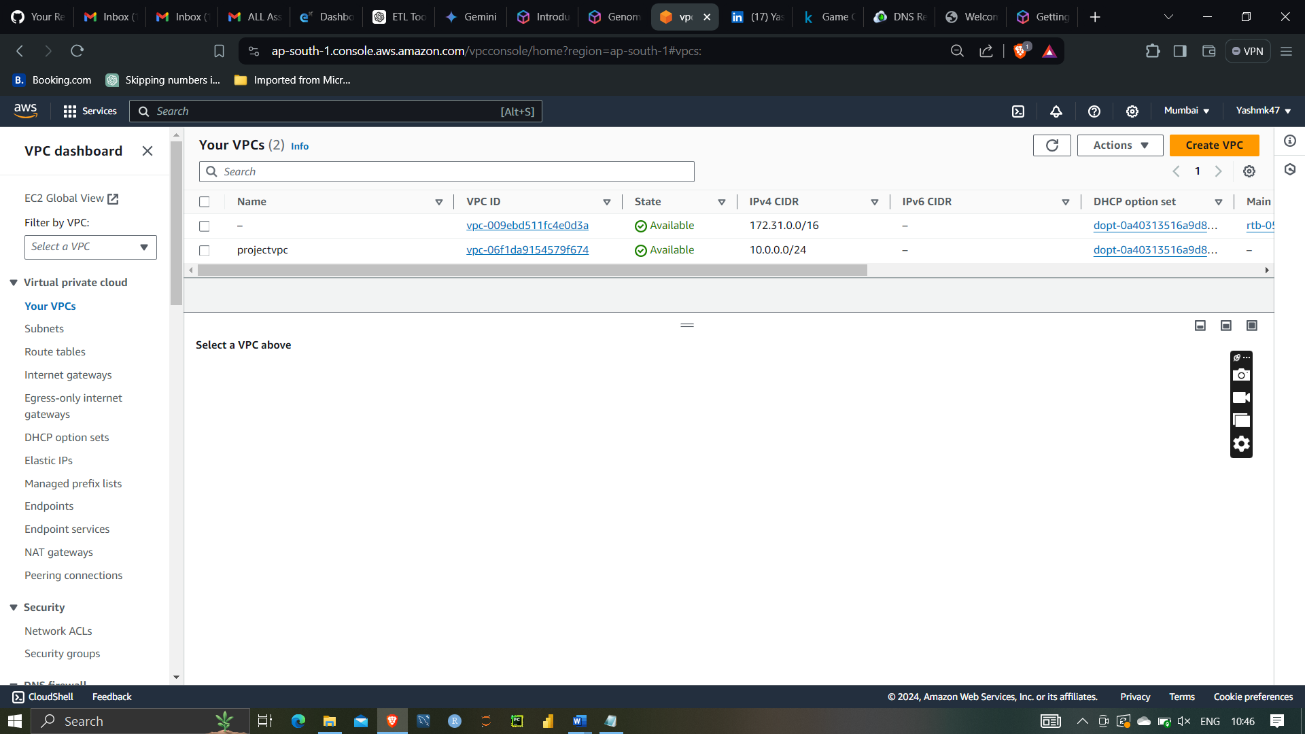

Subnet:-

A subnet, short for subnetwork, is a segmented piece of a larger network. In the context of a Virtual Private Cloud (VPC), a subnet is a range of IP addresses within the VPC. Subnets allow you to partition the network inside the VPC into smaller, more manageable sections, each with its own unique set of rules and policies.

Creating first subnet 10.0.0.0/25 with available zone of ap-south-1a

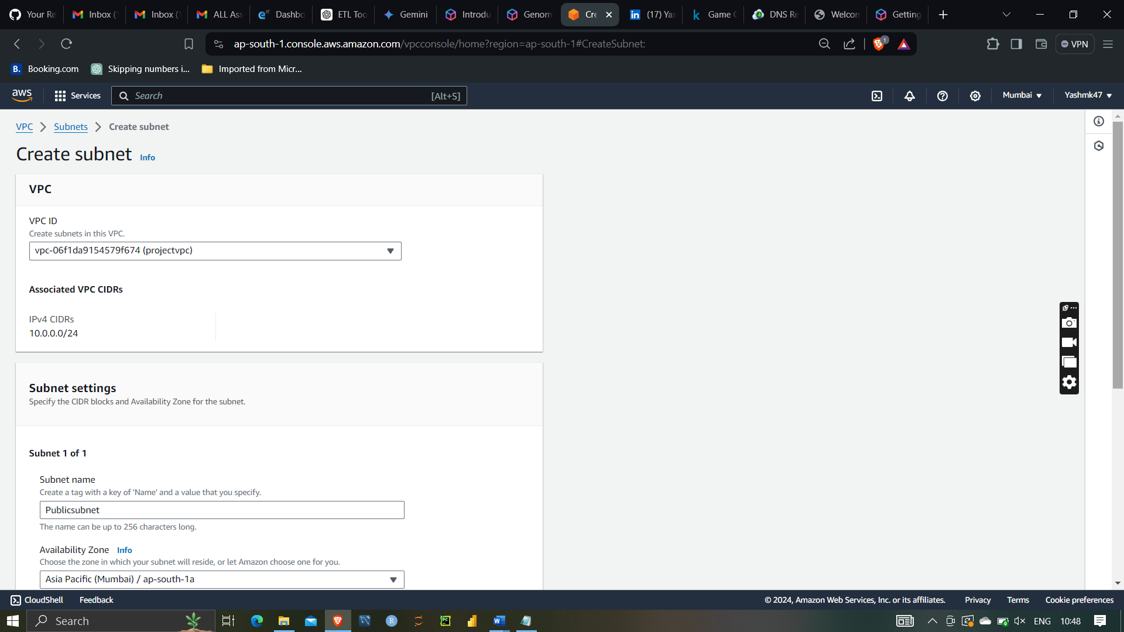

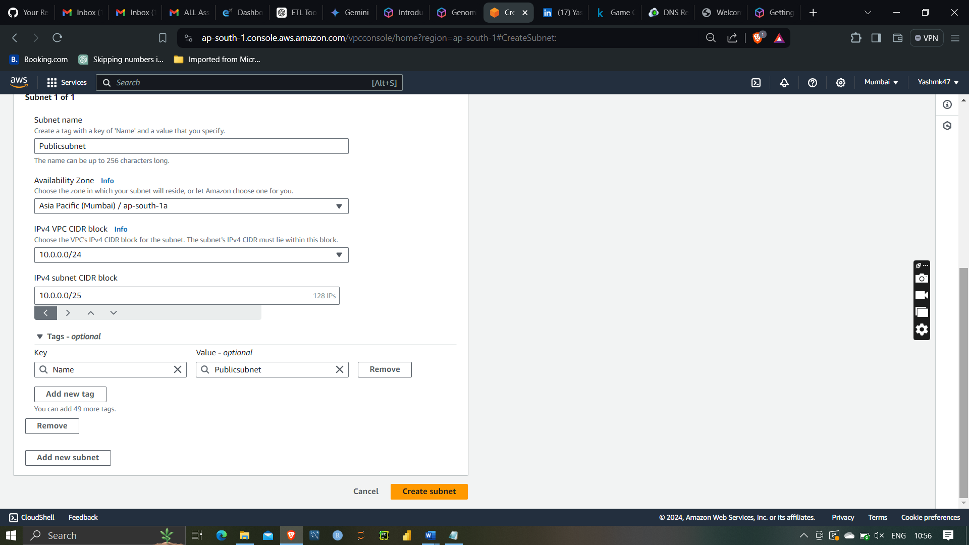

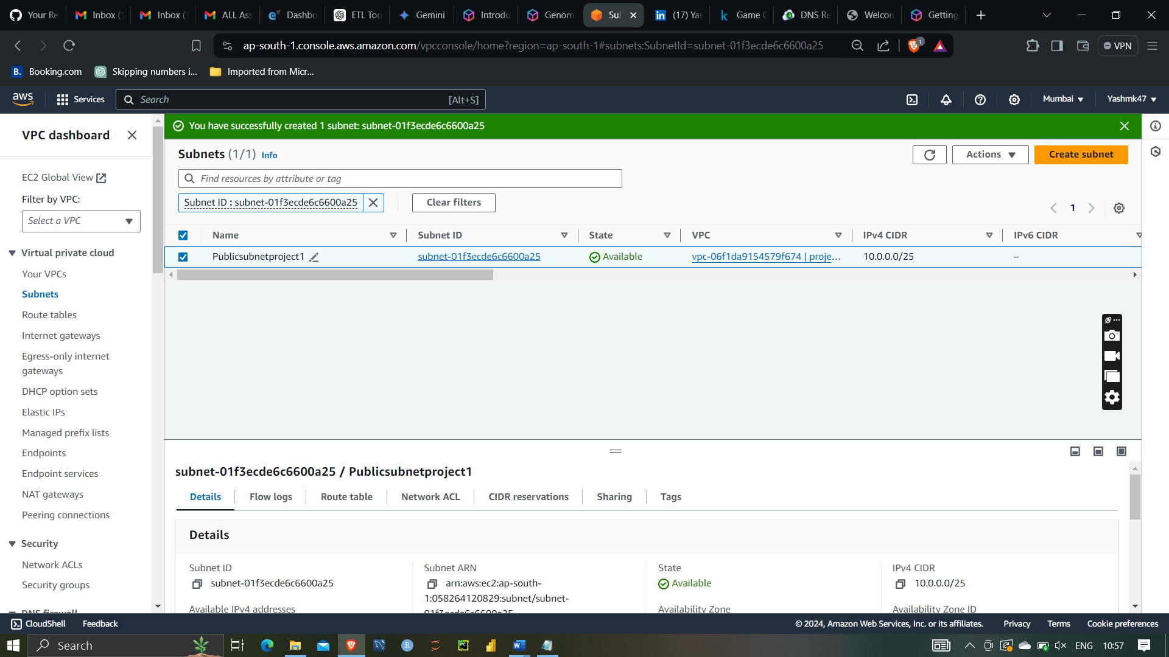

Second public subnet of available of ap-south-1b

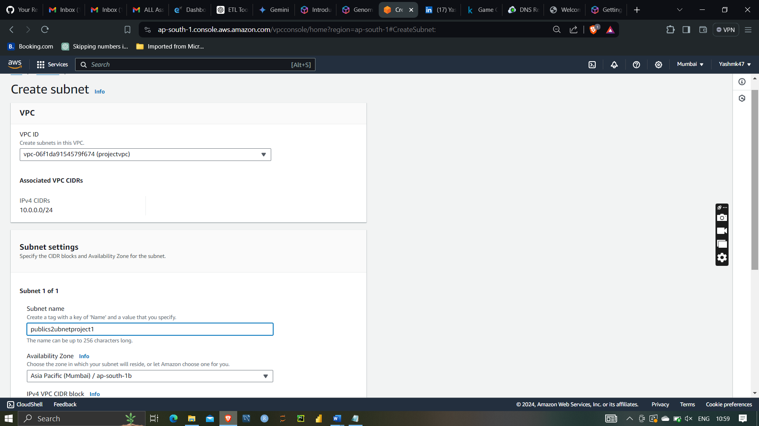

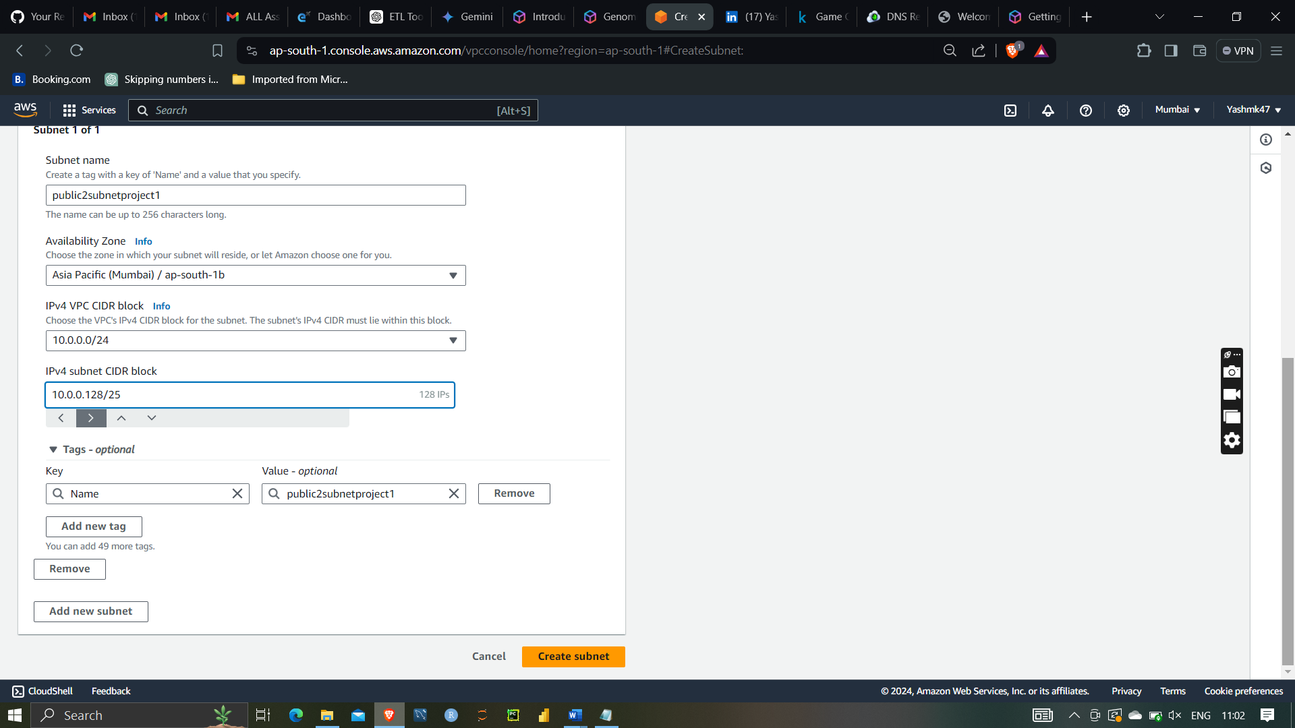

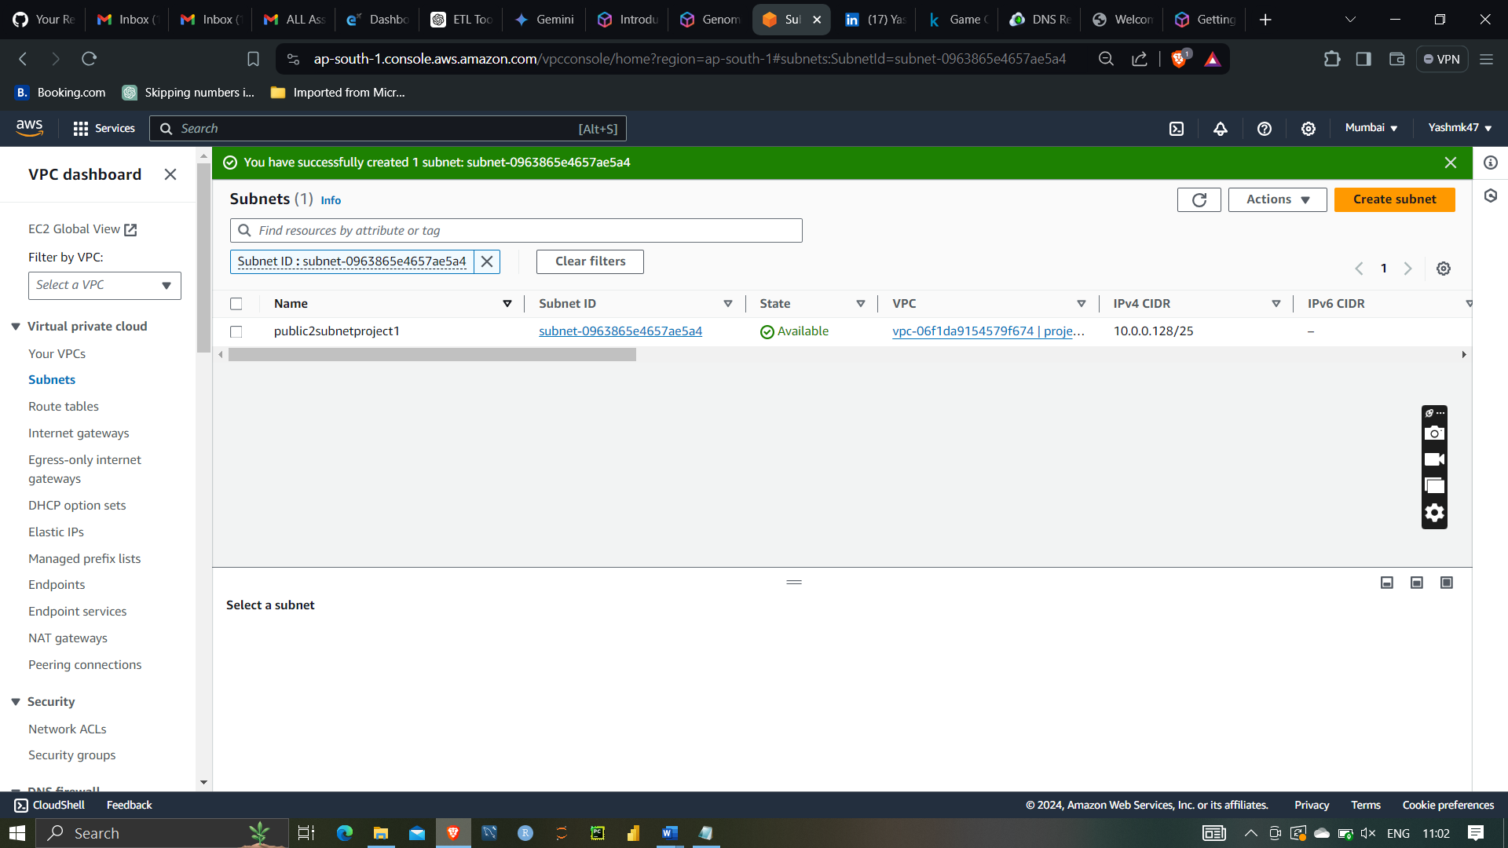

Both public subnet has been created with different availability zones

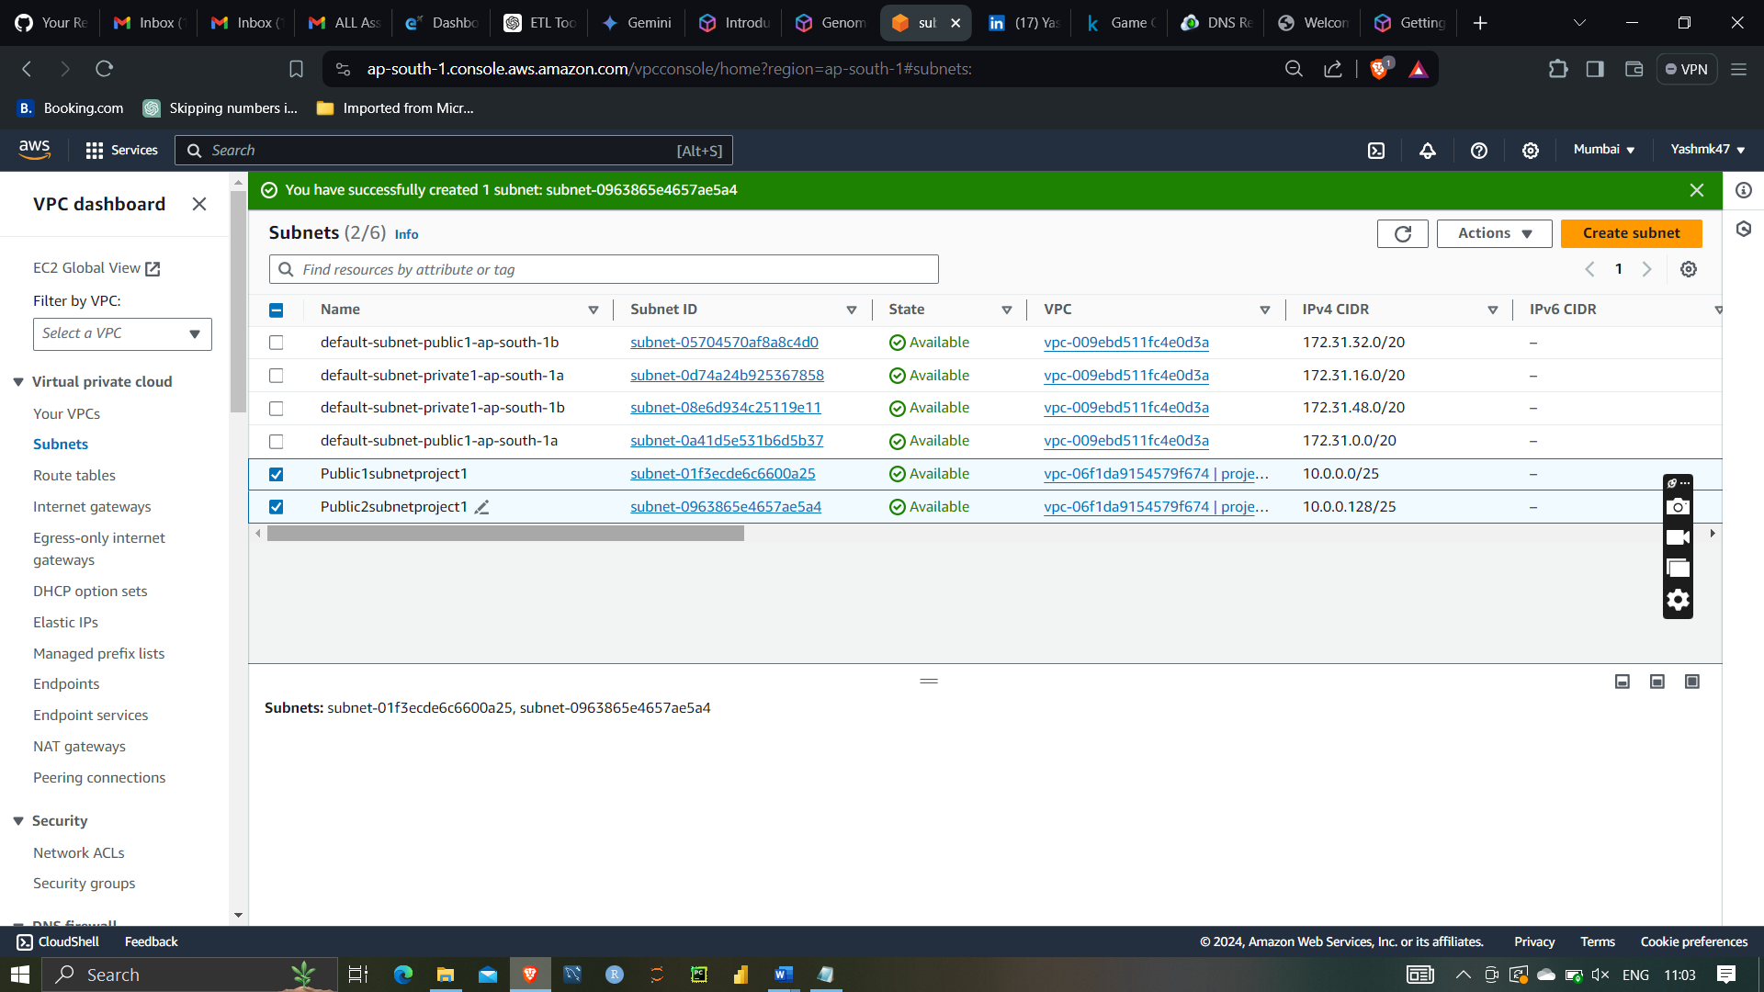

Internet gateway:-

An Internet Gateway (IGW) is a key component in a Virtual Private Cloud (VPC) that enables communication between instances in the VPC and the internet. It serves as a bridge, allowing inbound and outbound traffic to flow between the VPC and the internet

After that creating internet gateway for vpc to get the internet access to it

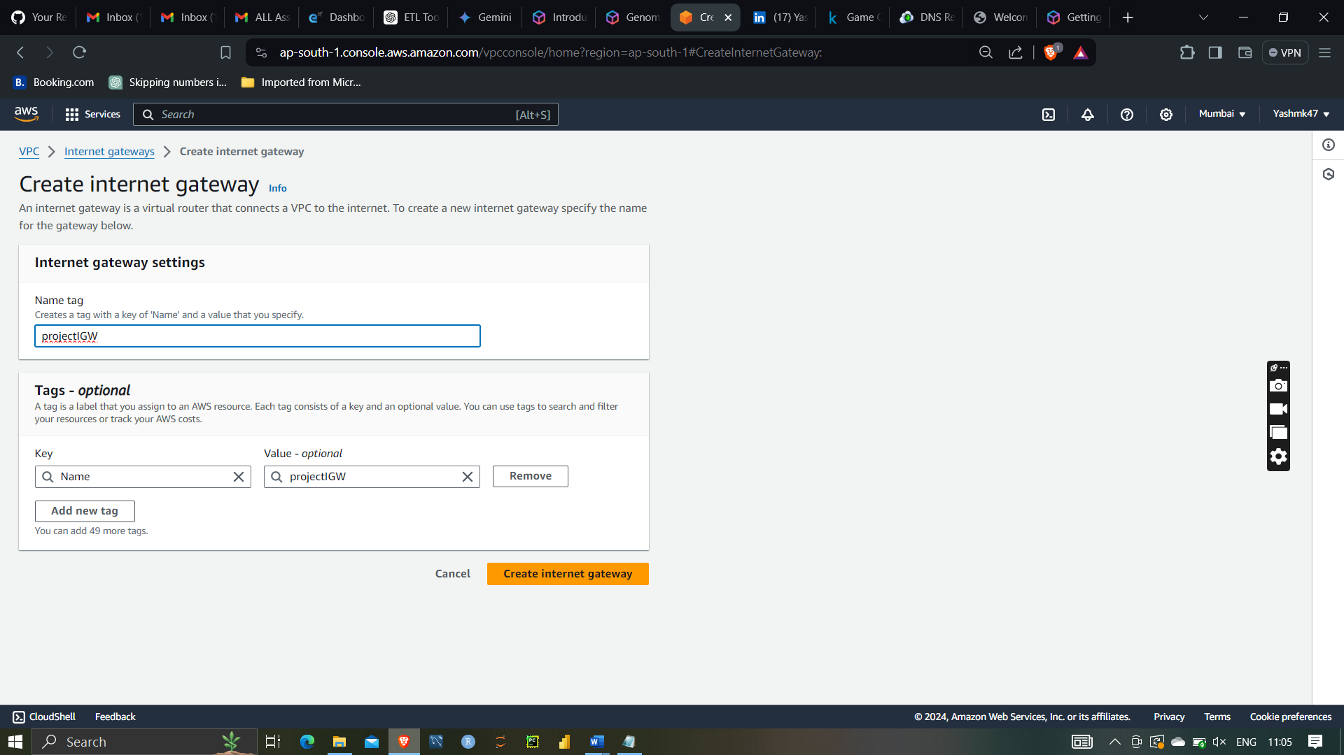

Attaching VPC to internet gateway

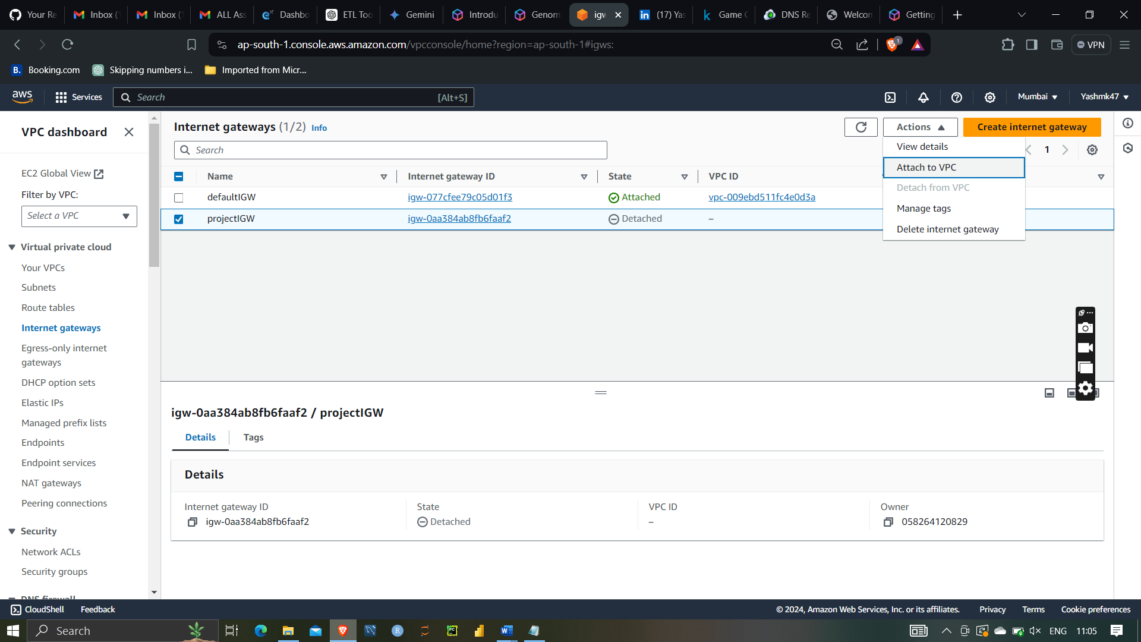

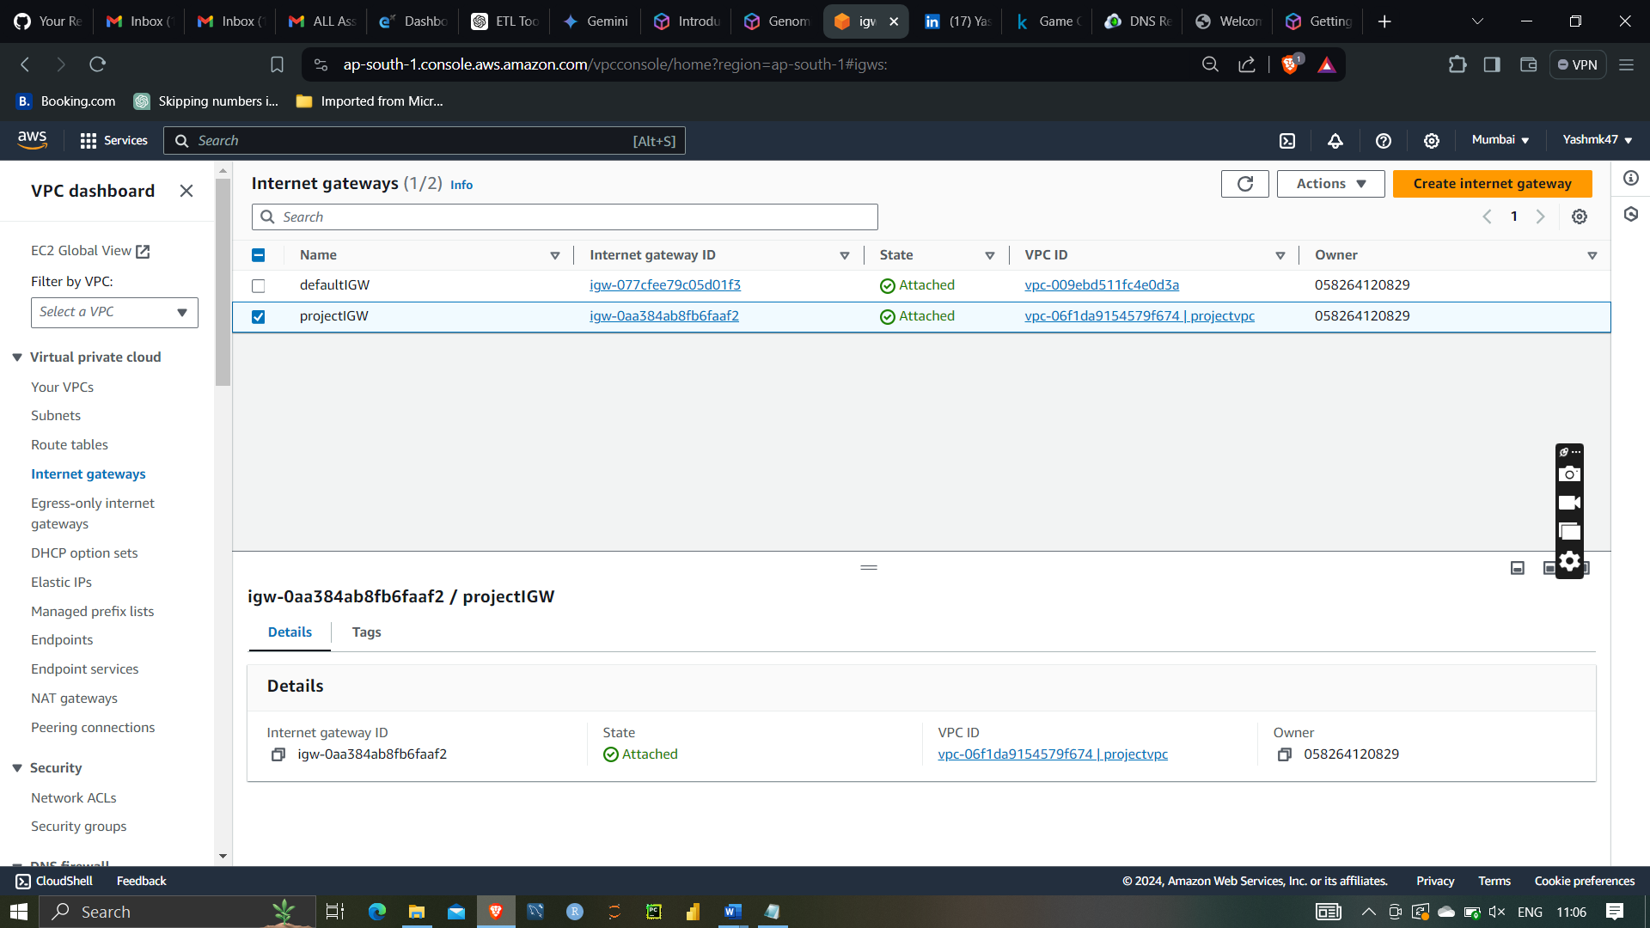

Route table:-

A route table is a critical component of networking in a Virtual Private Cloud (VPC) that directs the traffic flow between subnets within the VPC, to the internet, and to other network destinations. It contains a set of rules, called routes, that determine where network traffic from your subnet or gateway is directed.

After that creating route table for vpc and subnet

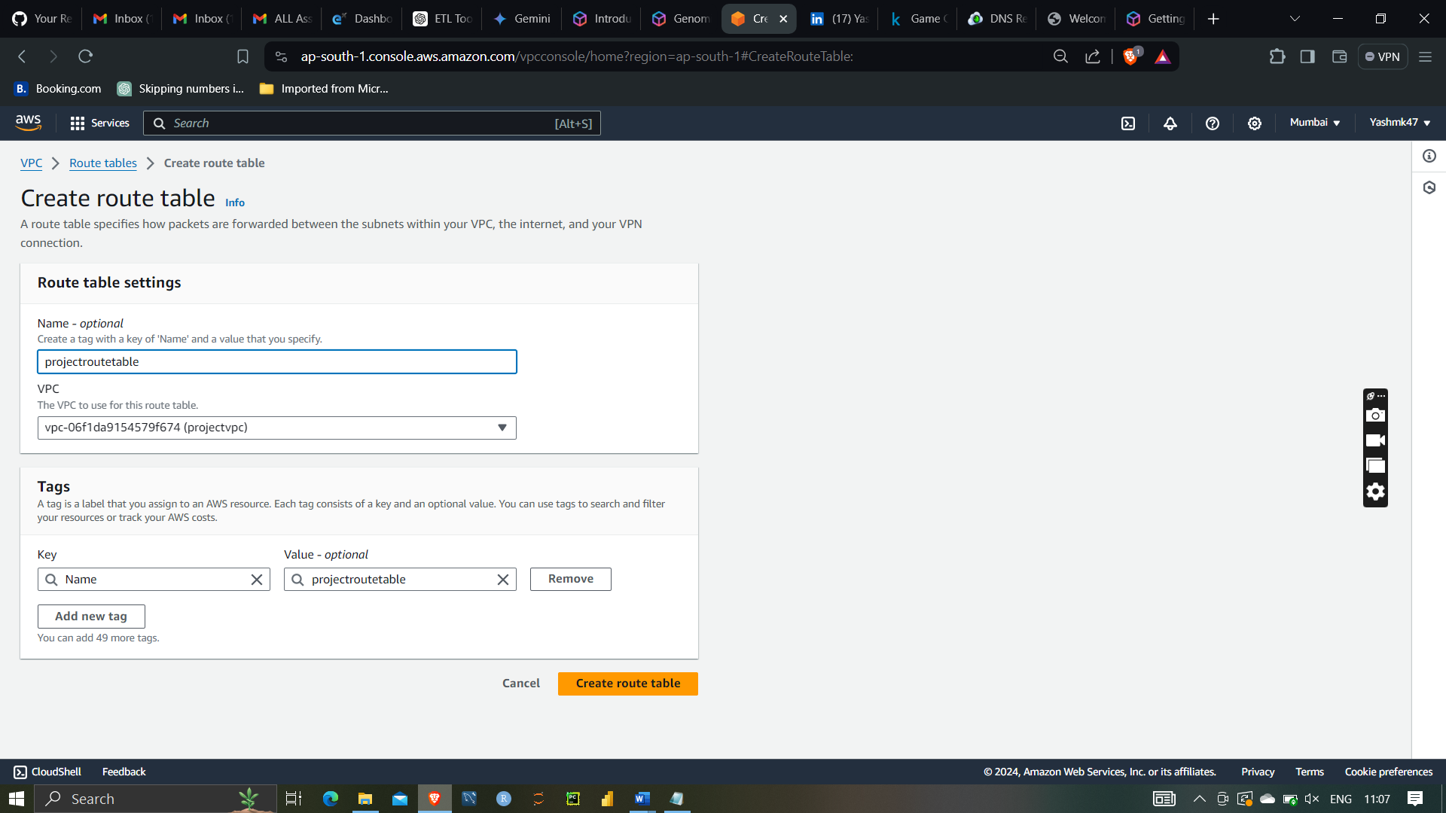

After that attaching subnet to the route table

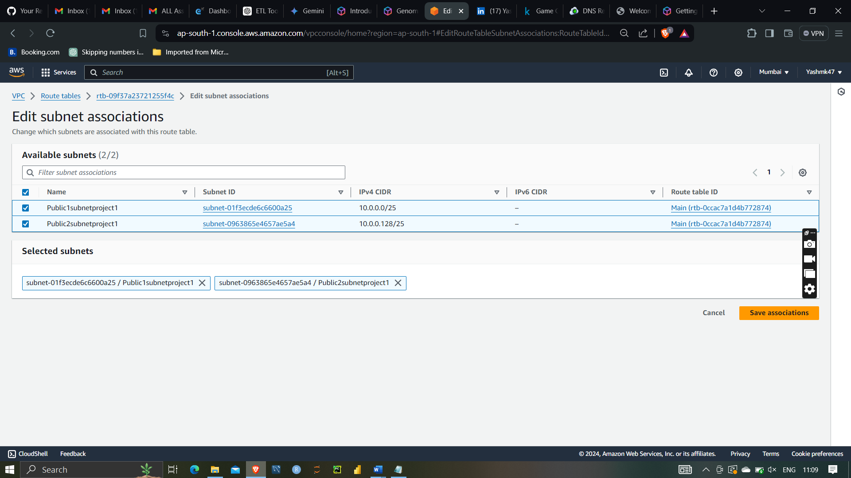

After that attaching route table to IGW (internet gatway) for internet access

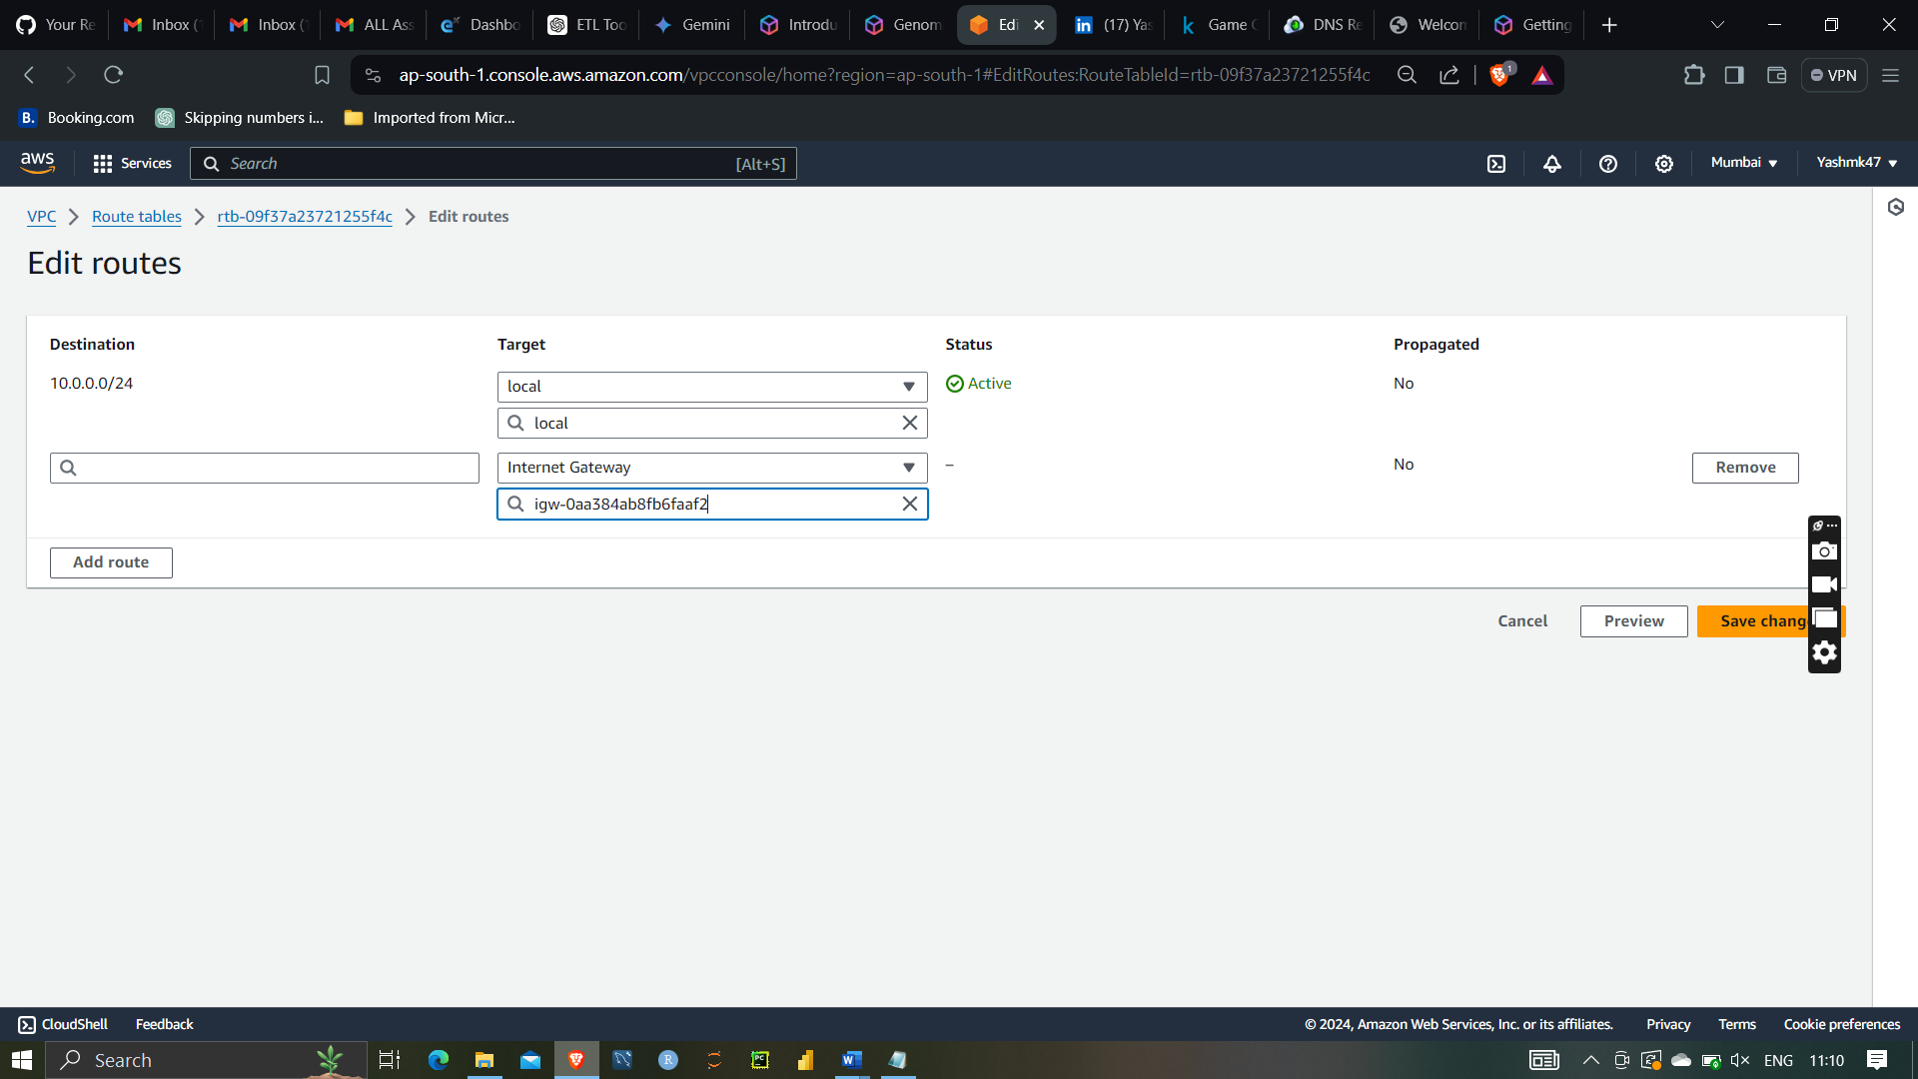

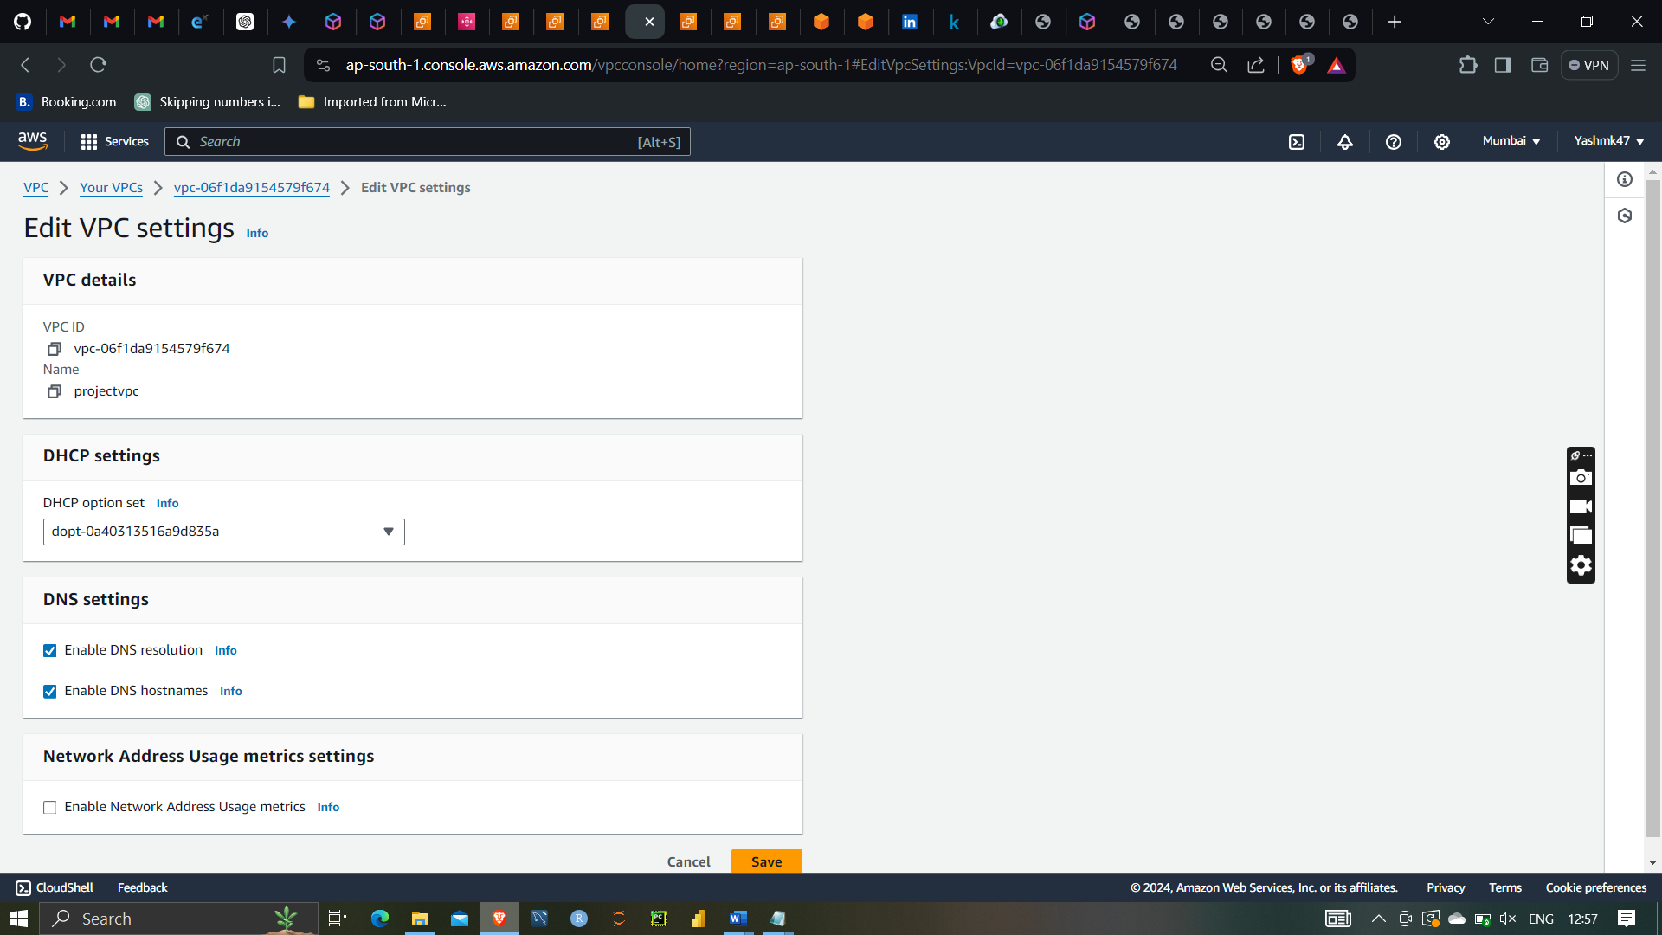

Enabling DNS resolution and DNS hostnames

After that enabling public IPv4 address for both server

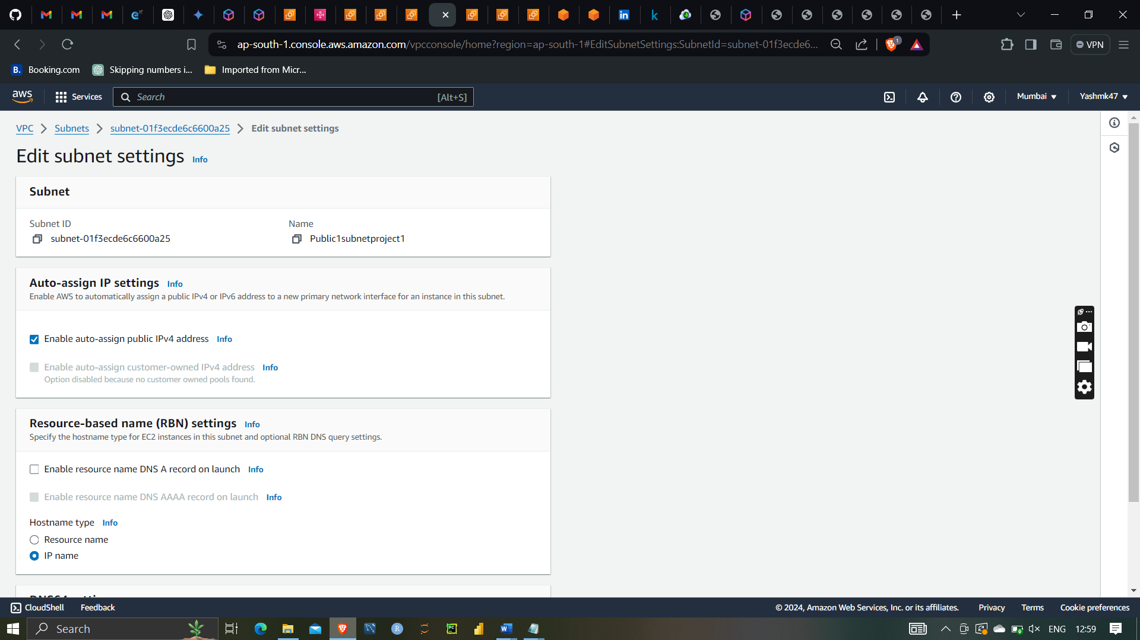 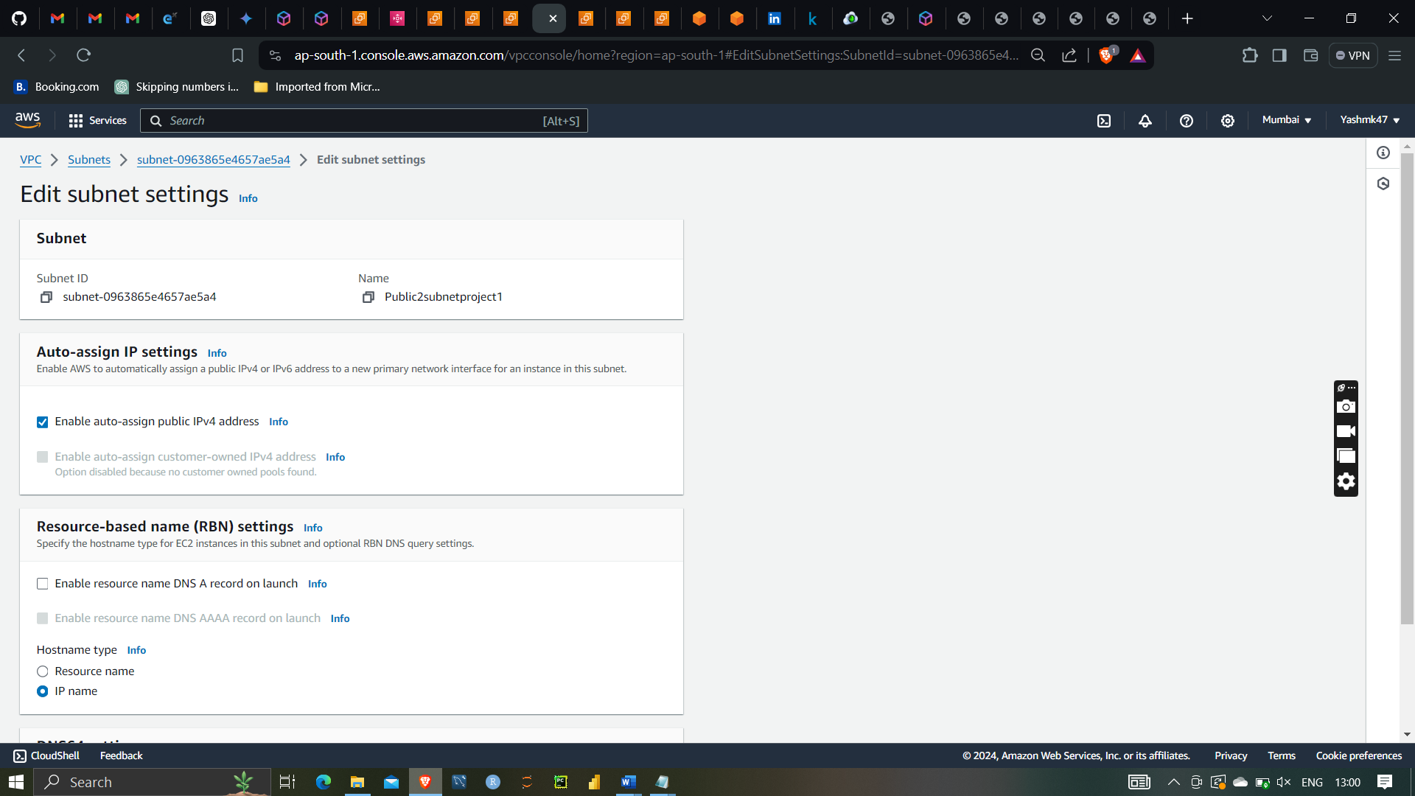

After that launching instances with different availability zones with my created vpc

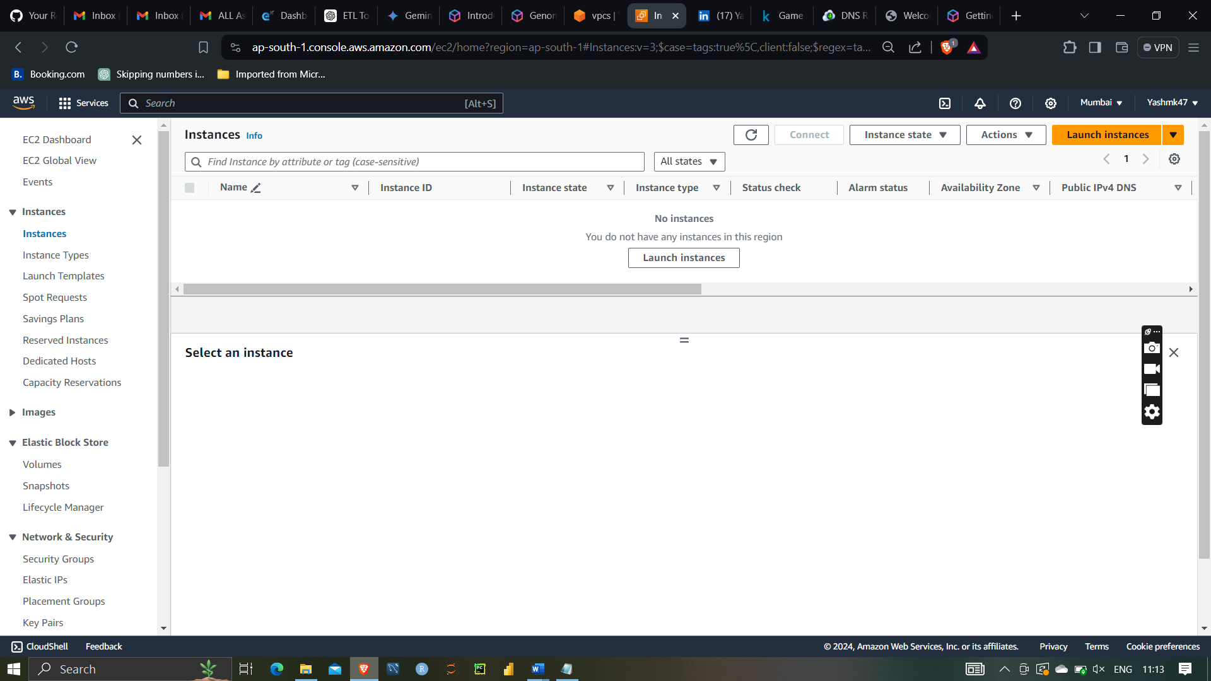

Creating instances

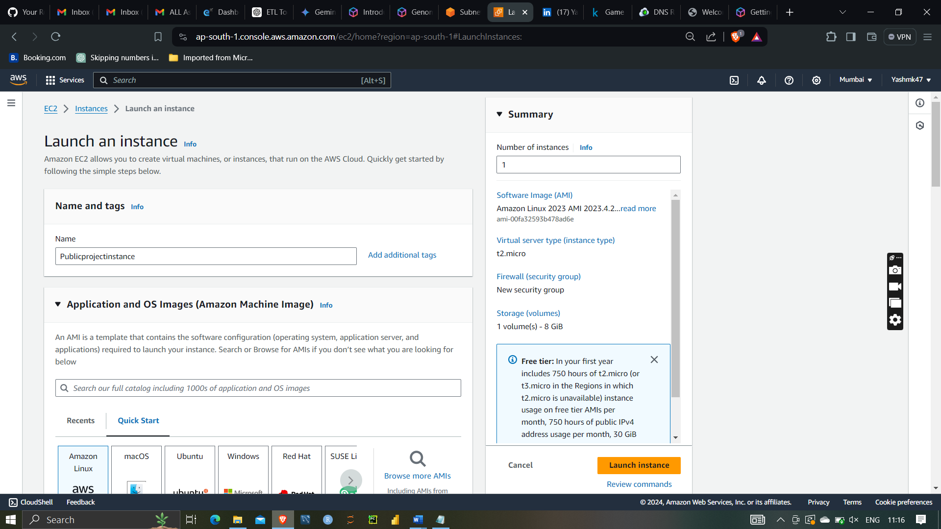

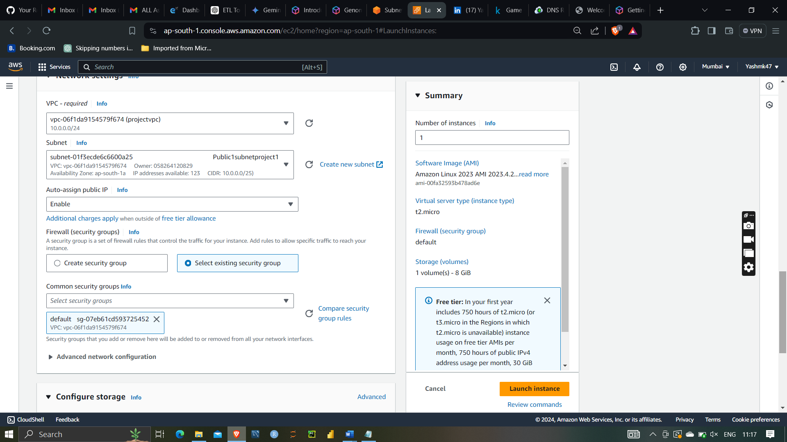

Then selecting project VPC with public subnet1 with availability zone ap-south-1a

Preinstalling apache web server using additional settings

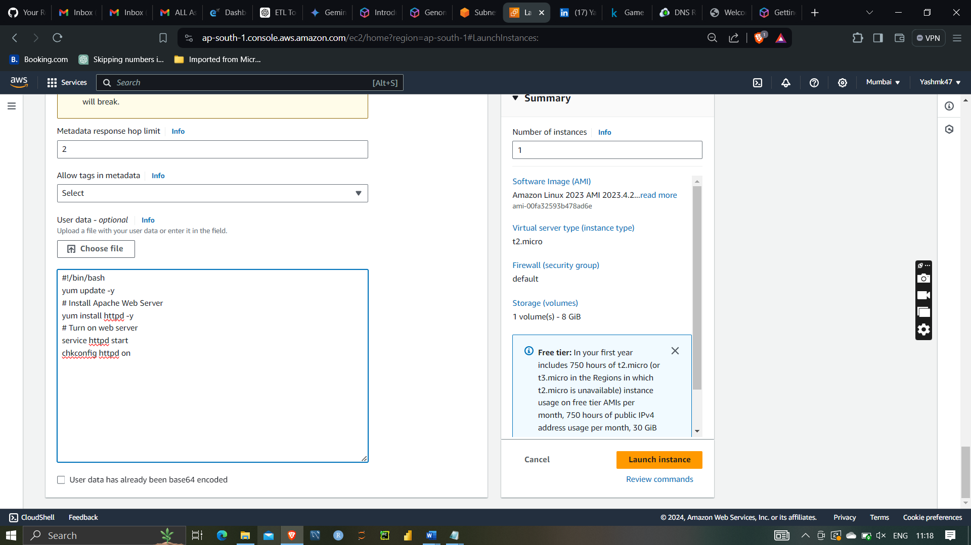

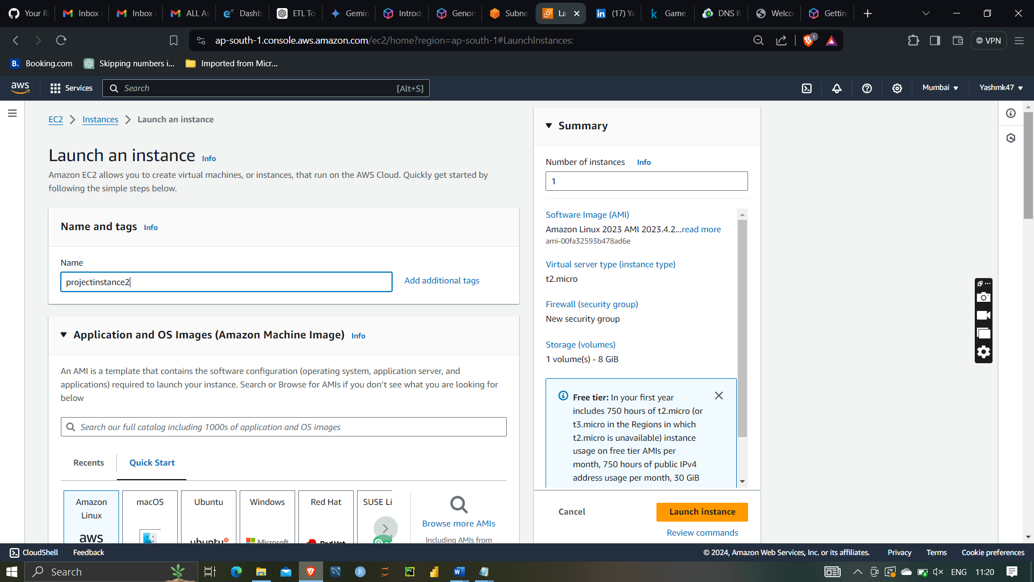

After that launching second instance

With projectVPC and selecting subnet with availability zones ap-south-1b

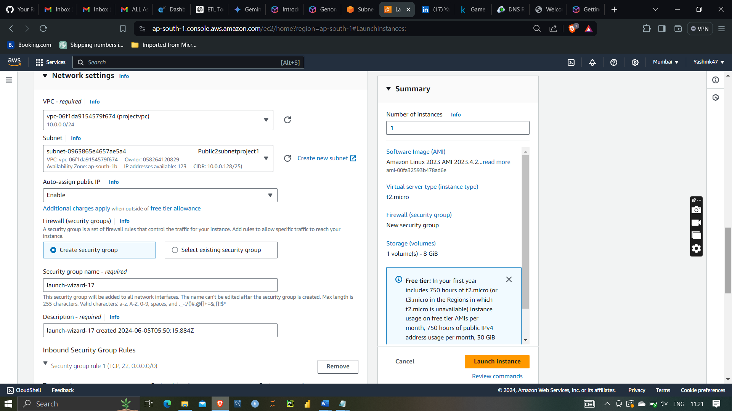

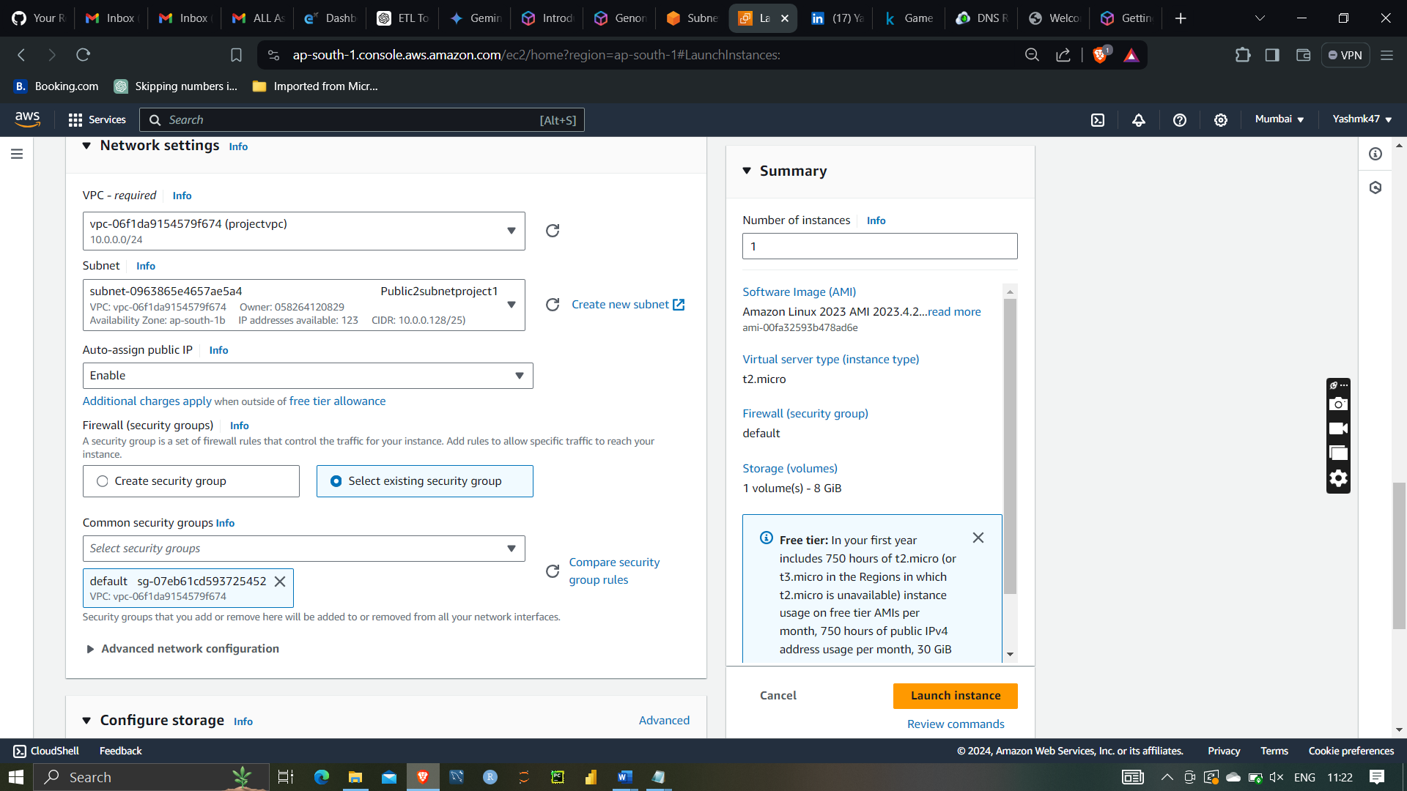

Selecting security groups

Security groups are virtual firewalls in cloud computing environments, such as Amazon Web Services (AWS), that control inbound and outbound traffic to and from resources within a Virtual Private Cloud (VPC). They provide a way to manage and enforce network security at the instance level, ensuring that only authorized traffic can reach your cloud resources.

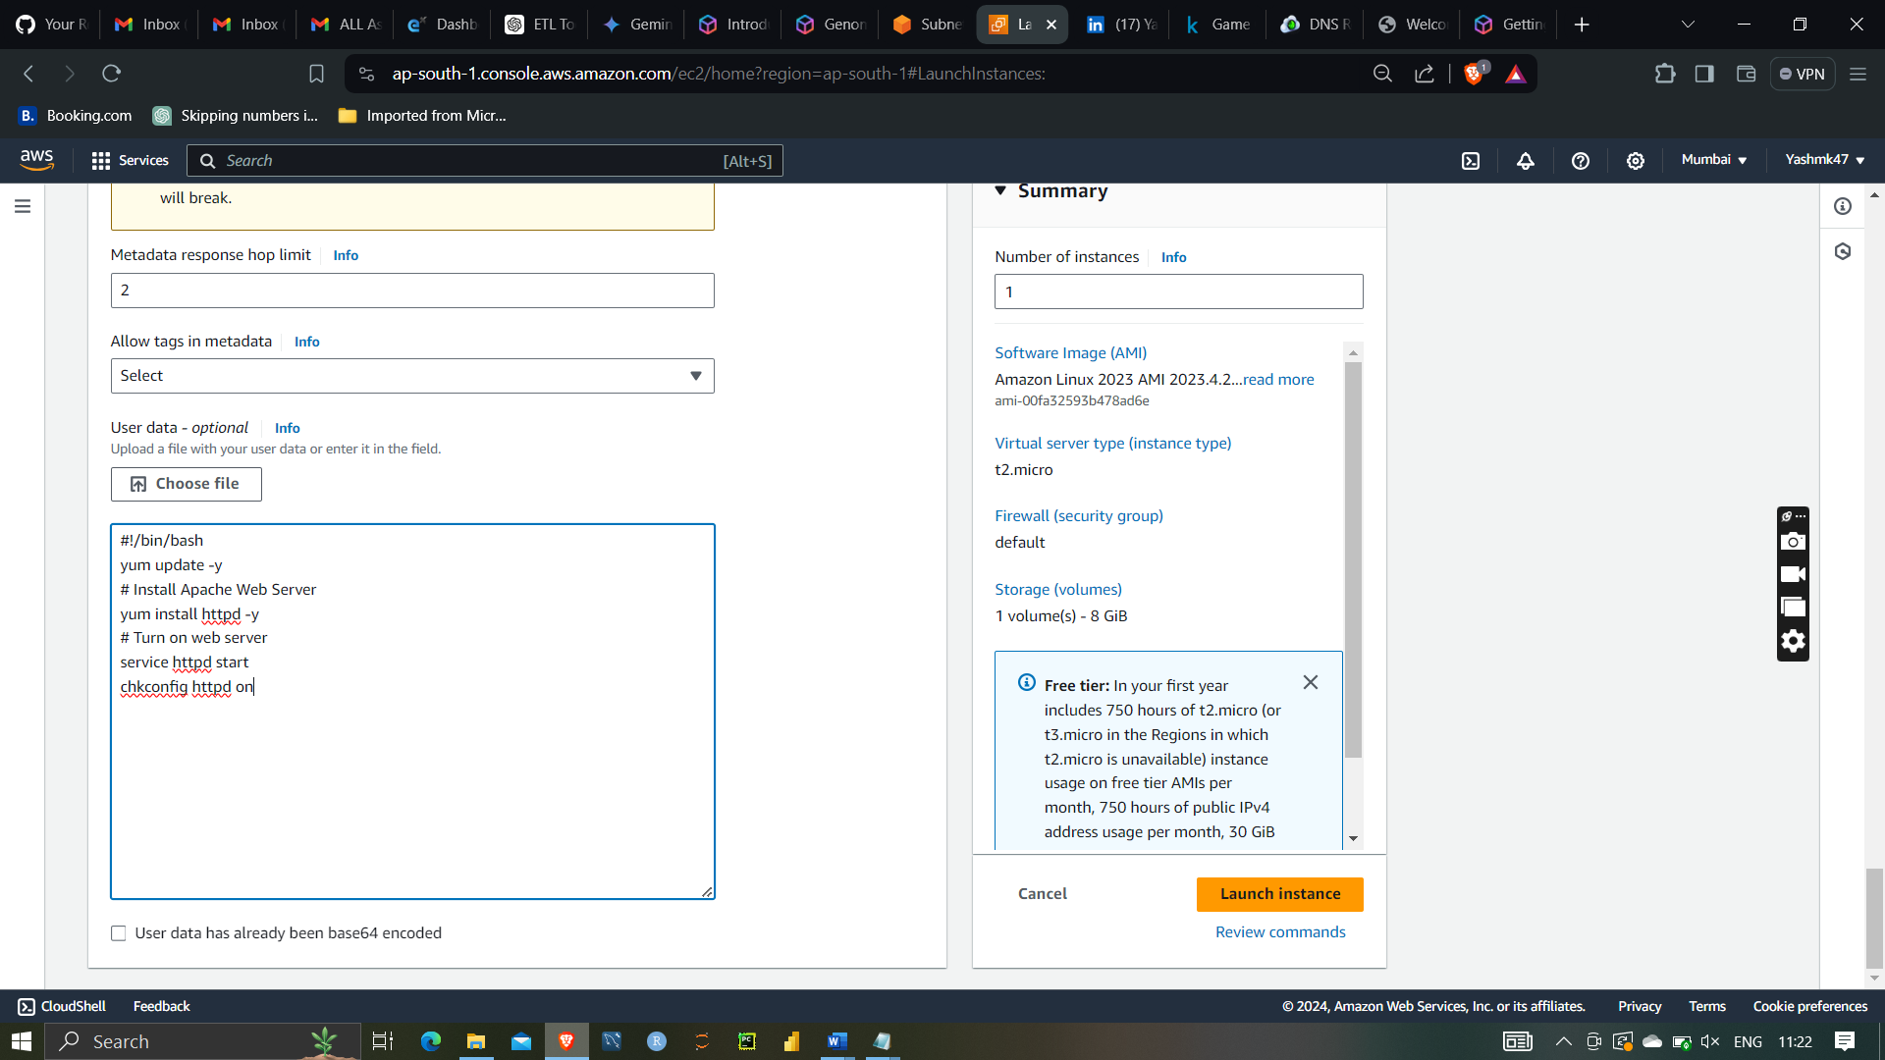

Preinstalling apache web server using additional settings

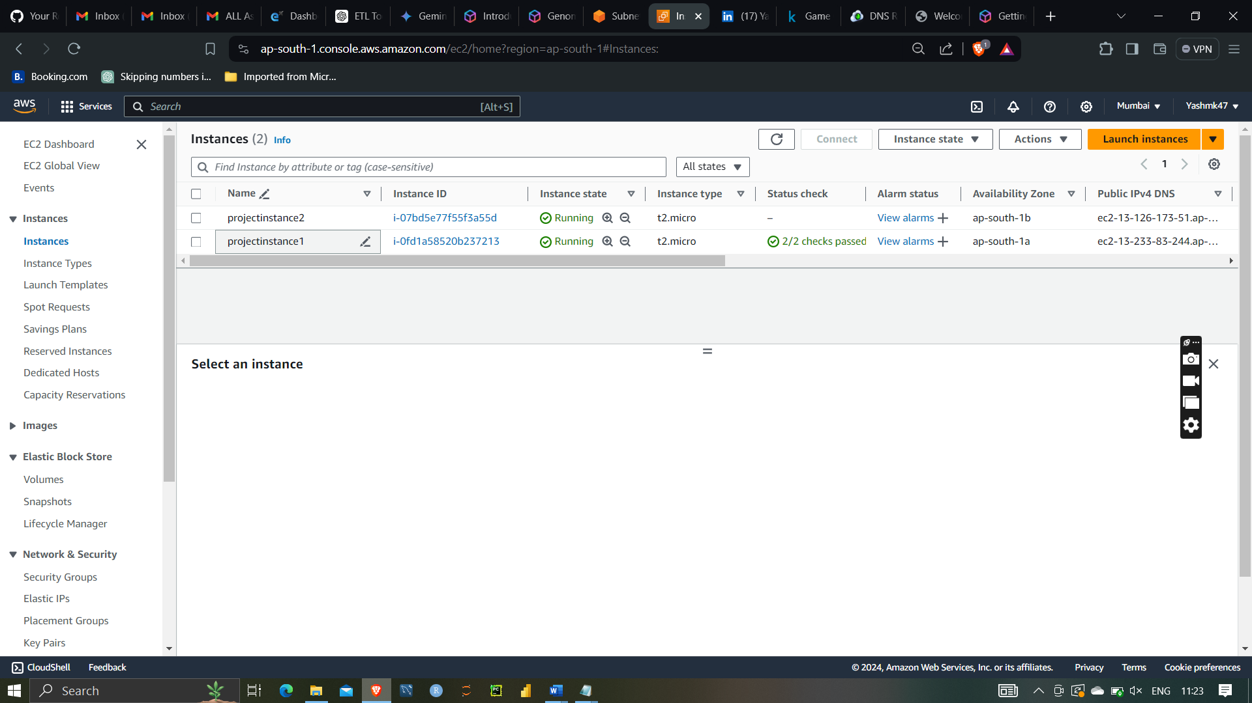

Both instances has been launch successfully

Selecting both SSH and HTTP port inside inbound rules of security group so that we instances should be properly connected

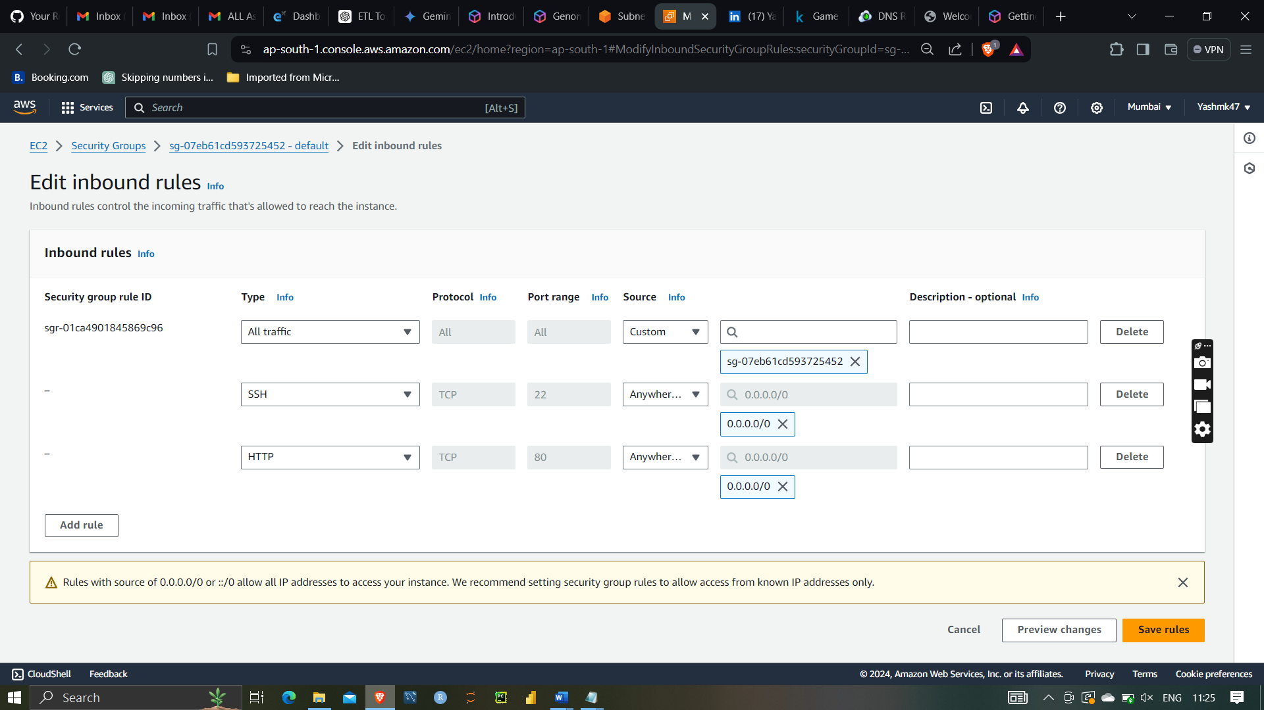

Hence both the instances has launch successfully

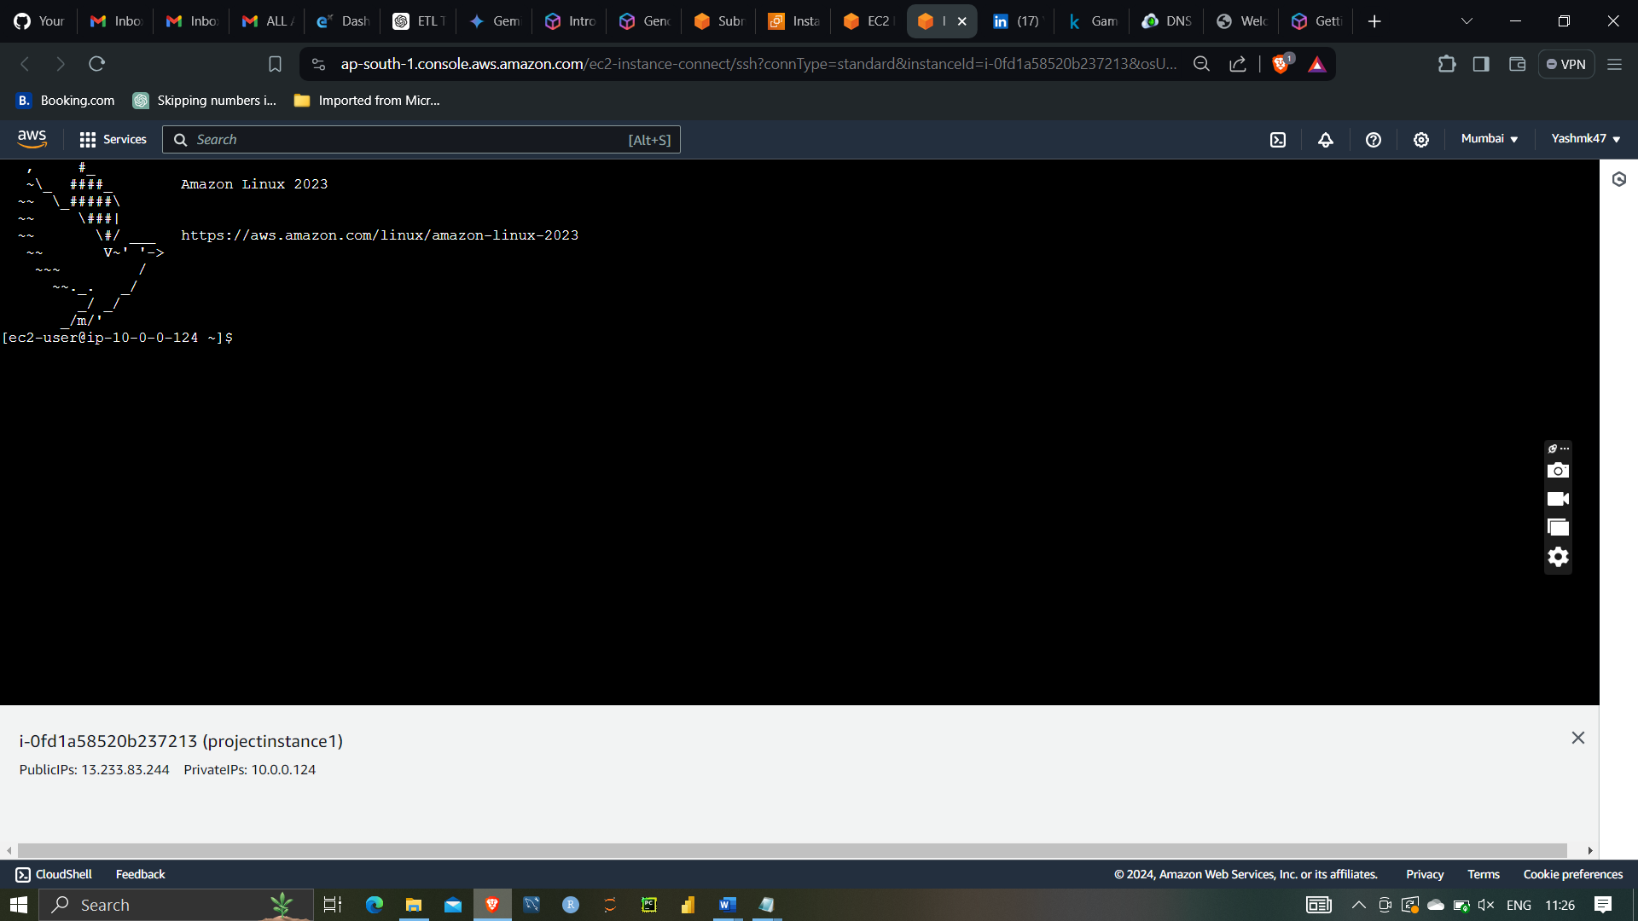

First project instances1

And second project instance1

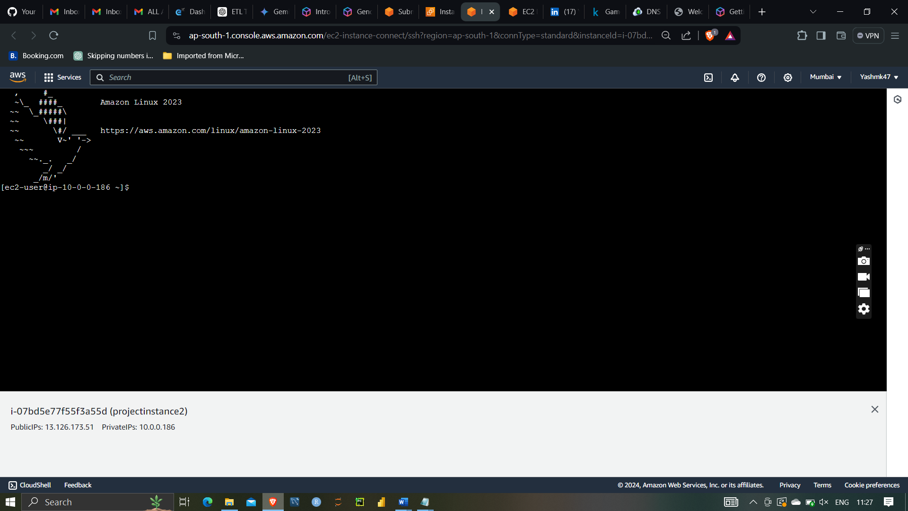

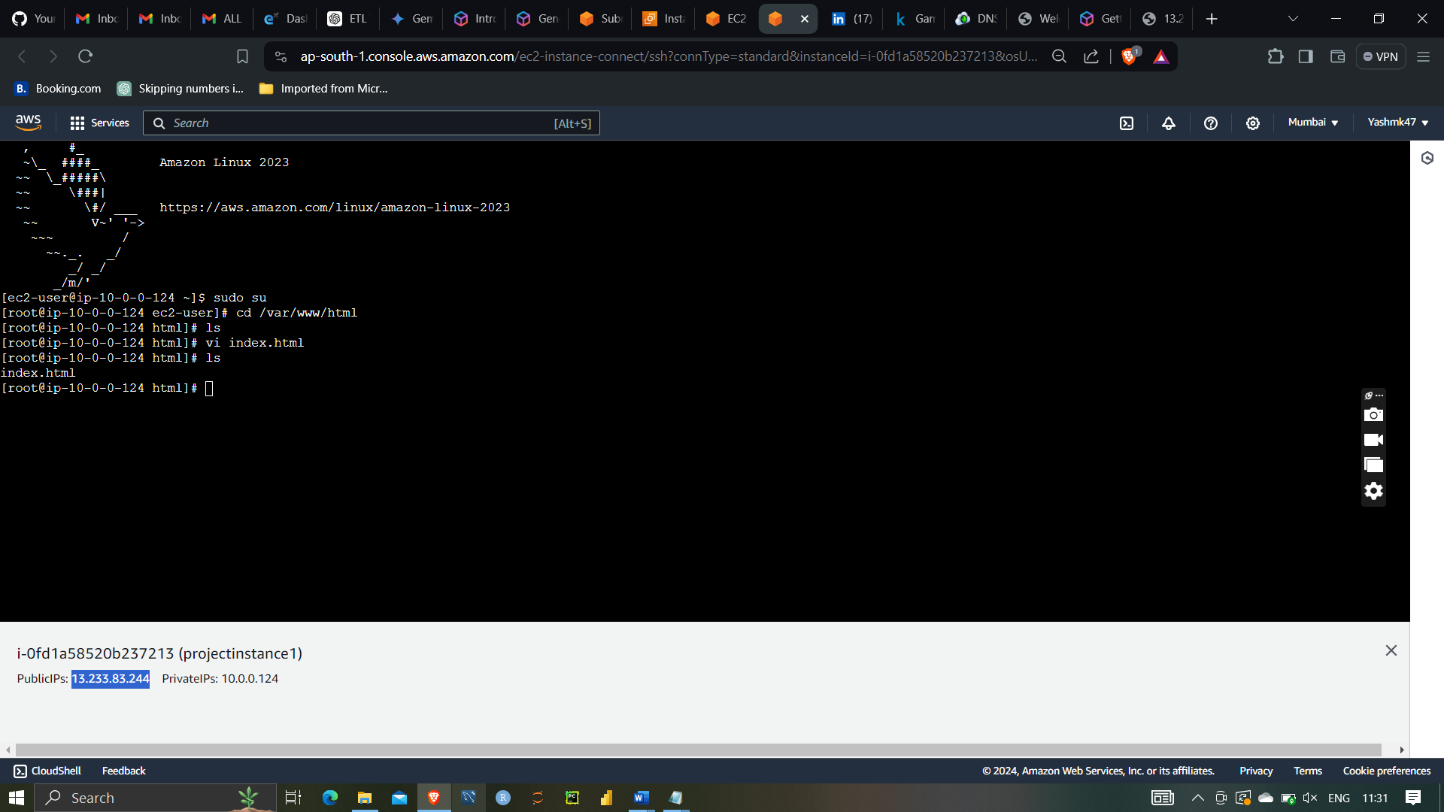

In first public server I have installing apache web server then I have create index.html file and writed

(first webserver project)

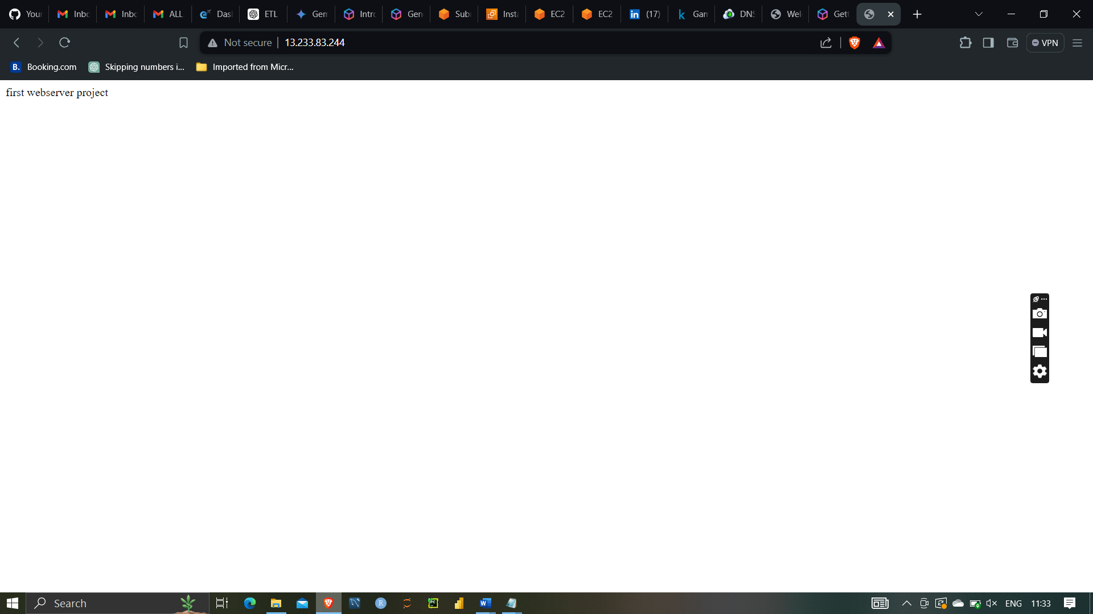

And similarly for second web server I have done the same . I have written second webserver project inside index.html file

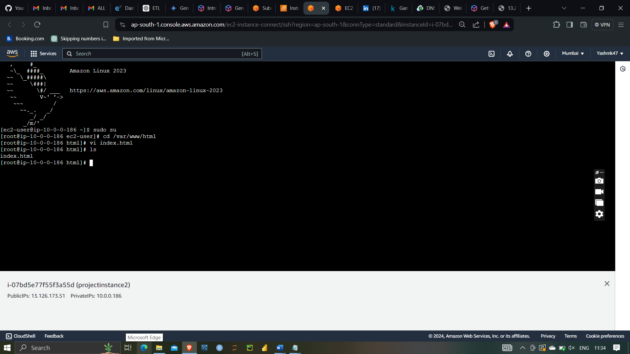

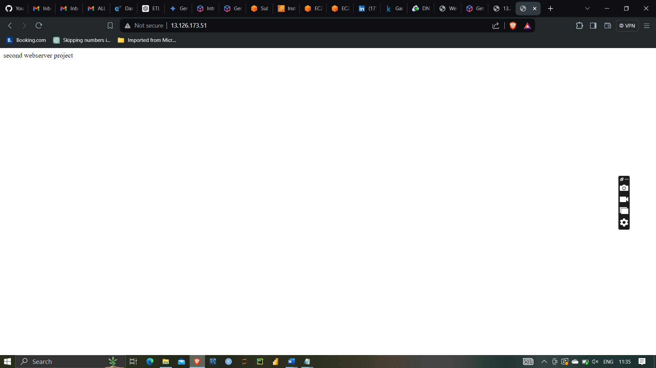

Load balancer:-

A load balancer is a network device or service that distributes incoming network traffic across multiple servers to ensure no single server becomes overwhelmed. It enhances the availability, reliability, and performance of your applications by spreading the load, facilitating fault tolerance, and providing redundancy.

Creating a load balancer

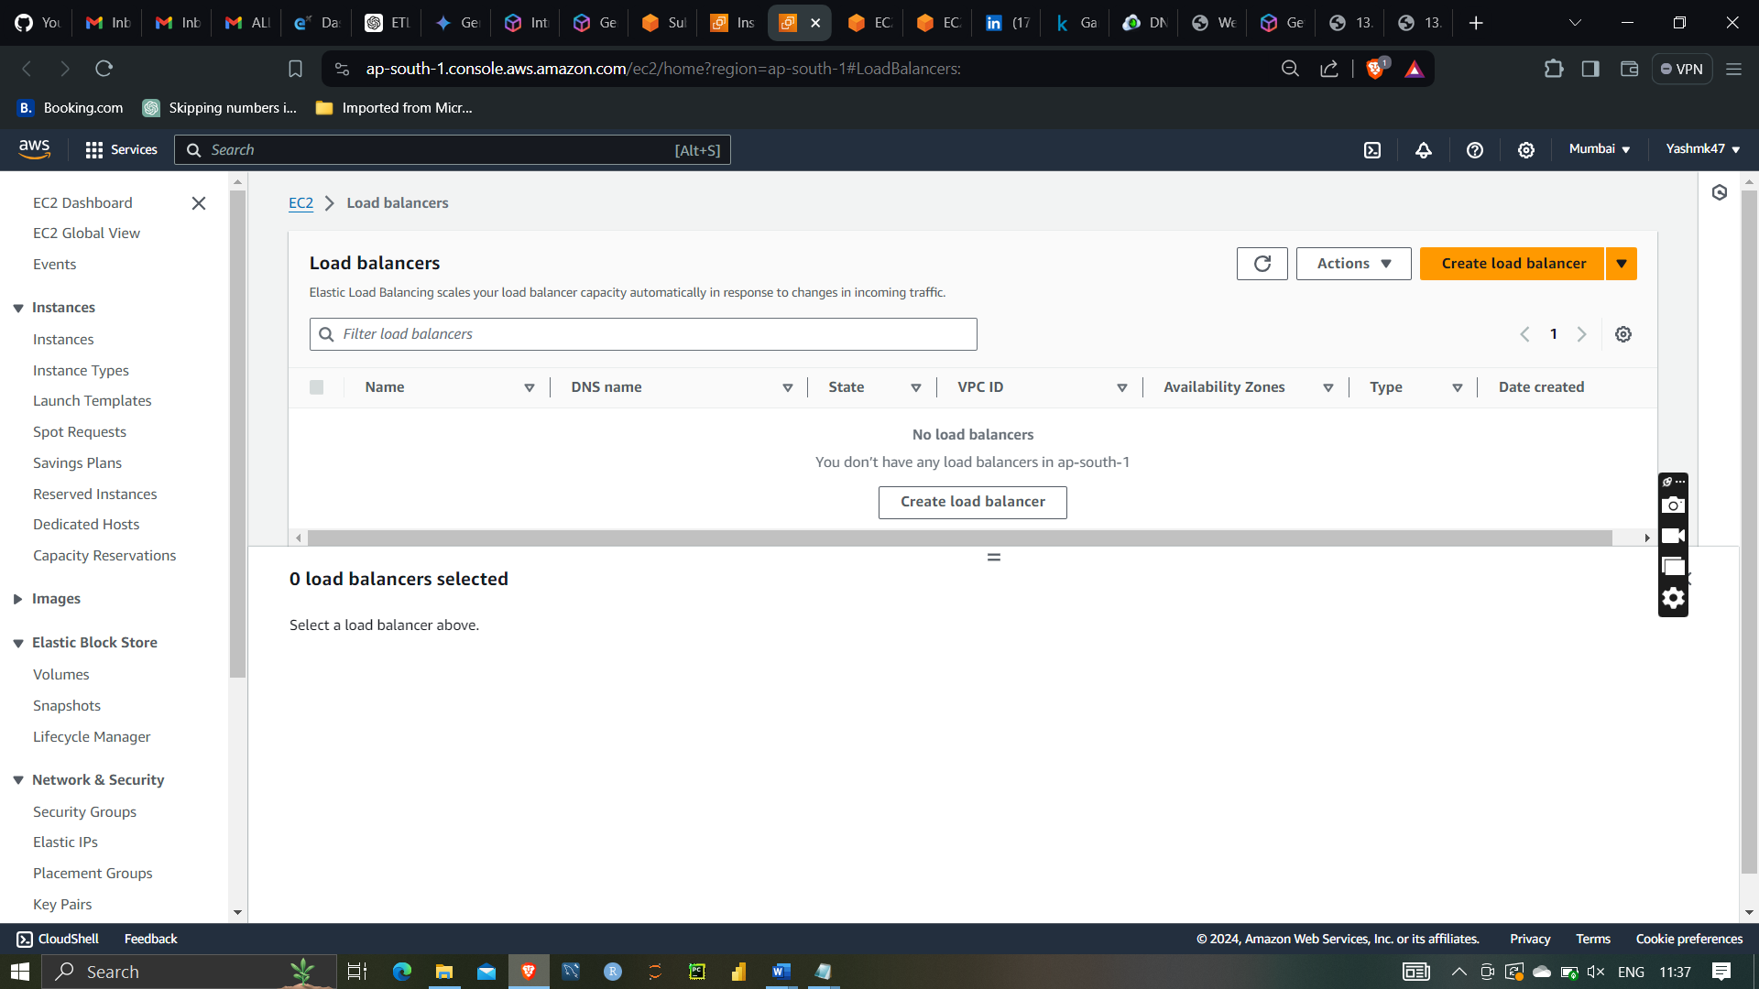

Selecting application load balancer for launching website

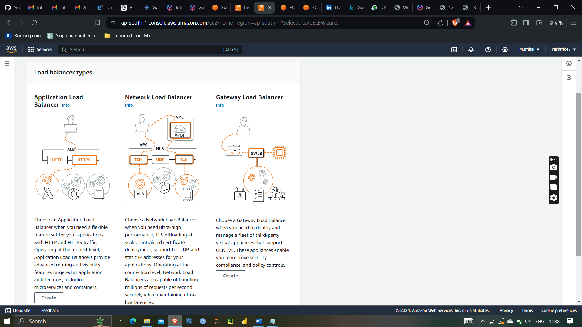

Creating projectlb balancer

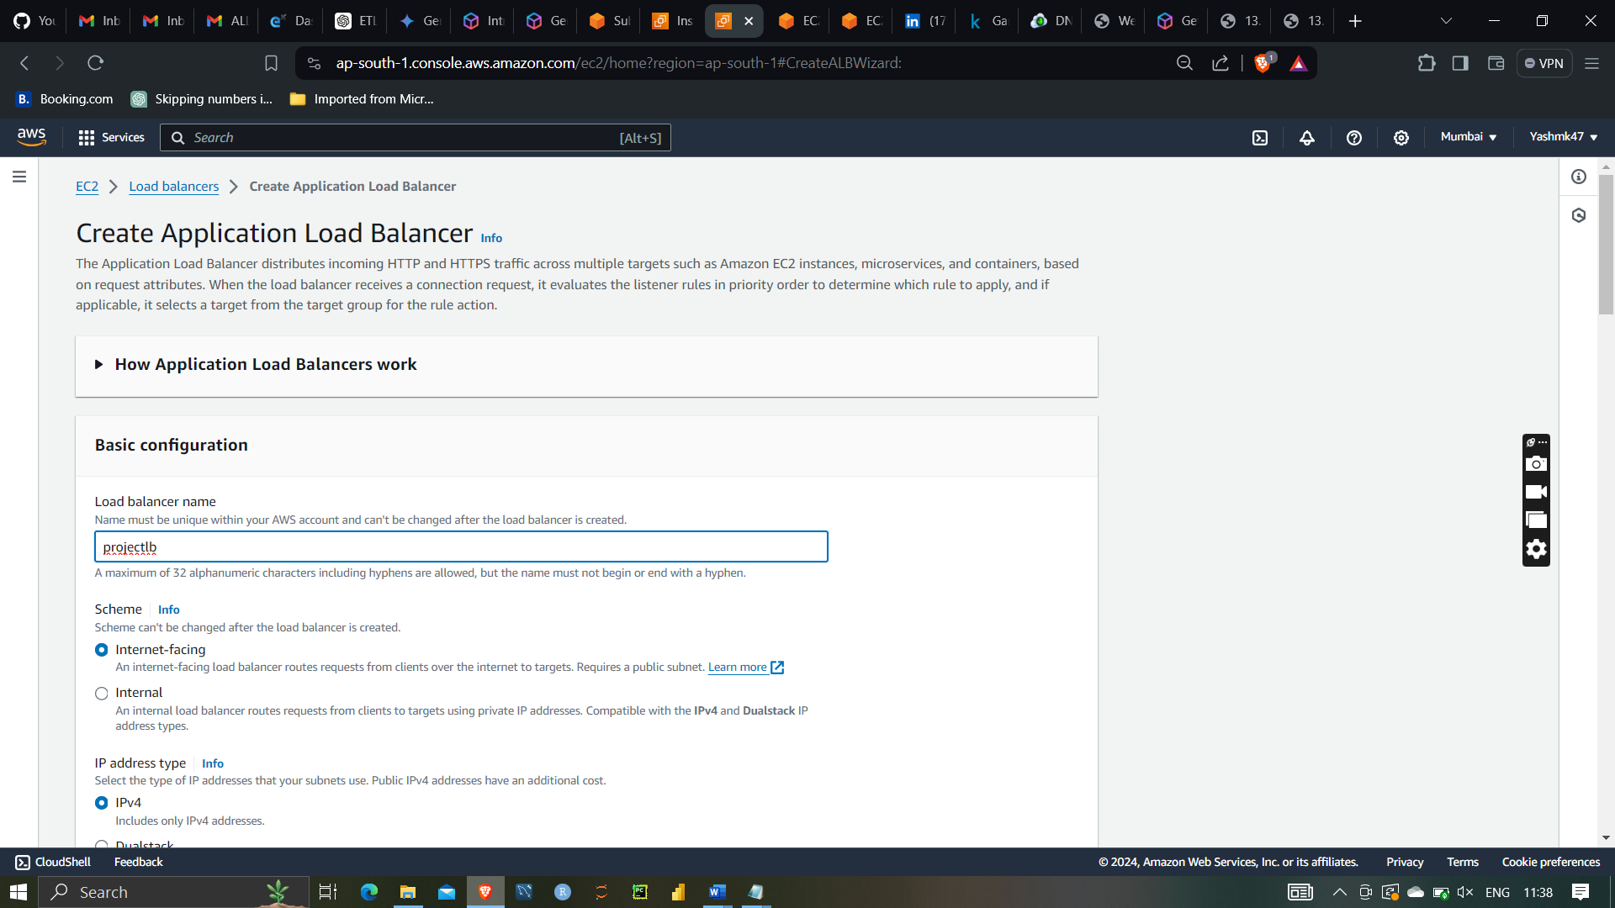

Selecting projectVPC with subnet selection

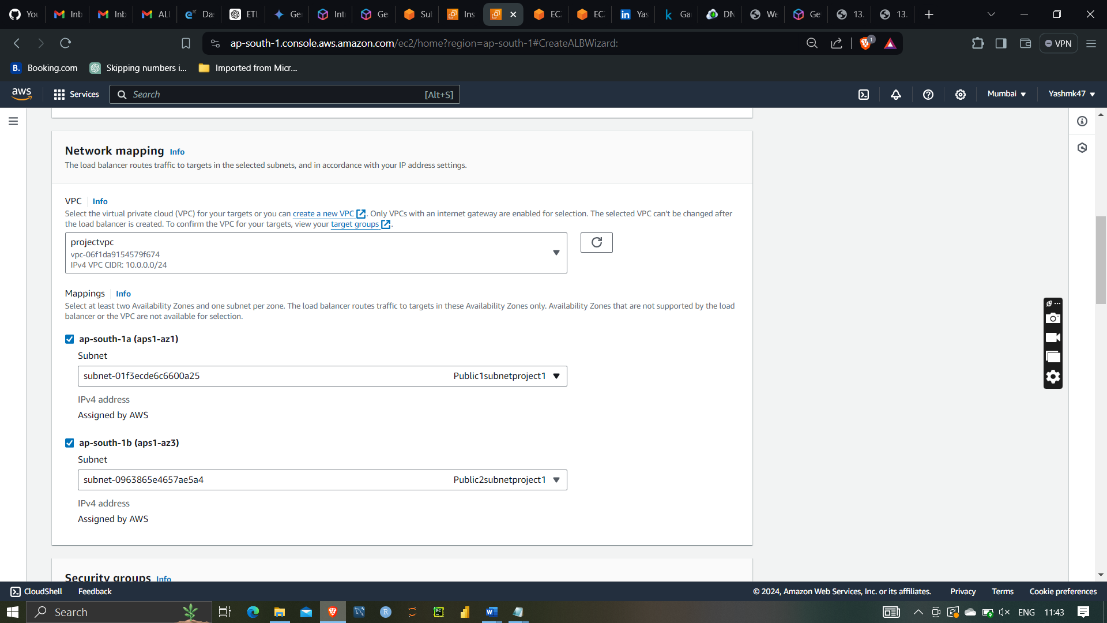

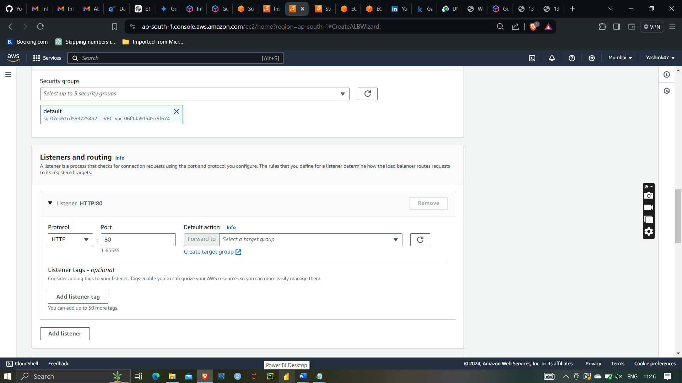

Target groups:

In AWS, target groups are a key component of load balancing, particularly when using Application Load Balancers (ALBs) and Network Load Balancers (NLBs). A target group is a logical grouping of endpoints (such as EC2 instances, IP addresses, or Lambda functions) that the load balancer routes traffic to.

load balancing, target groups are a fundamental concept used to define the set of endpoints that receive traffic from the load balancer. They are crucial for managing and directing traffic efficiently to ensure optimal performance and high availability of applications.

Selecting target groups

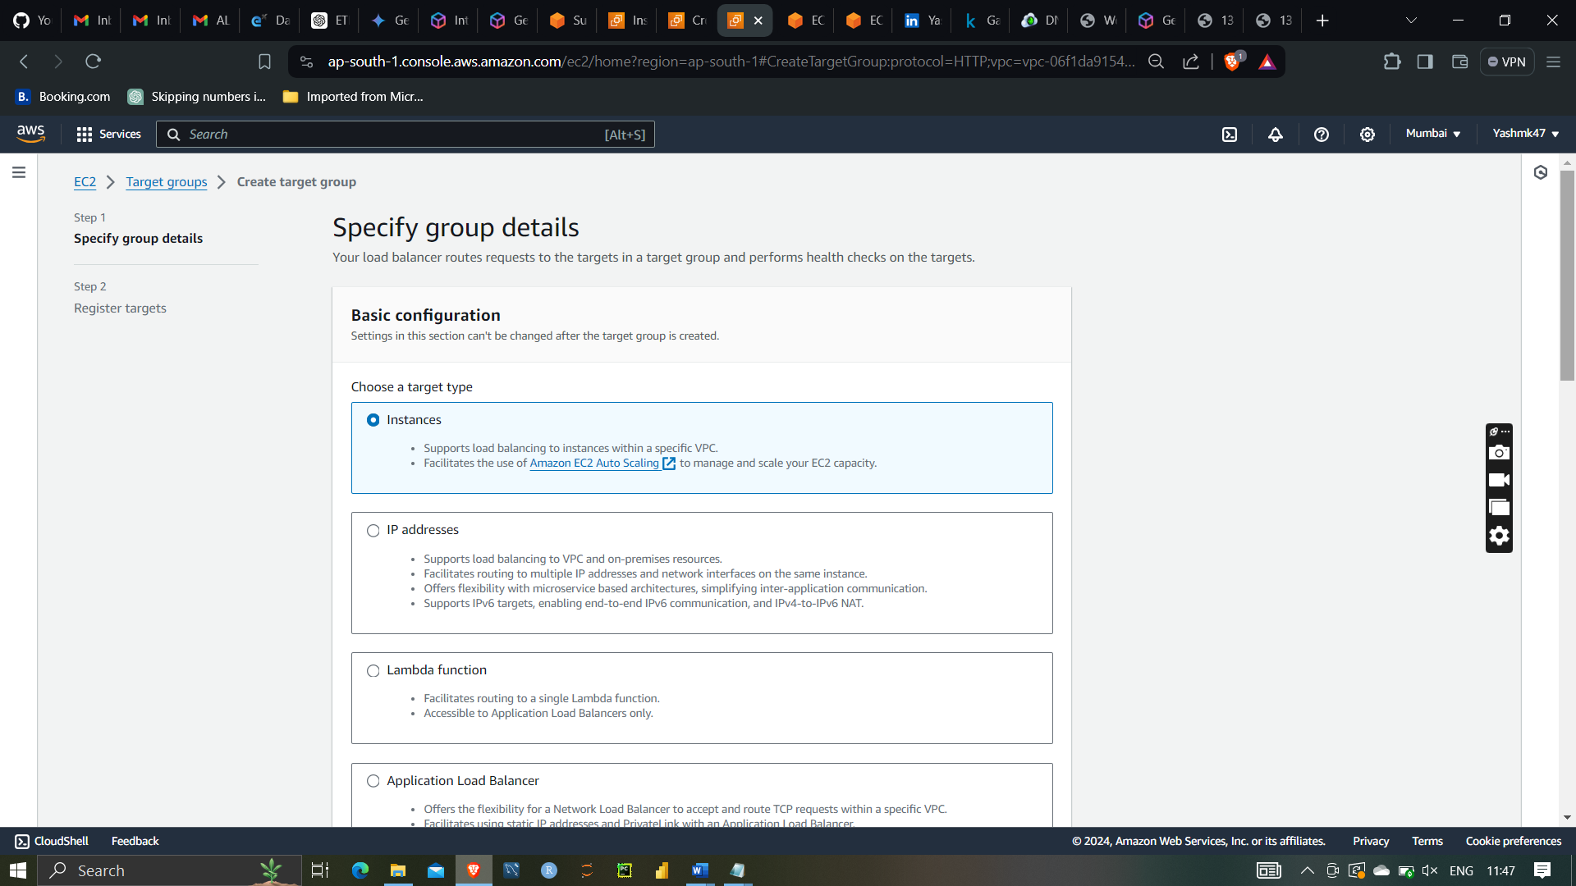

Given name to the target group as targetproject

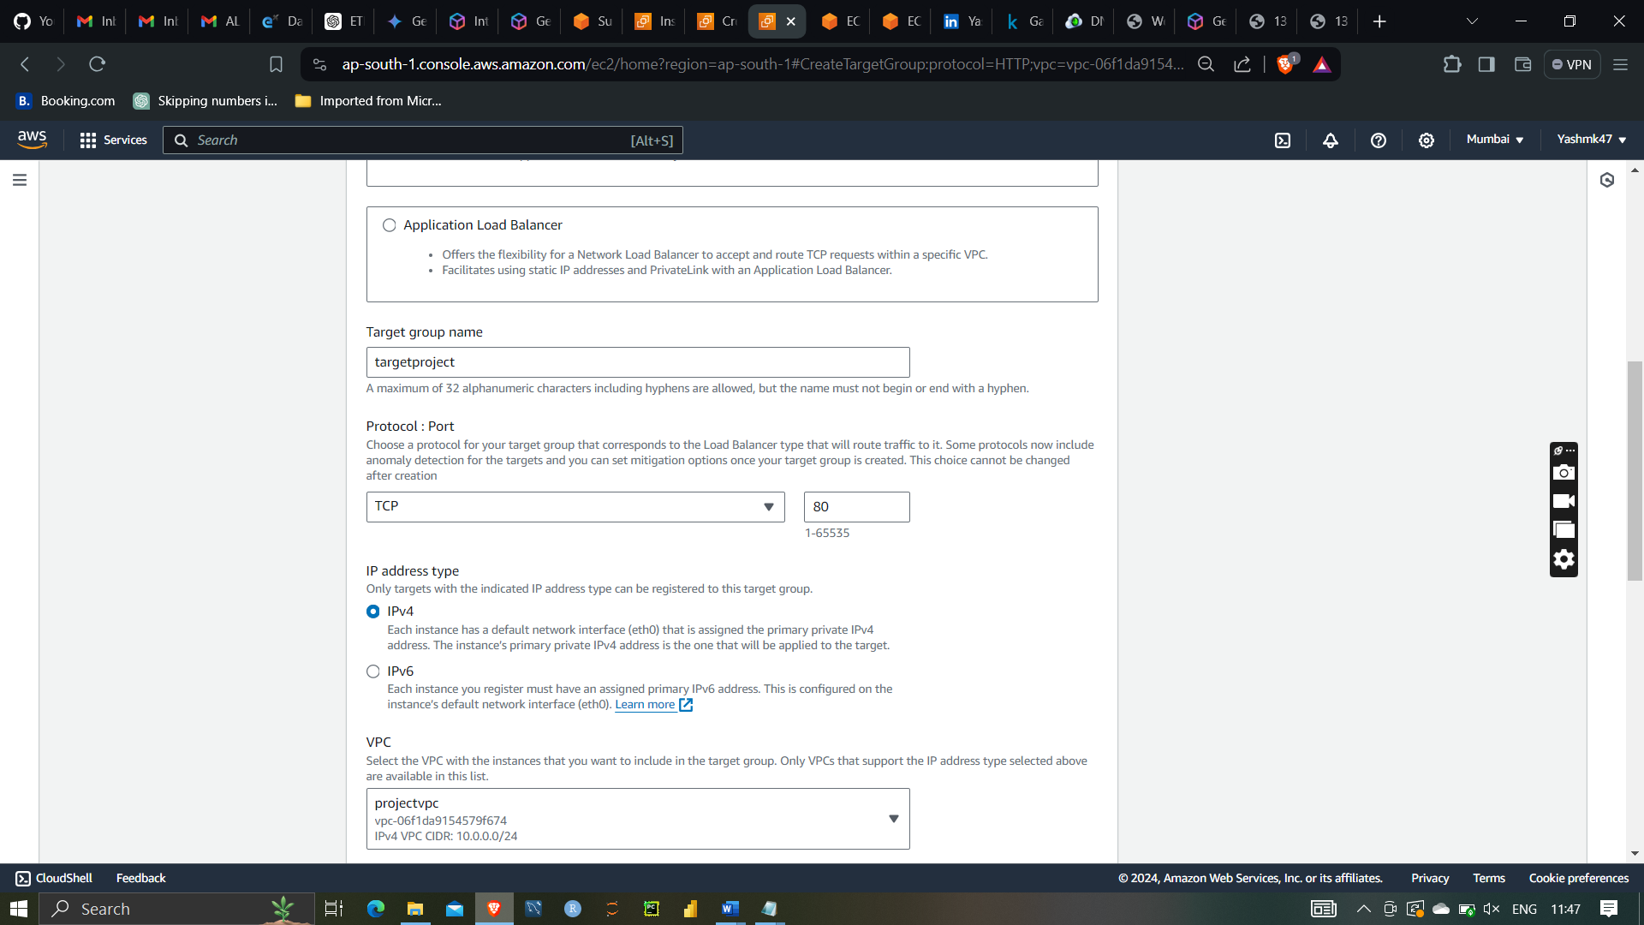

Registrating target

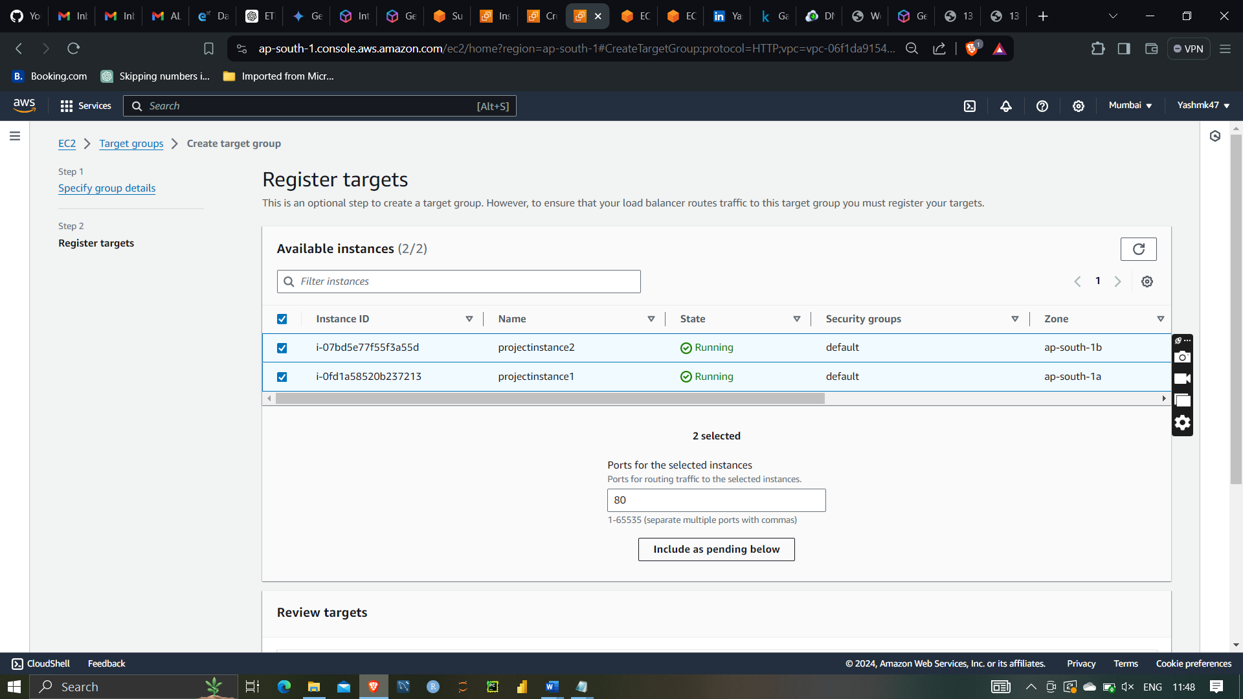

After clicking on include pending below

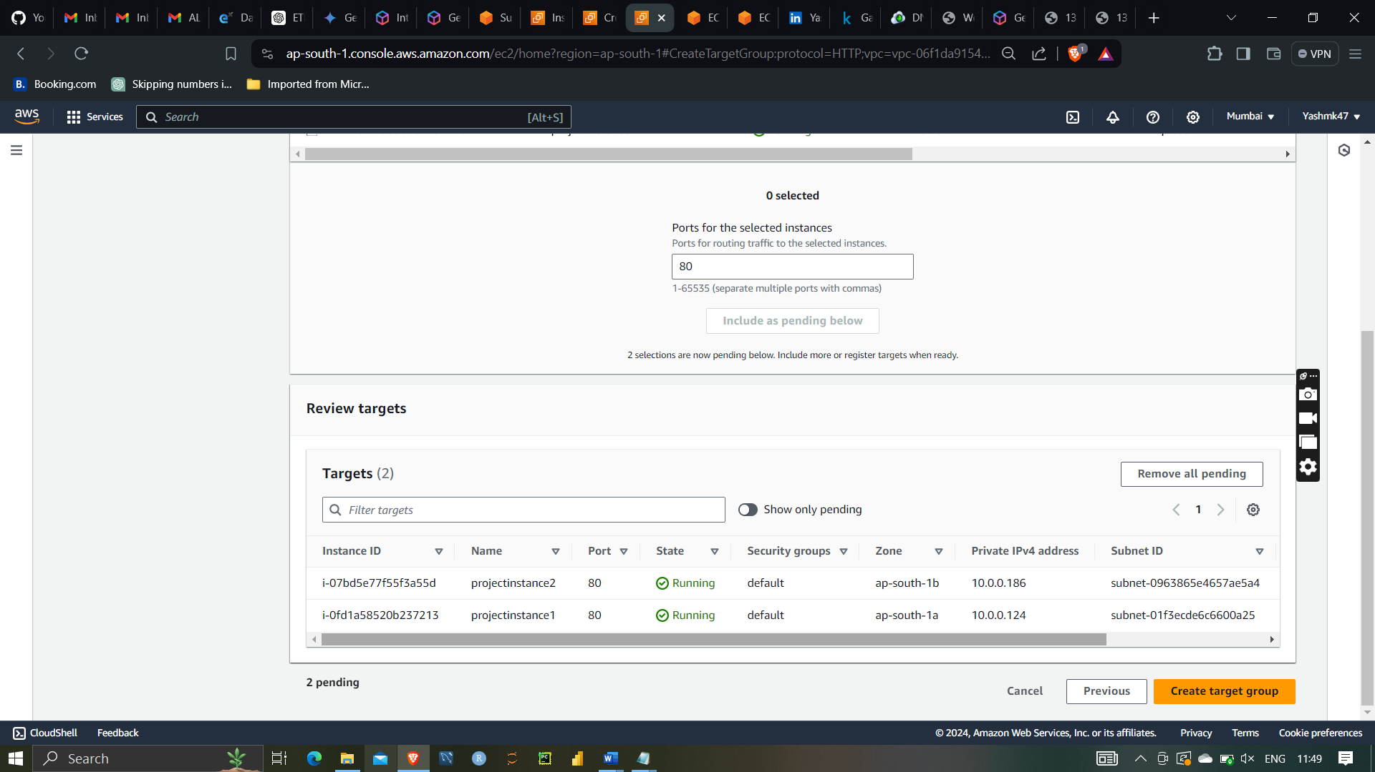

Then creating the target groups



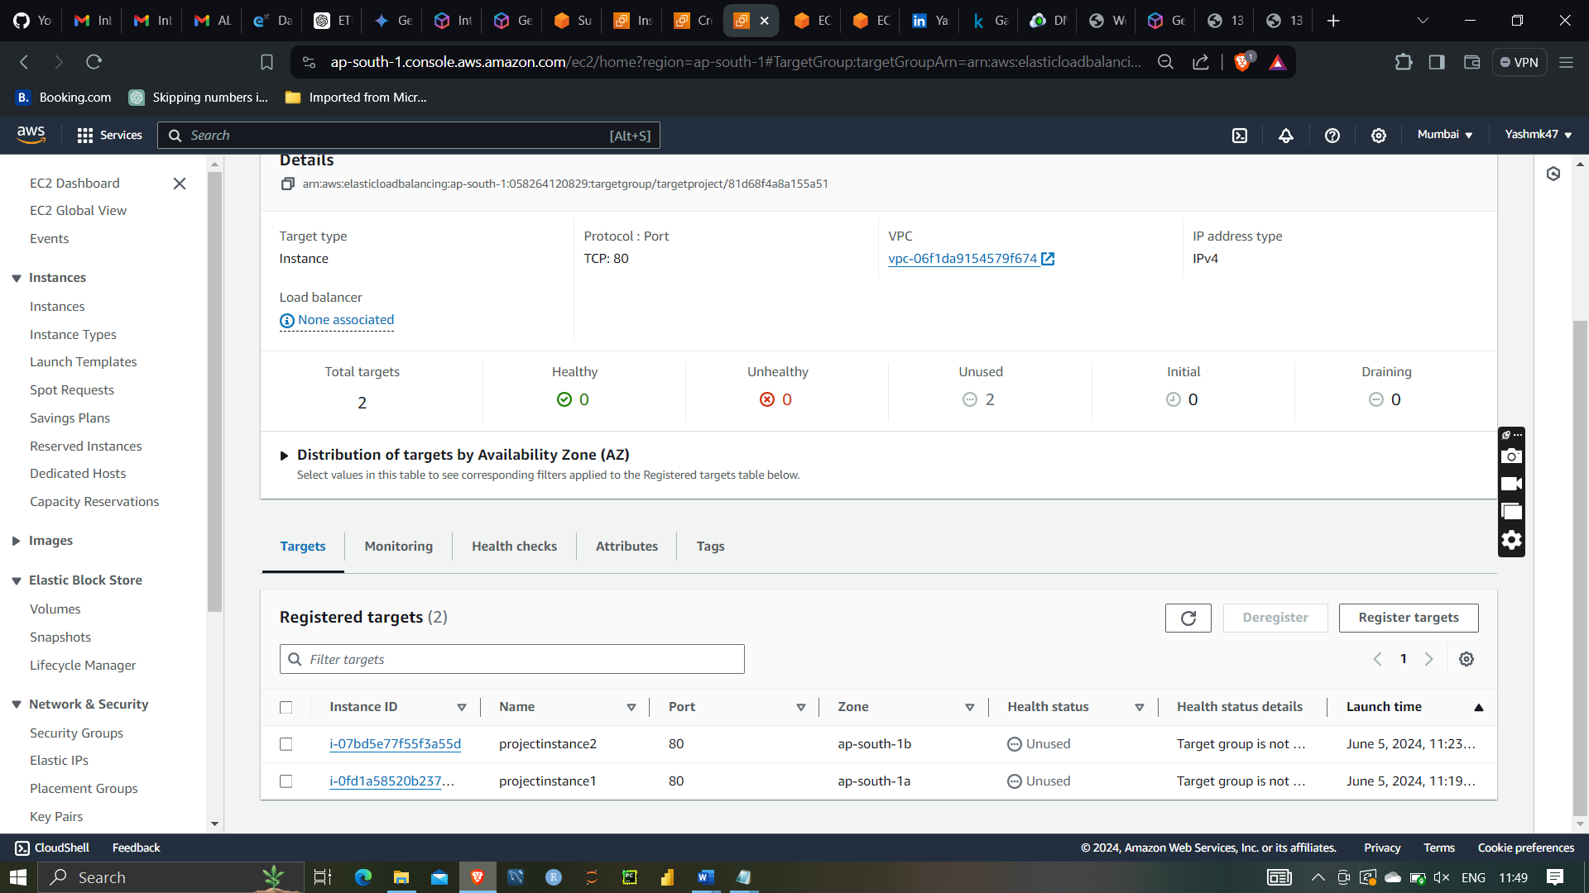

Selecting target group in load balancer

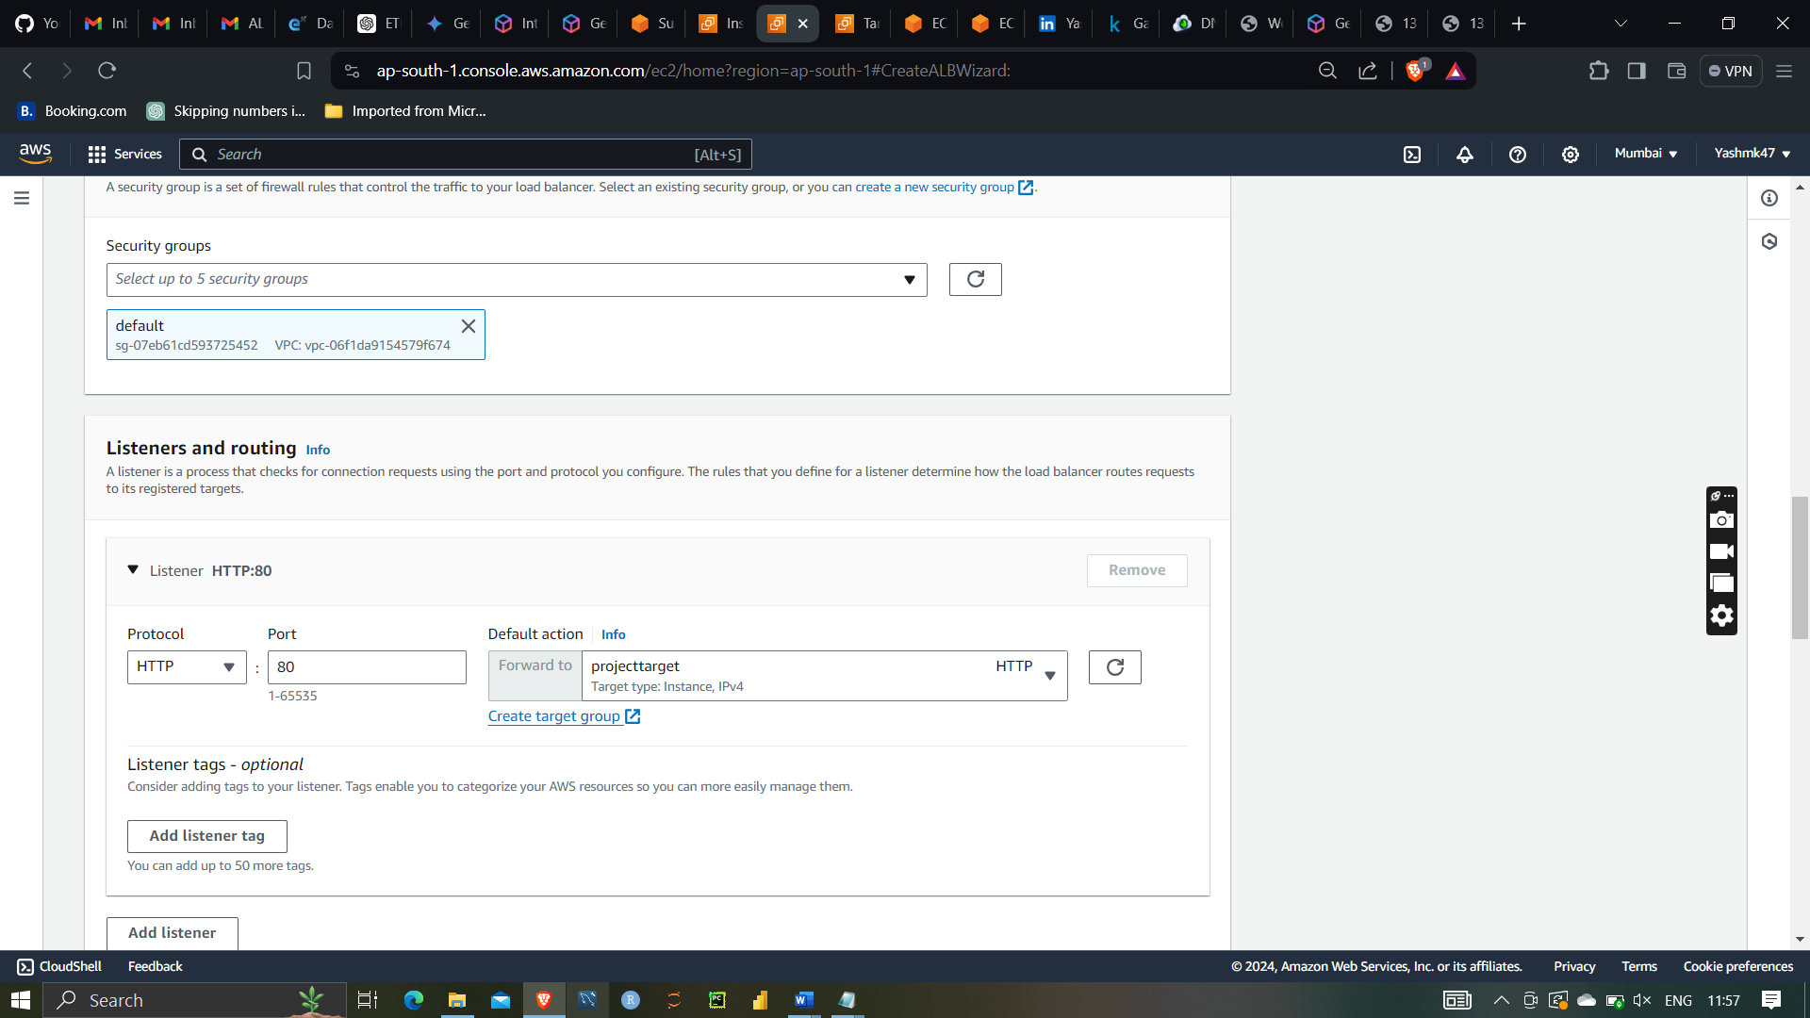

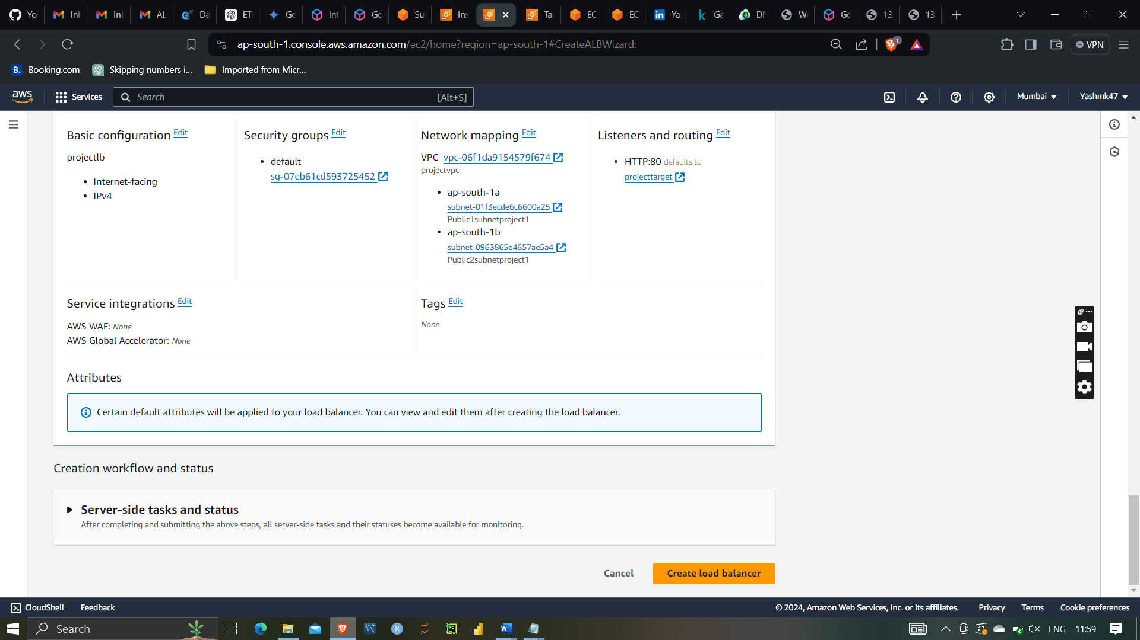

After that creating load balancer

Hence load balancer has been launched successfully

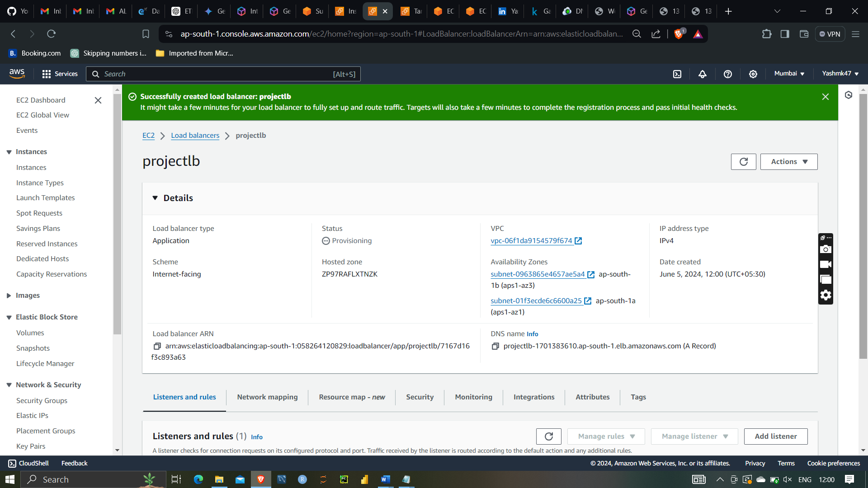

As you can see target group the register target groups are now healthy

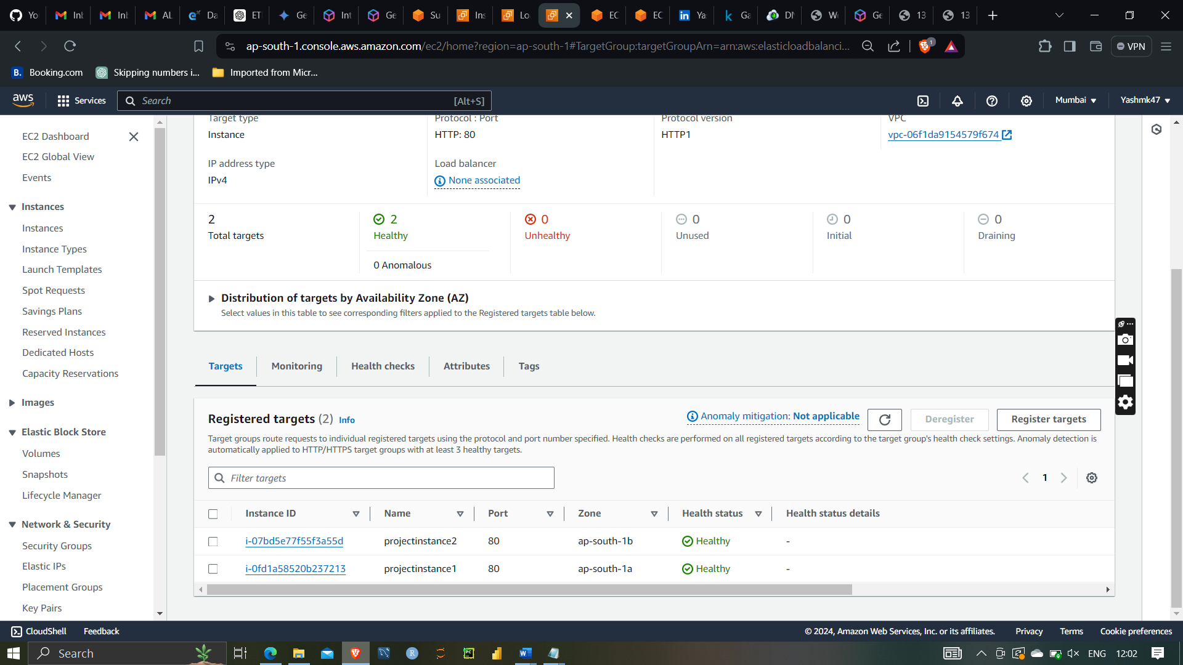

So the load balancer has provided us with default DNS name so I had copied and pasted in the web browser so we can it is working properly as it is trying to balance the in both the server

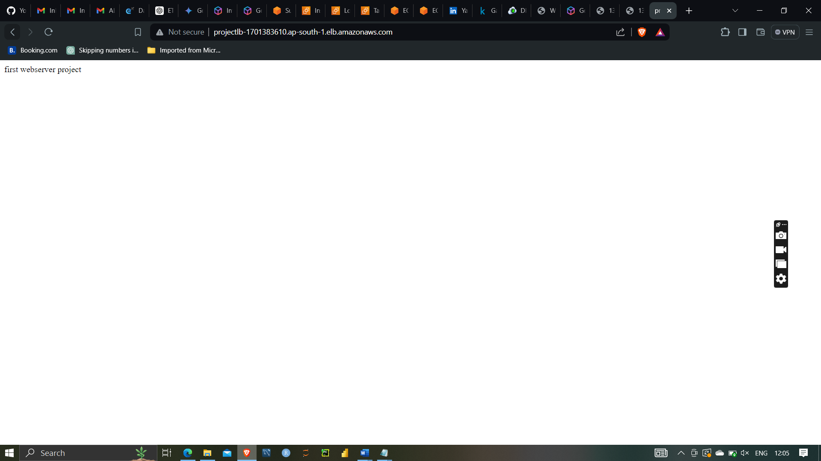

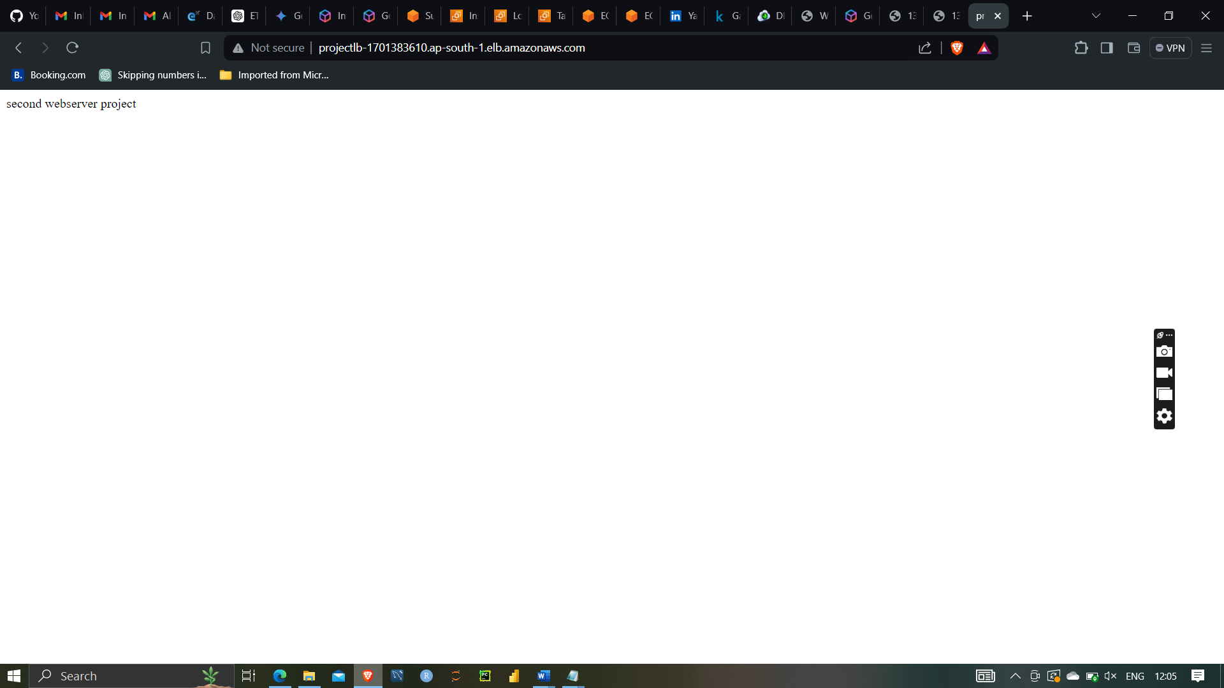

AMI:-

An Amazon Machine Image (AMI) in AWS is a pre-configured template that contains the necessary information to launch a virtual server, known as an instance, in the Amazon Elastic Compute Cloud (EC2). AMIs serve as the foundational building blocks for EC2 instances and provide a standardized, repeatable environment for deploying applications and services.

After that trying to create AMI of intances1(first webserver project) because we are trying to launch the template that is why AMI is necessary

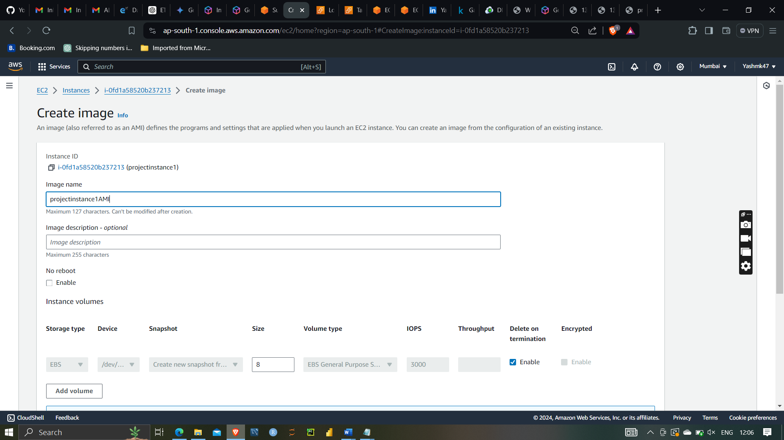

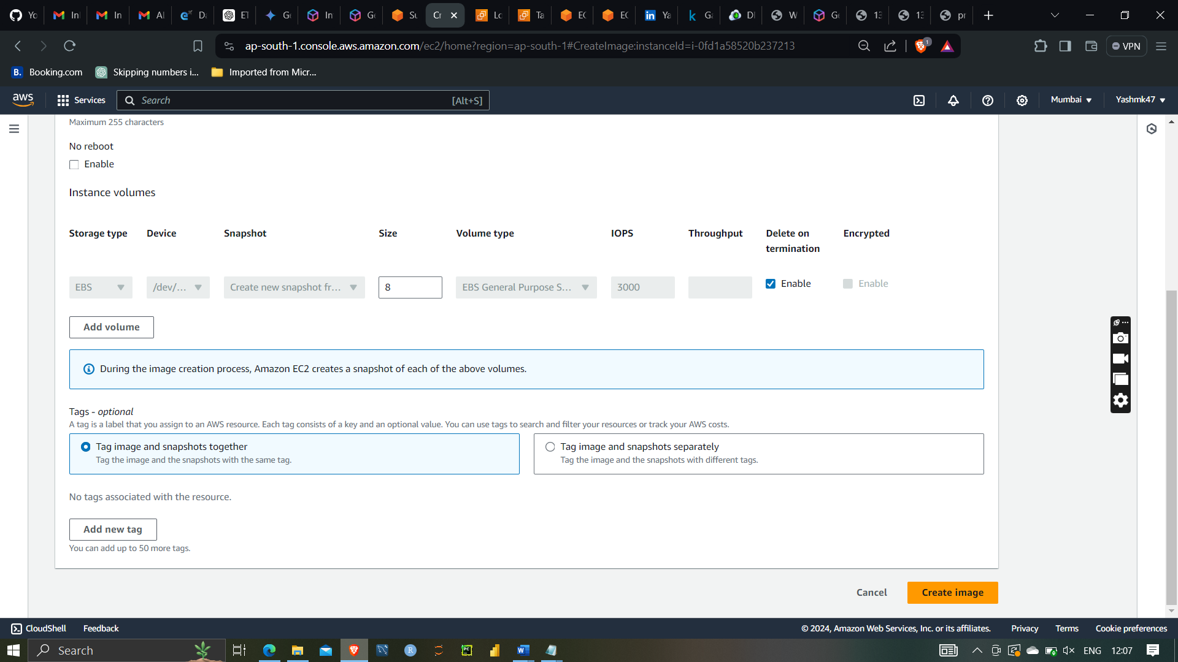

Launching a template

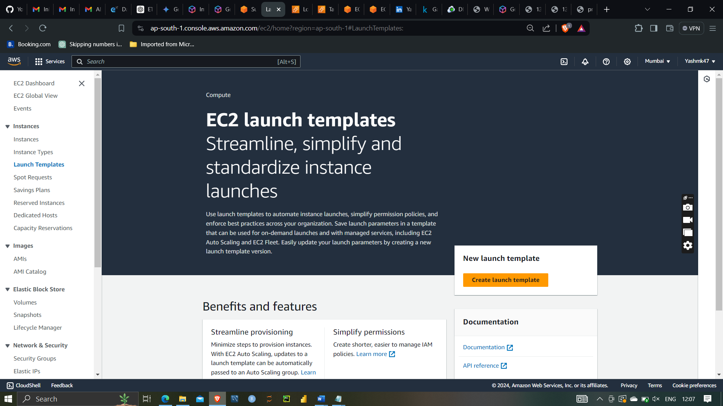

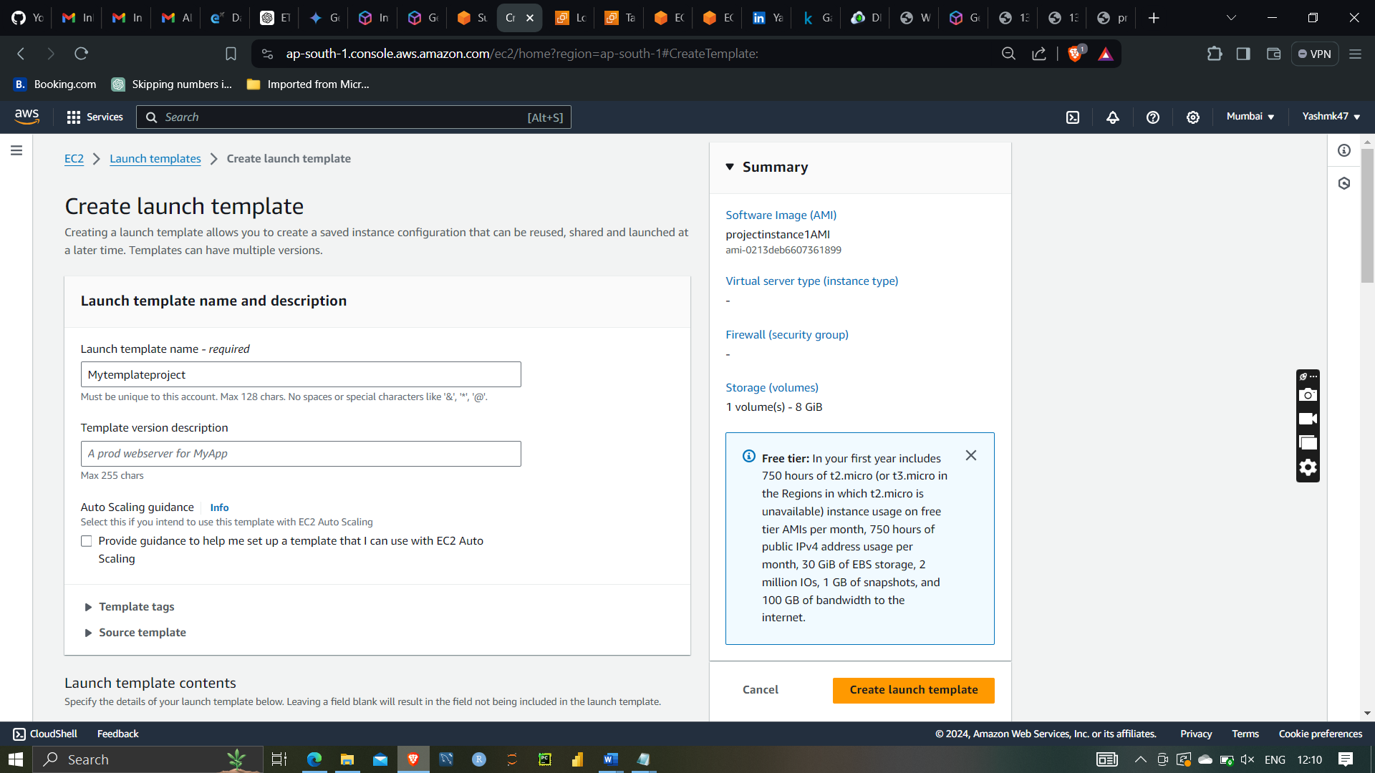

Creating my templateproject

Selecting AMI which I have created from project instance1

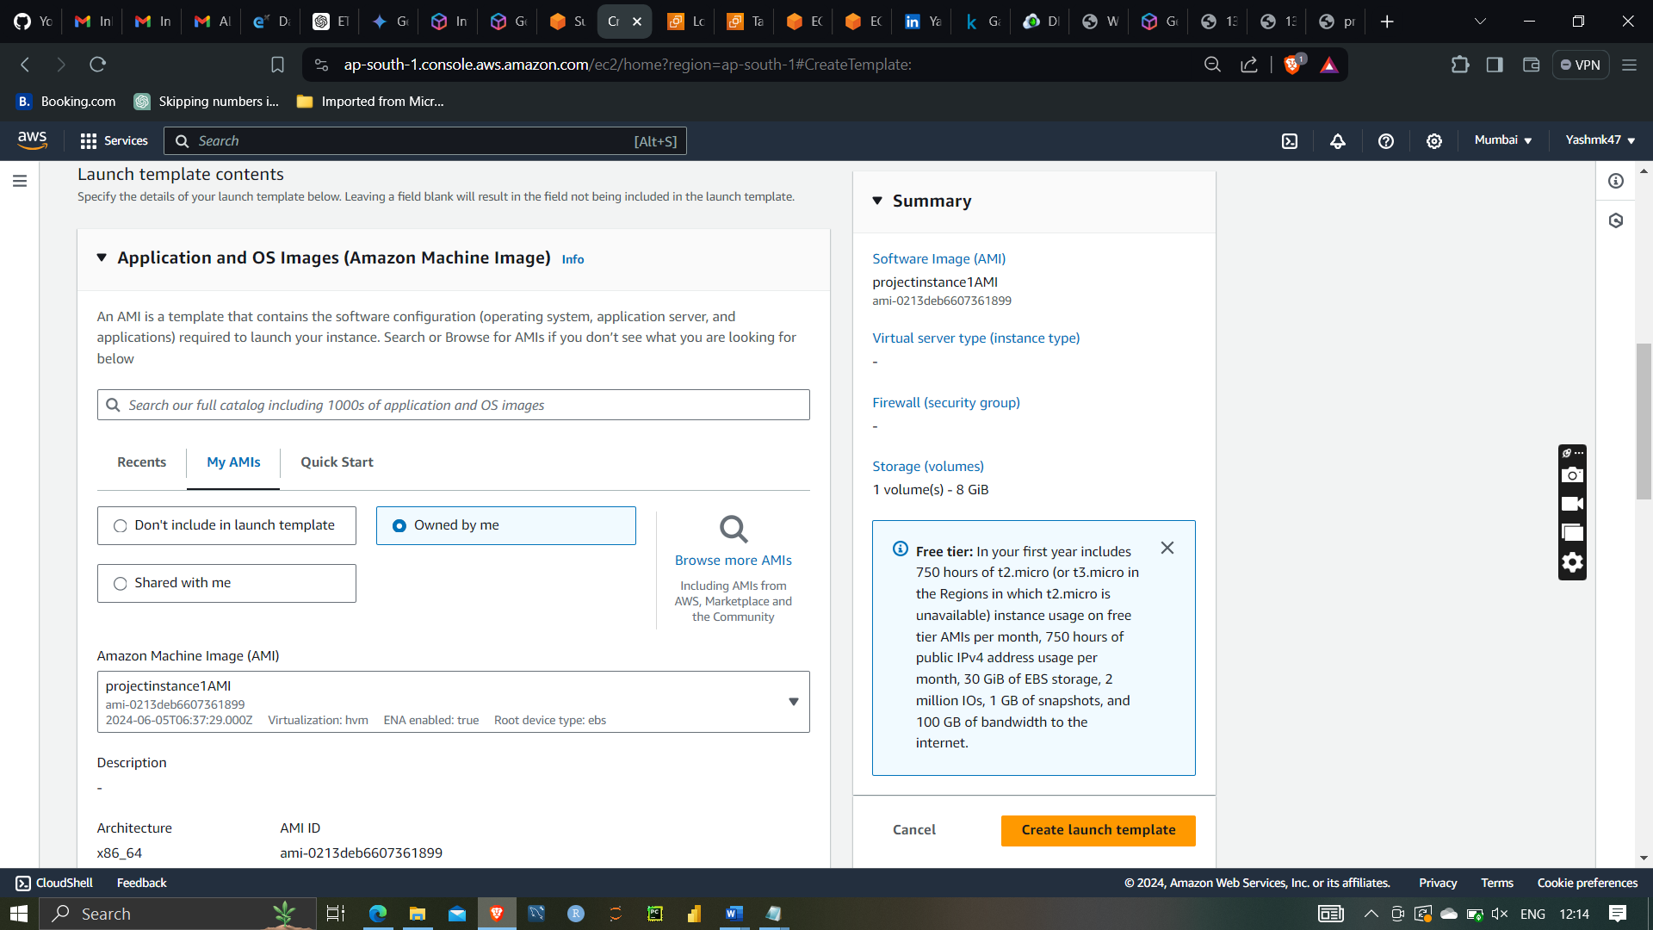

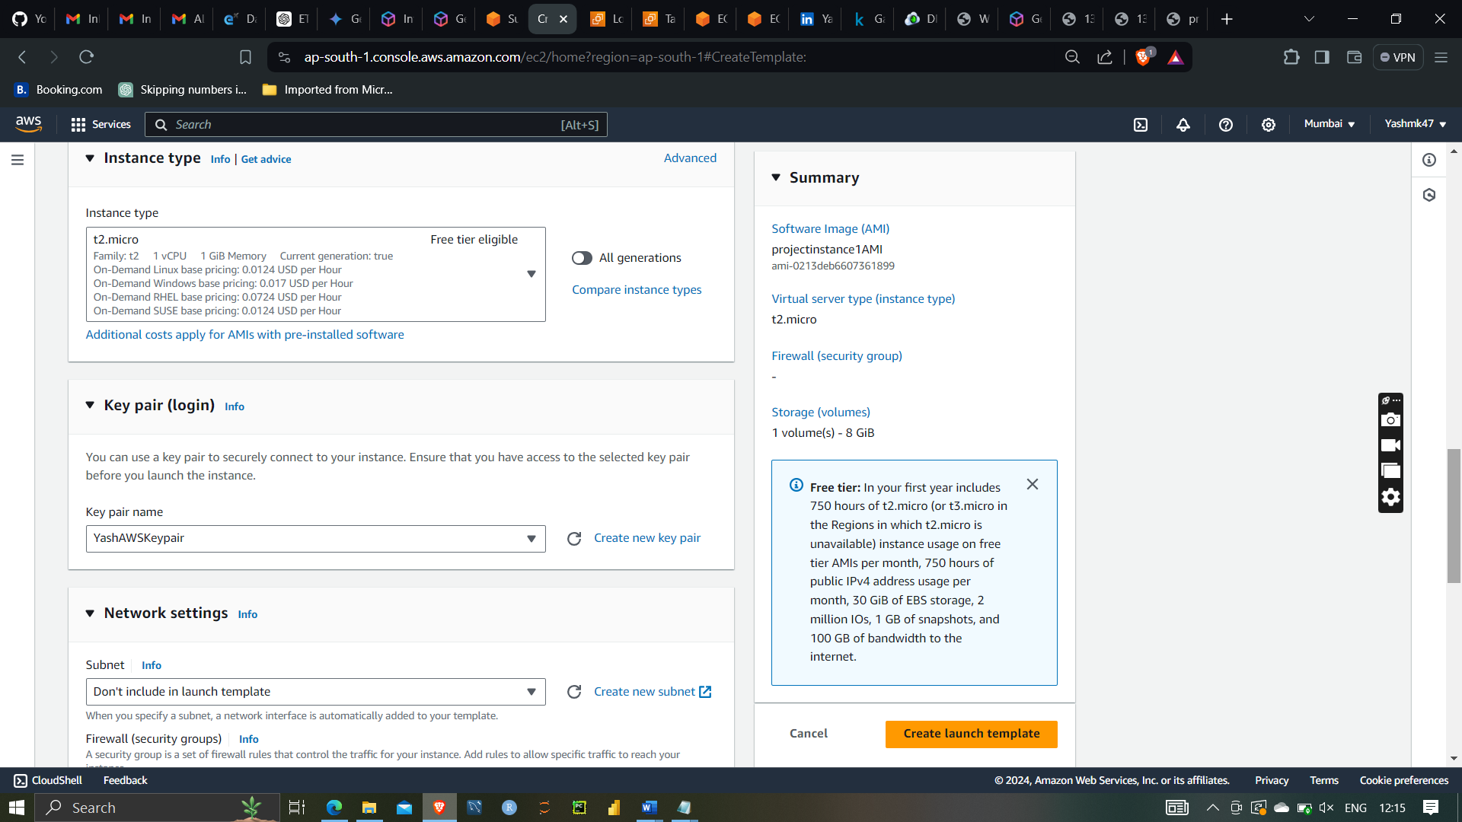

Selecting instances type t2.micro and selecting AWS keypair

Selecting default security group

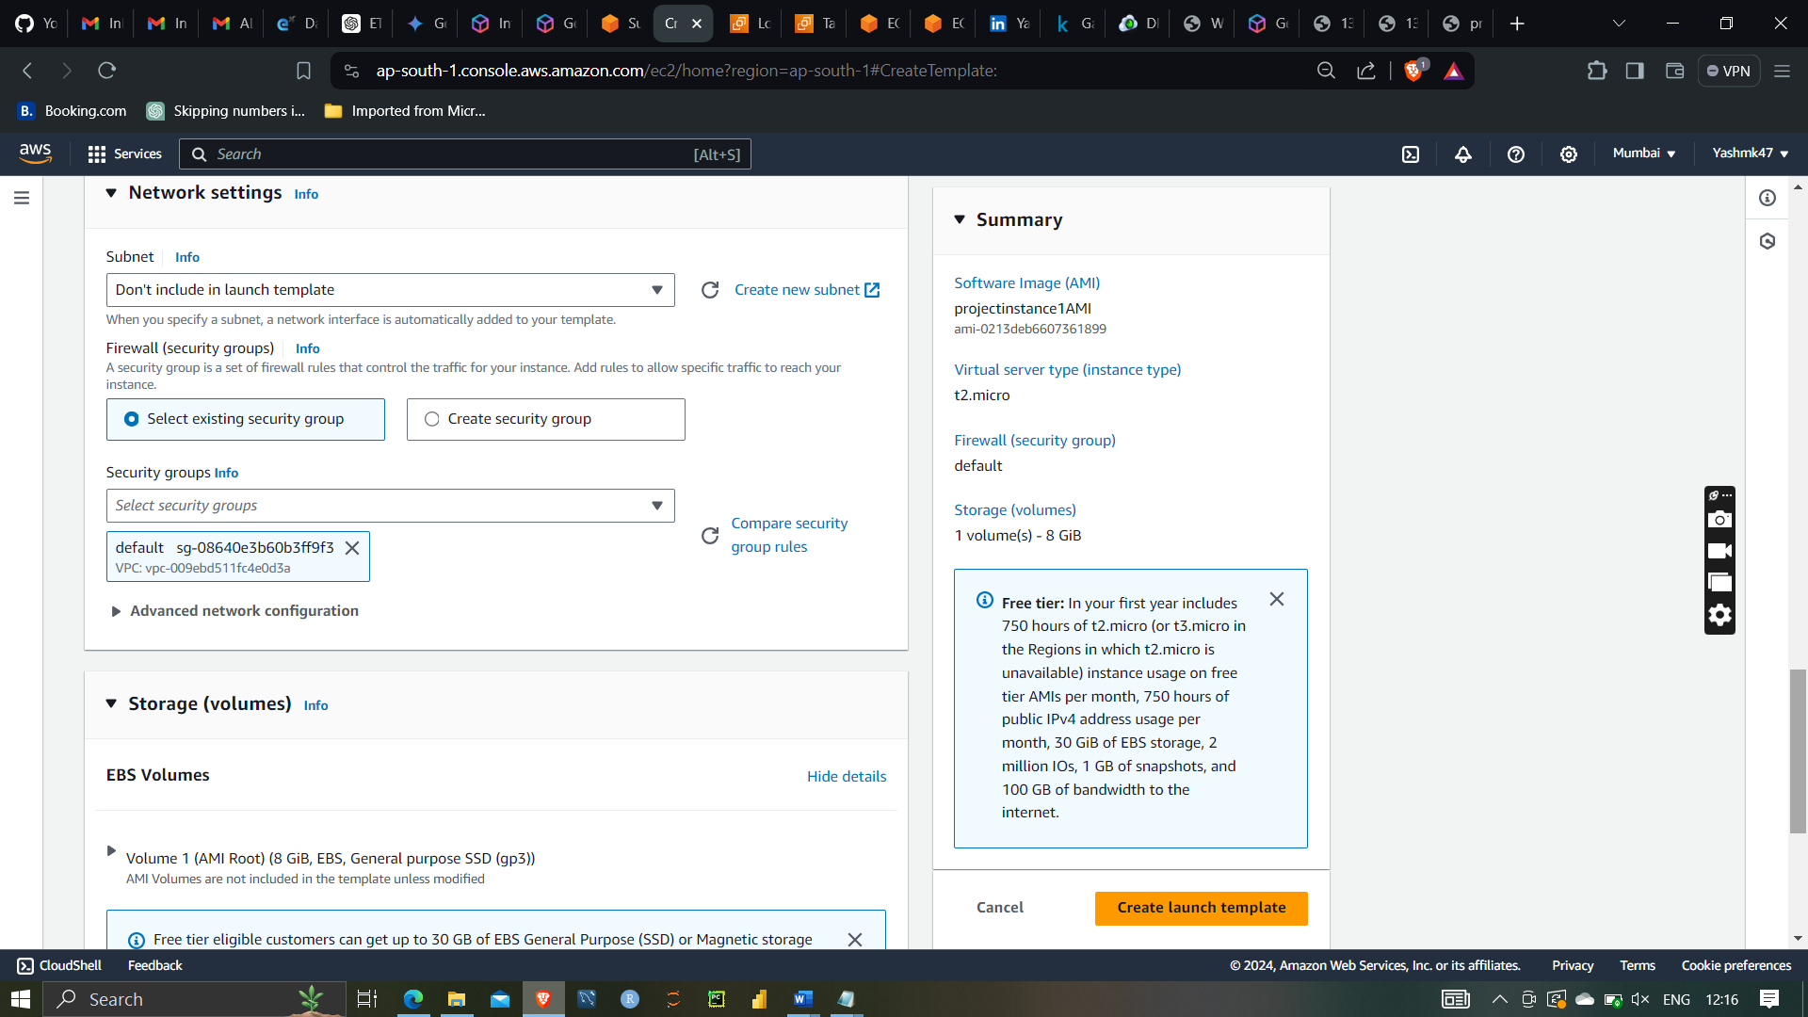

Launch template successfully

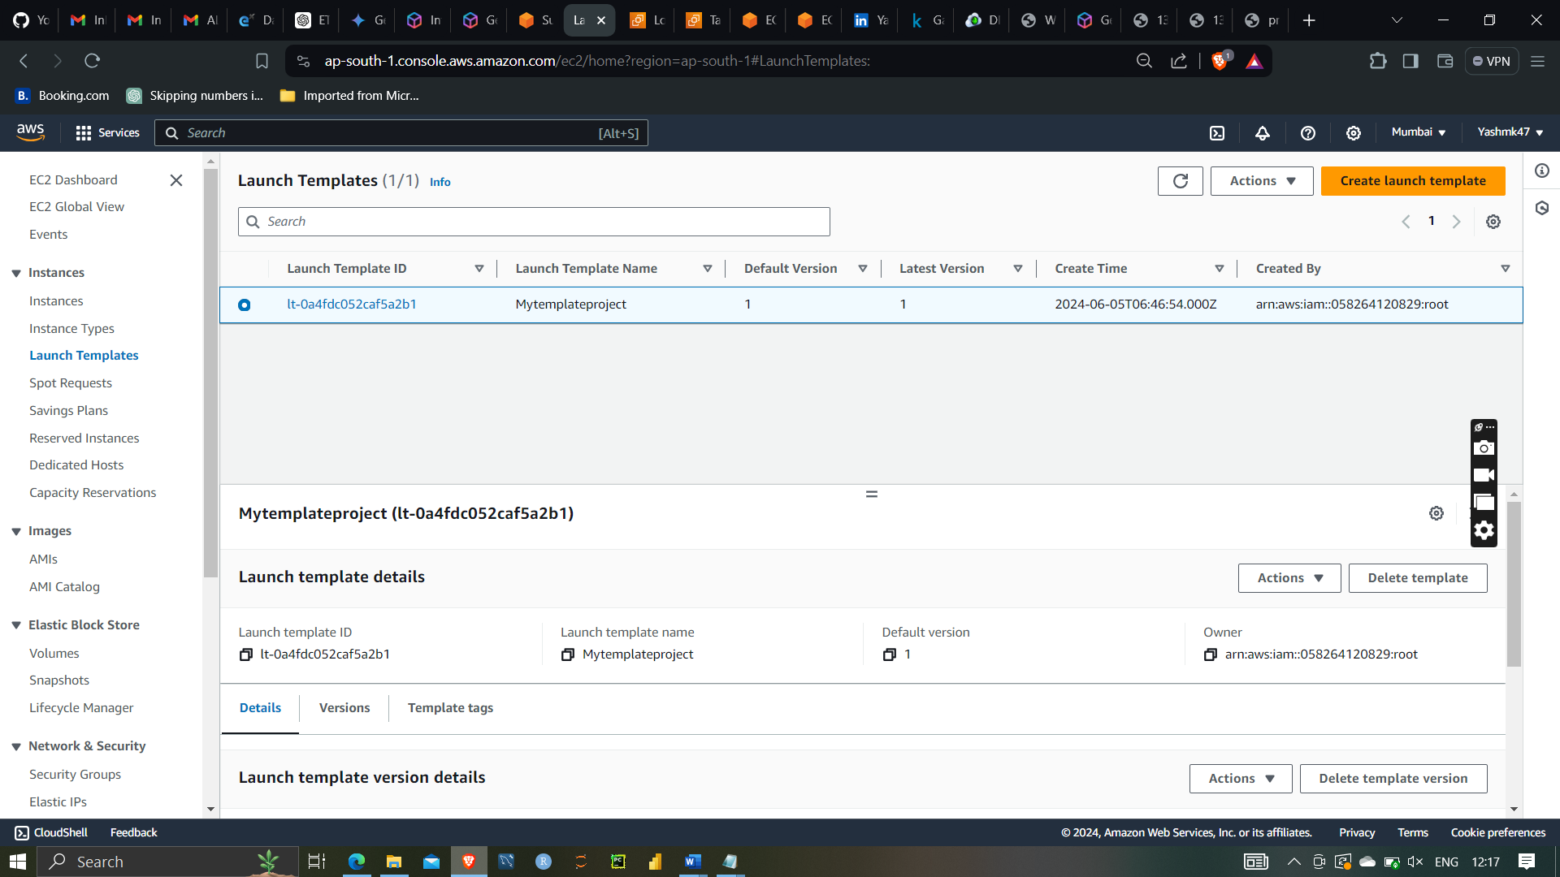



Auto scaling groups:-

Auto Scaling Groups (ASGs) are a key feature of Amazon Web Services (AWS) that enable automatic scaling of compute resources based on demand. They allow you to automatically adjust the number of instances in response to changing application load, ensuring that you have the right amount of capacity to handle traffic spikes while minimizing costs during periods of low demand.

After that creating autoscaling groups

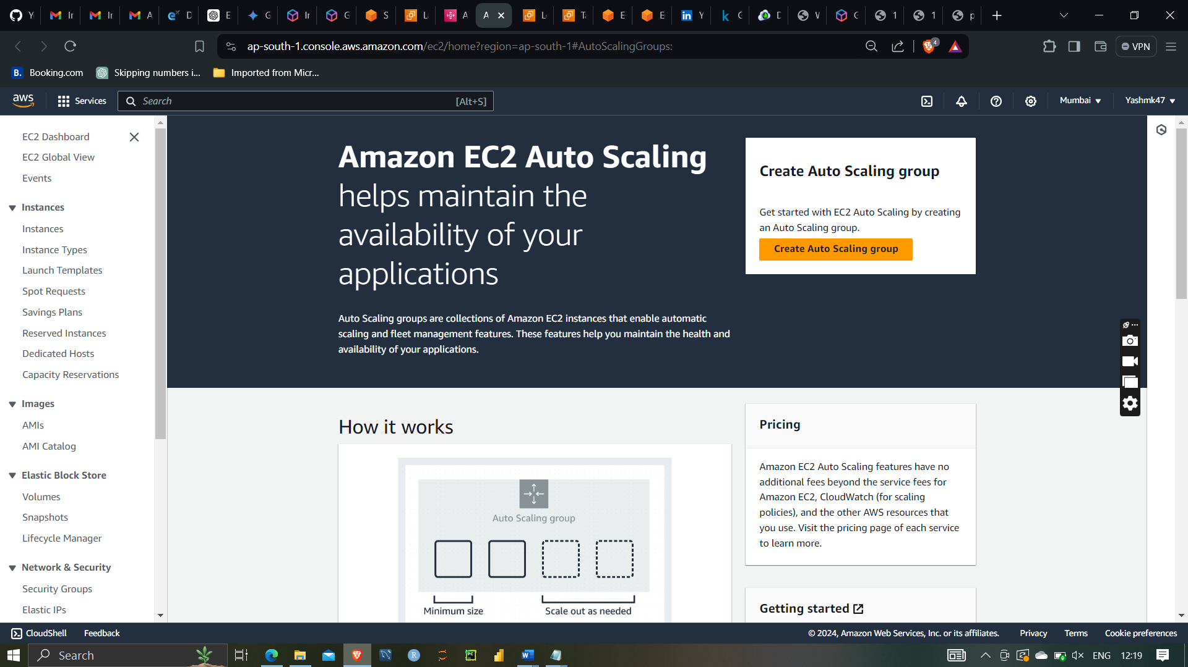

Give name projectautoscalingroups and selecting and template mytemplate project

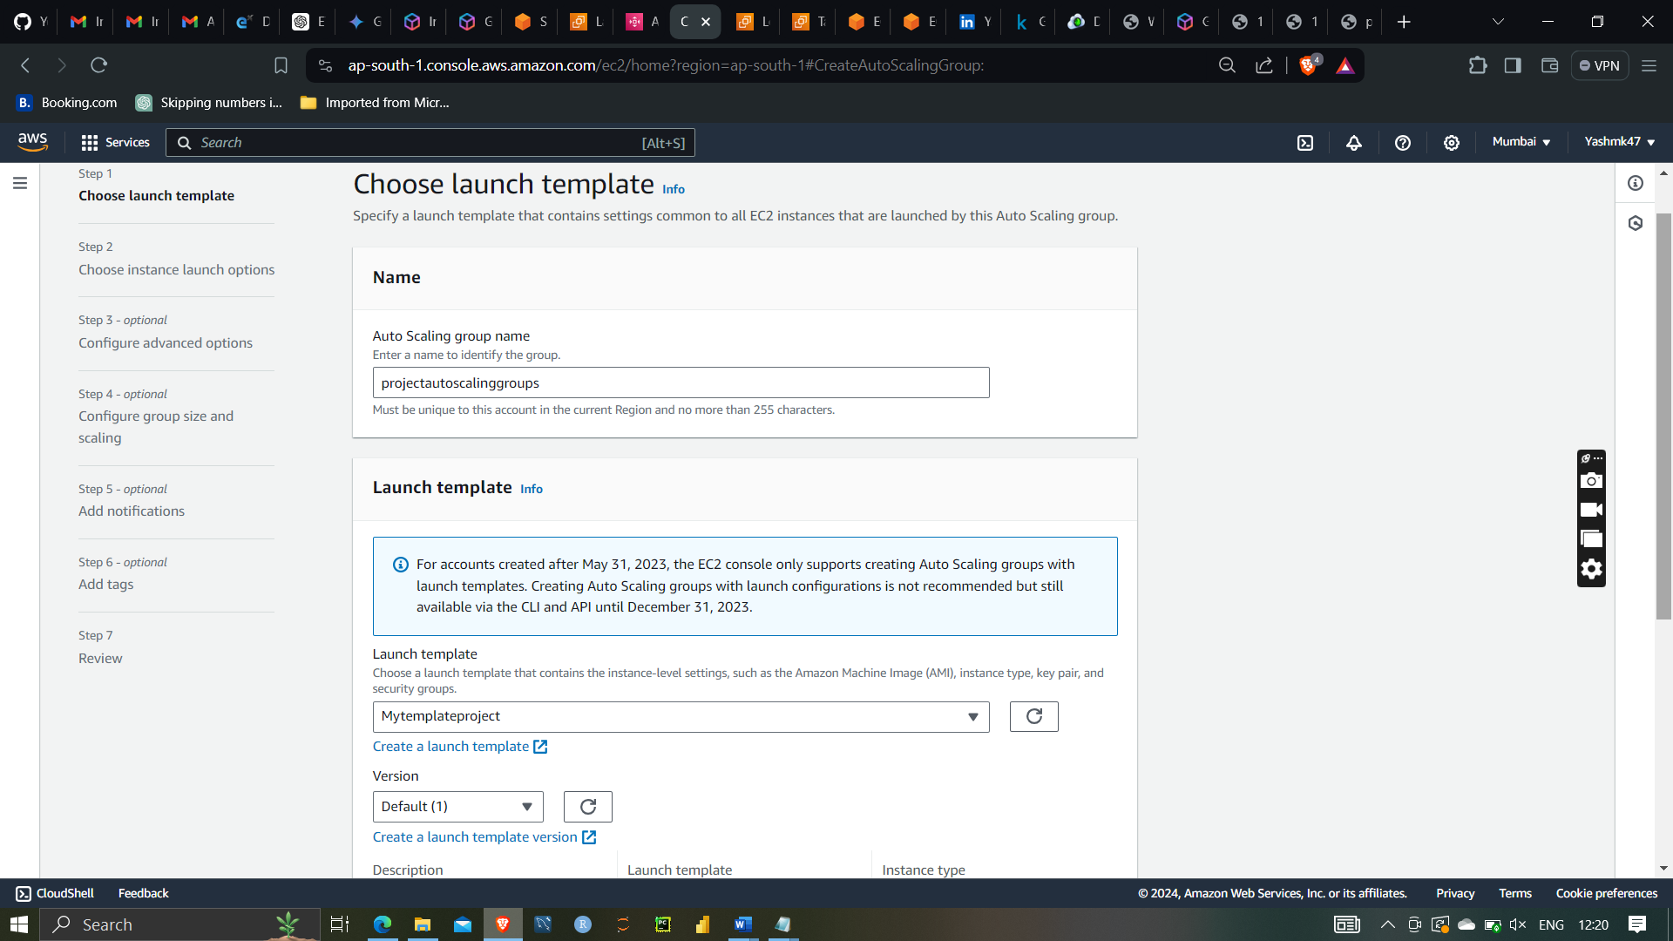

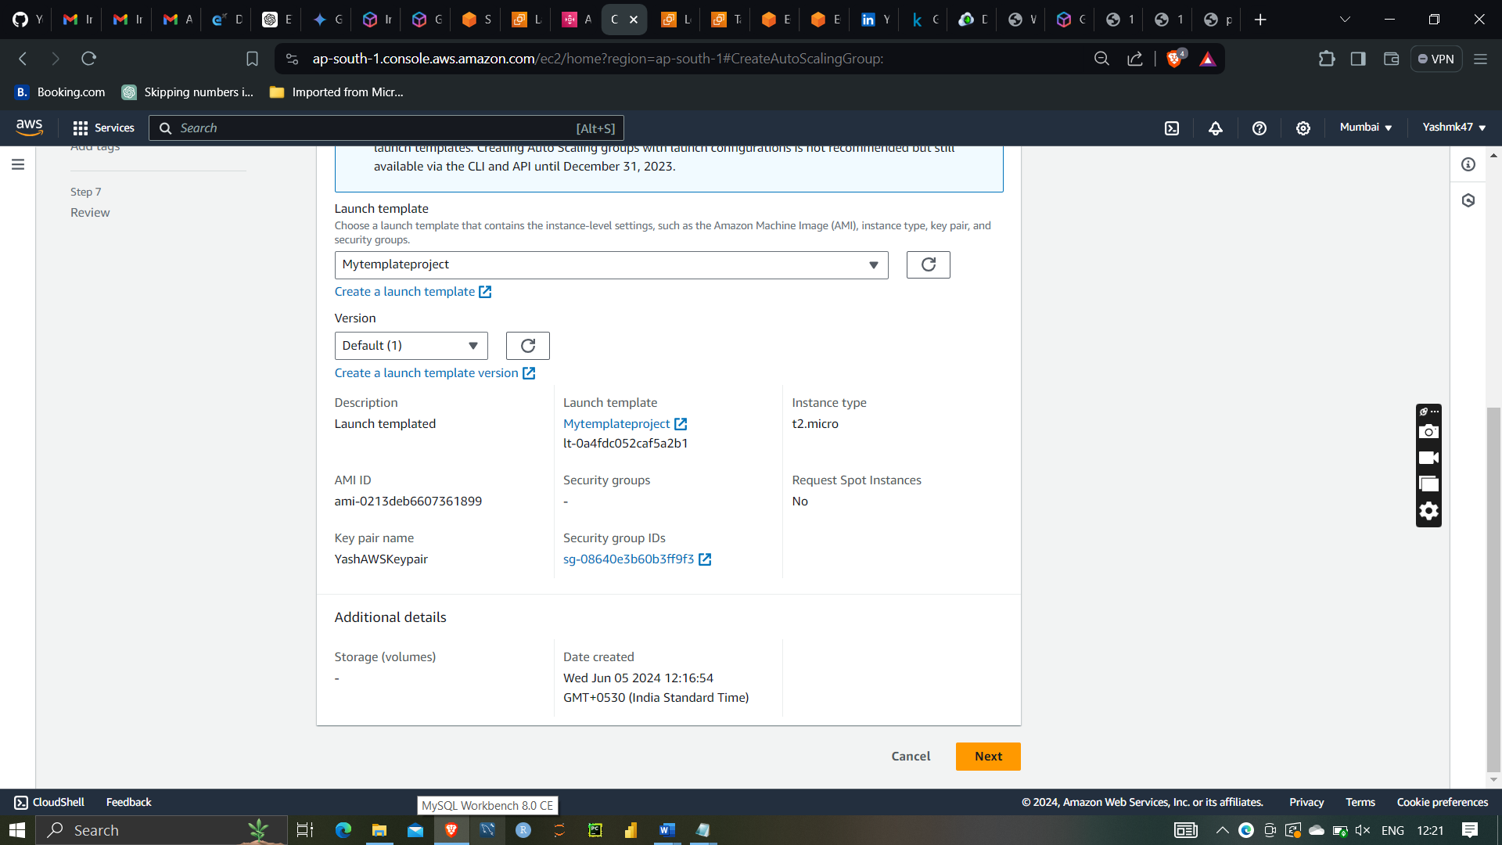

Selecting project vpc and both subnet of different availability zone

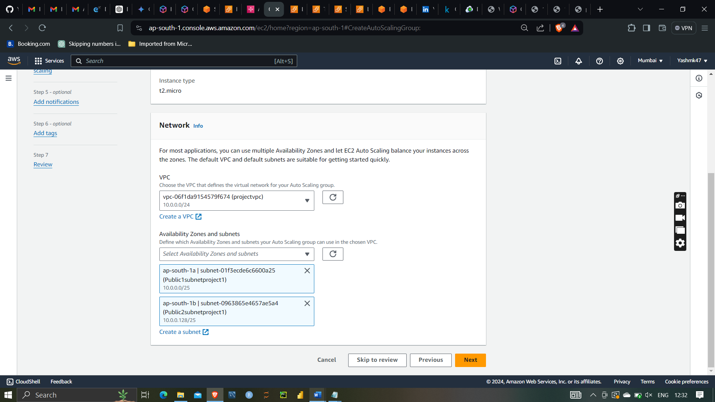

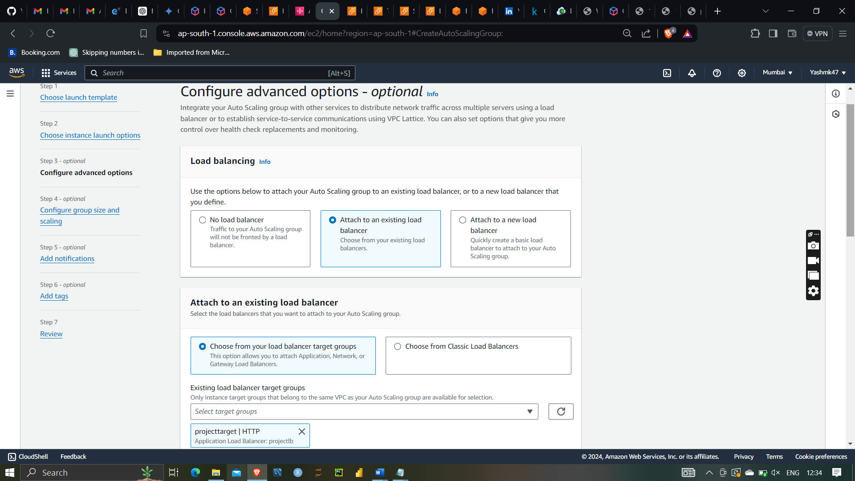

Selecting attaching to existing load balancer with projecttarget as targetgroups

Selecting desired capacity as 2

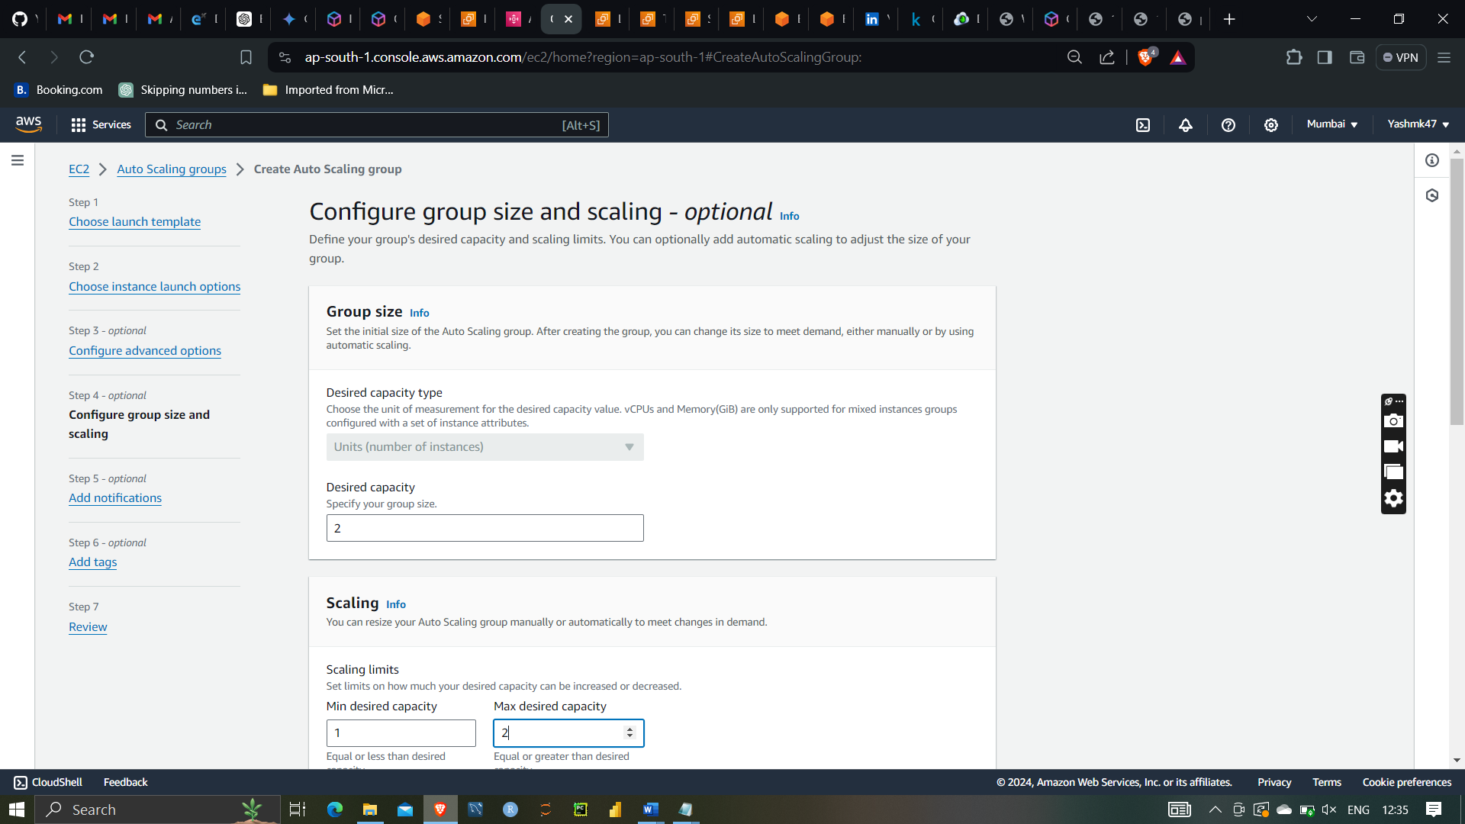

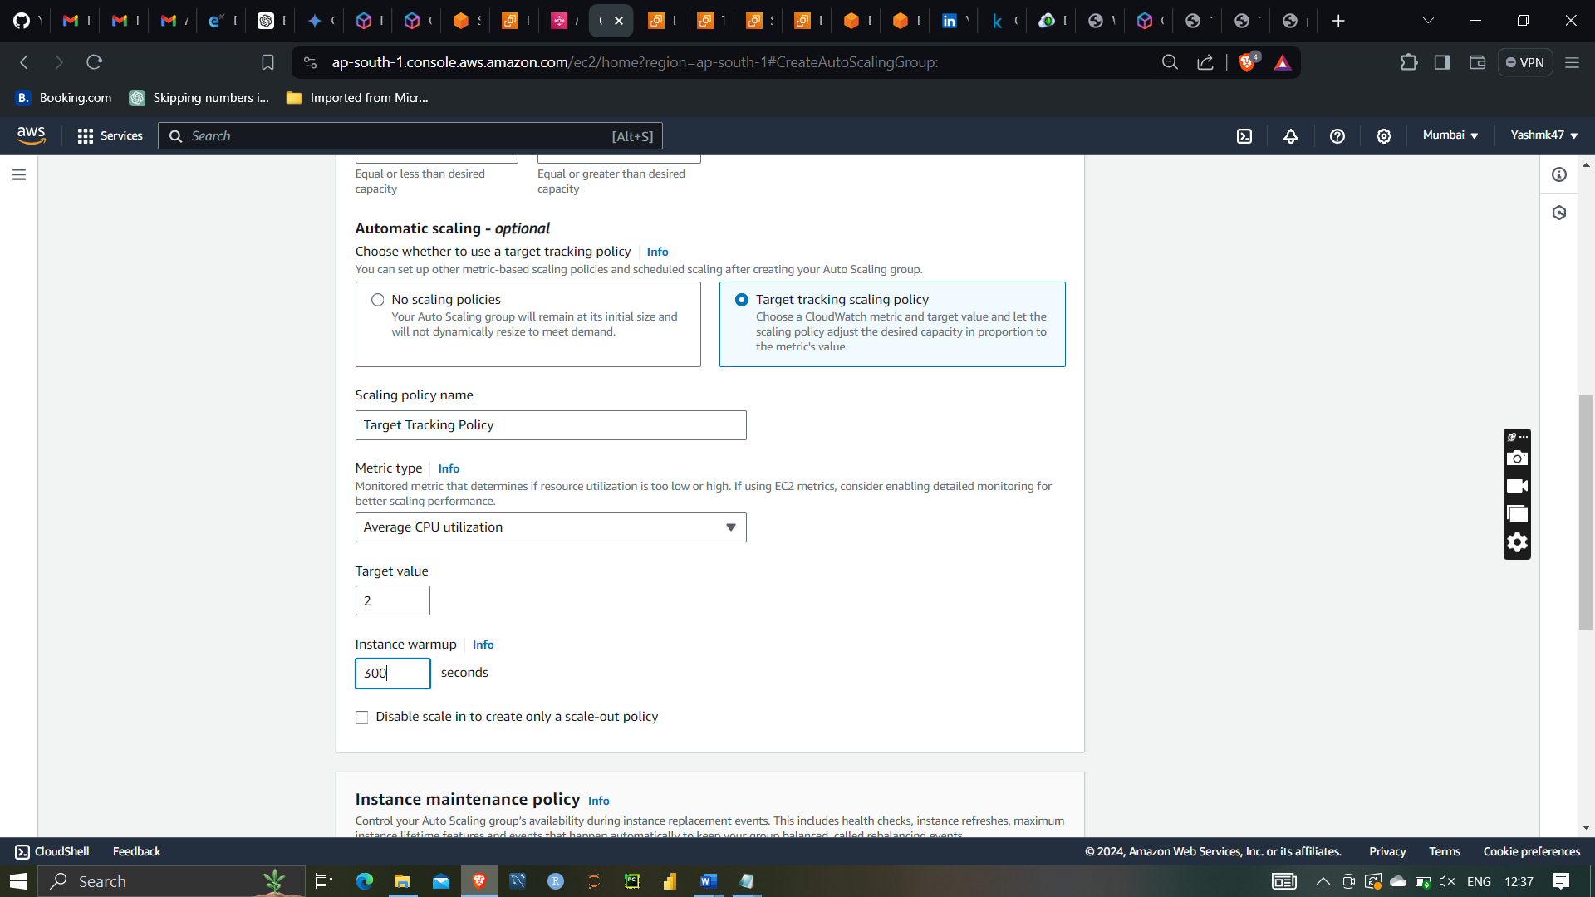

Selecting metric type as Average CPU utilization and target value 2

Instance warmup 300 seconds



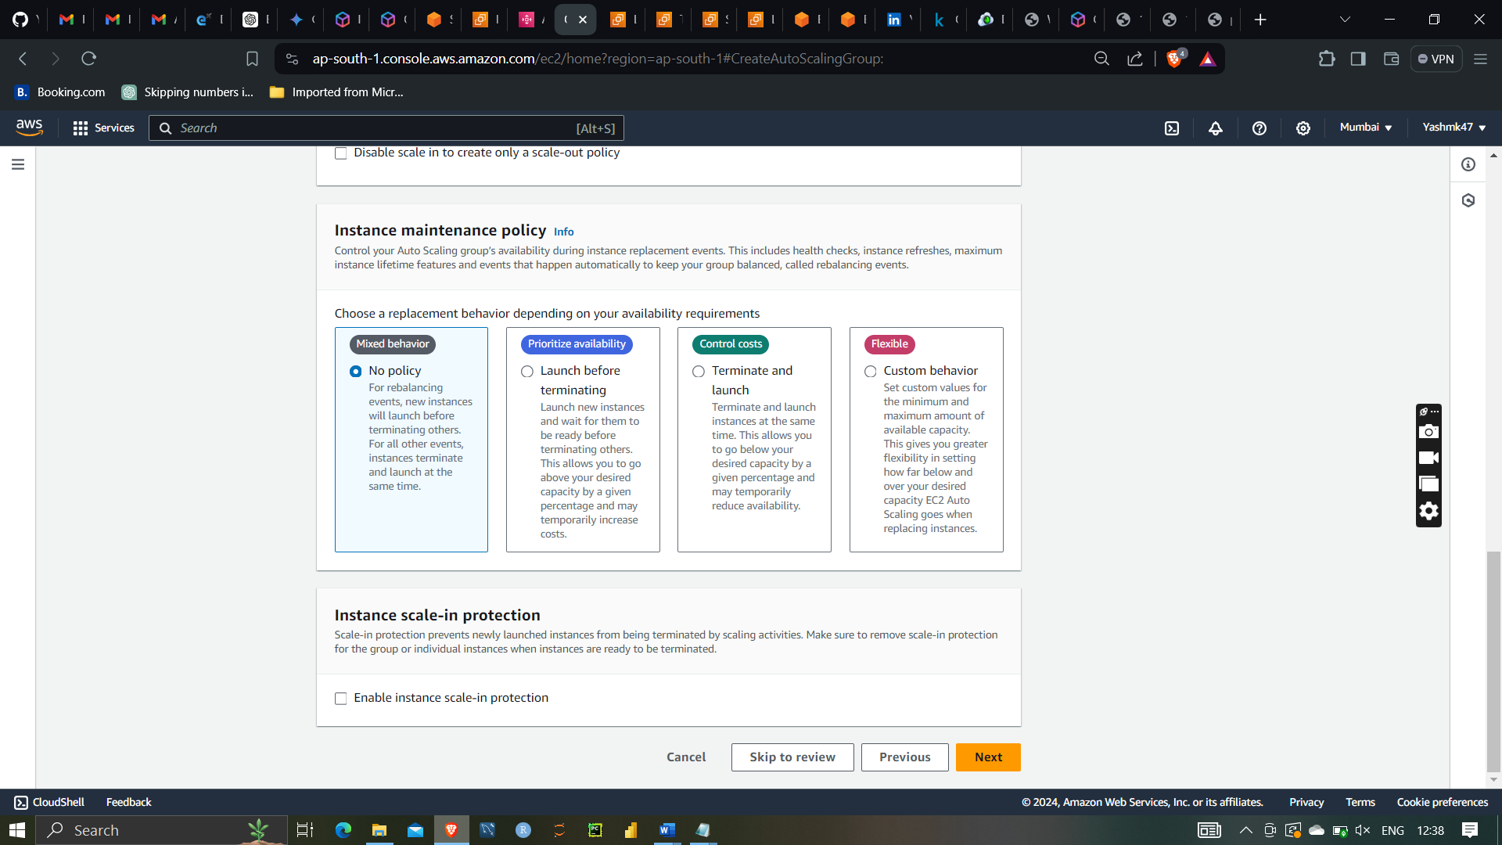

Creating Auto scaling groups

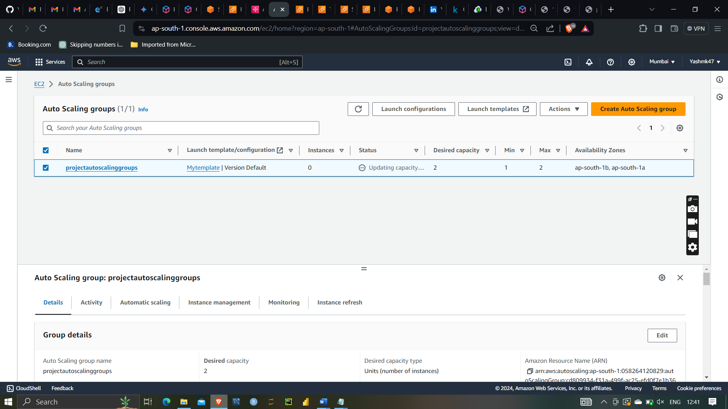

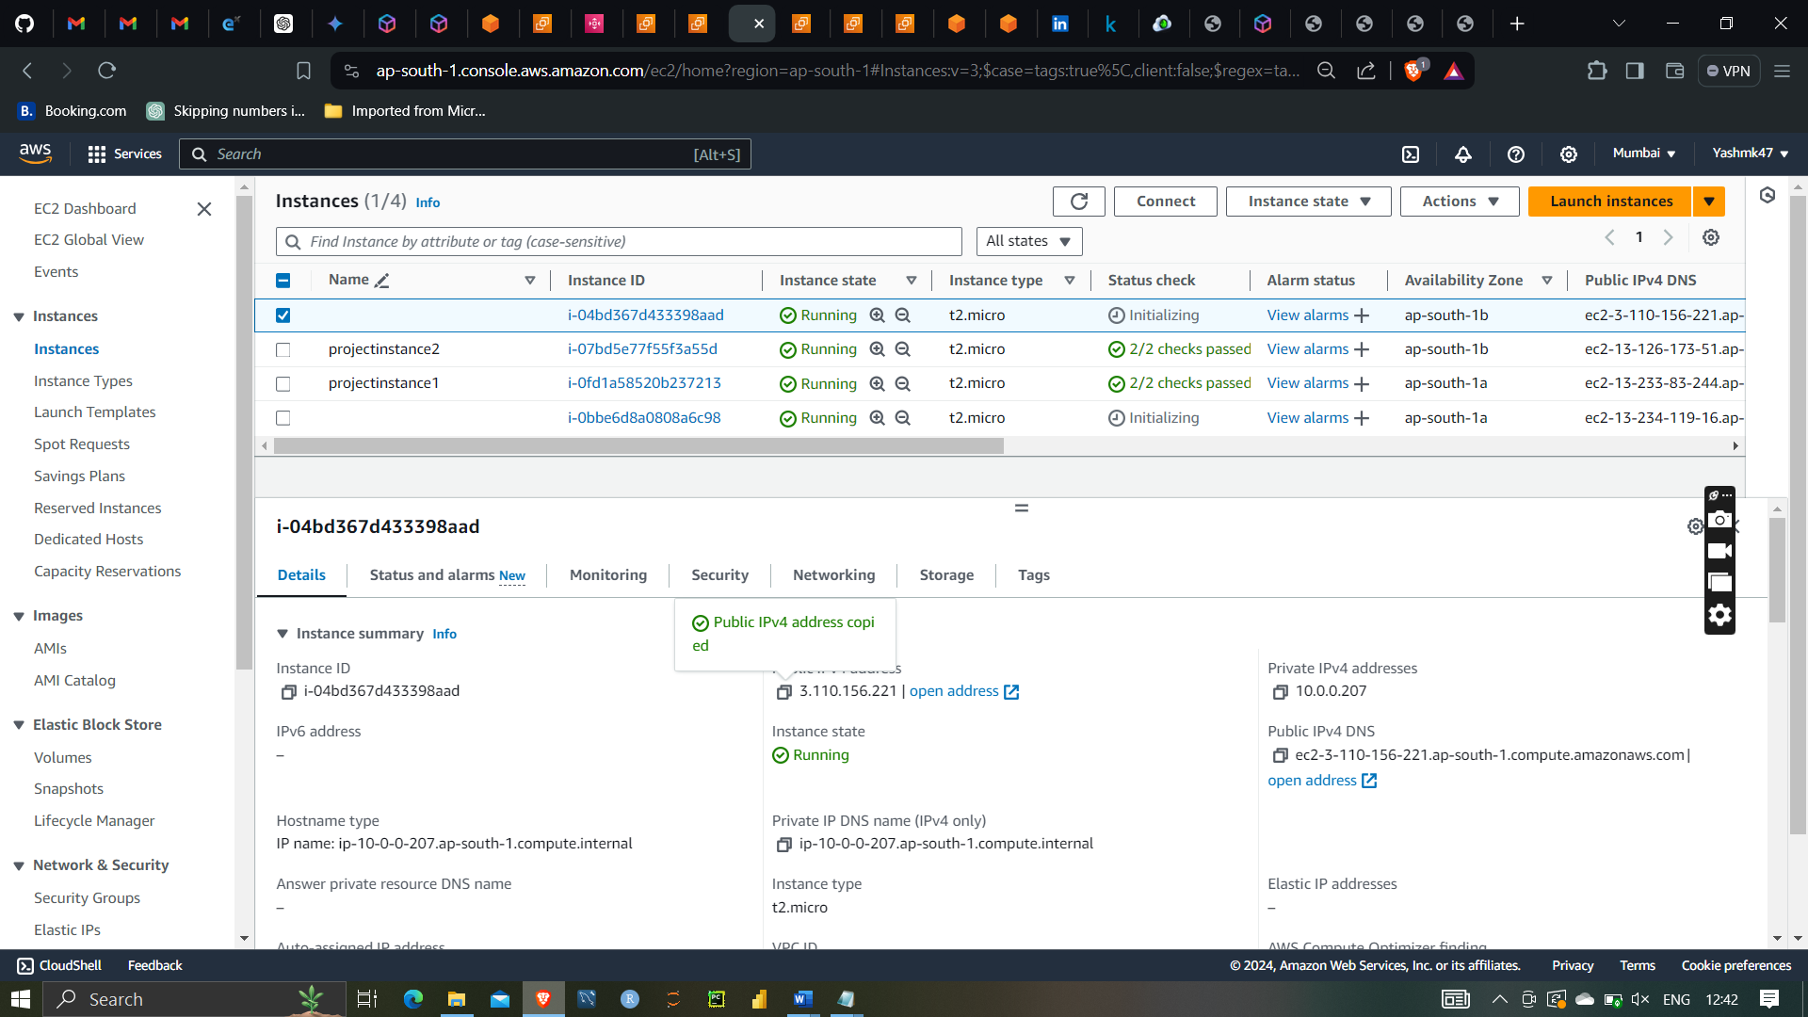

As you can see the new server are trying to launch under autoscaling

As you can see we have successlaunch new server with help of autoscaling (AMI and template which I have selecting from instances1)

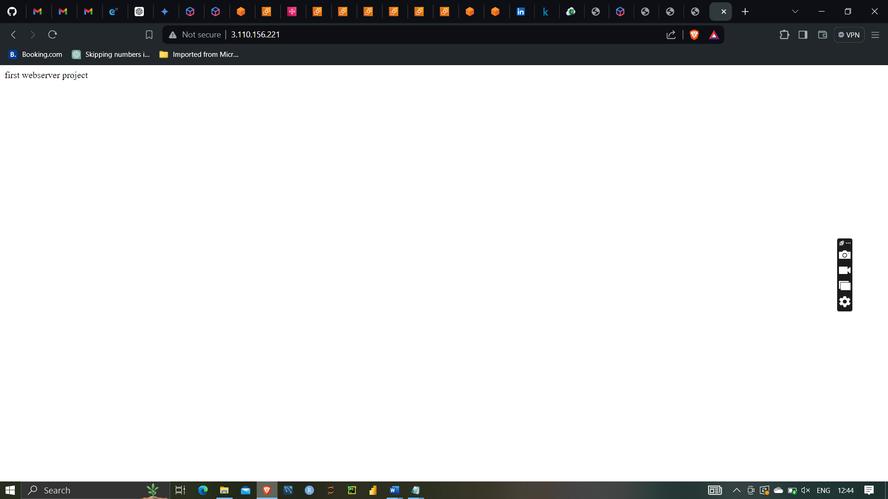

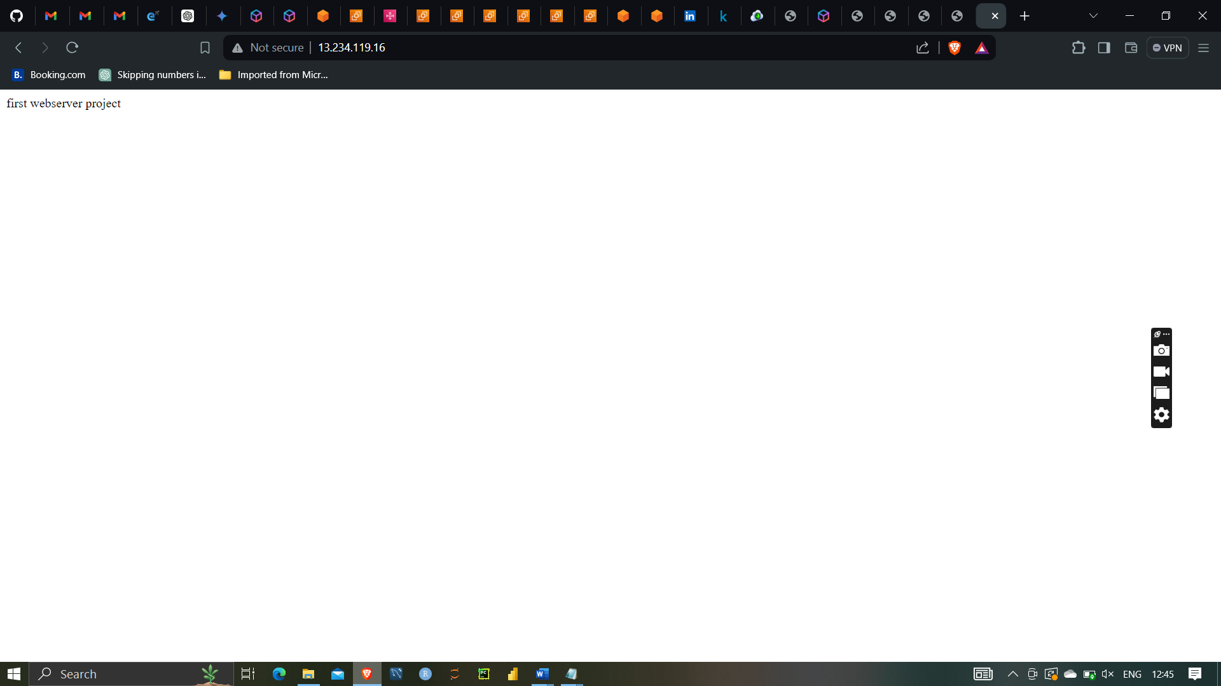

Similarly for second autoscaling server

I have manually deleted two server (assuming Both server has problems so because of that they have shutdown ) so auto scaling will try to launch another server automatically

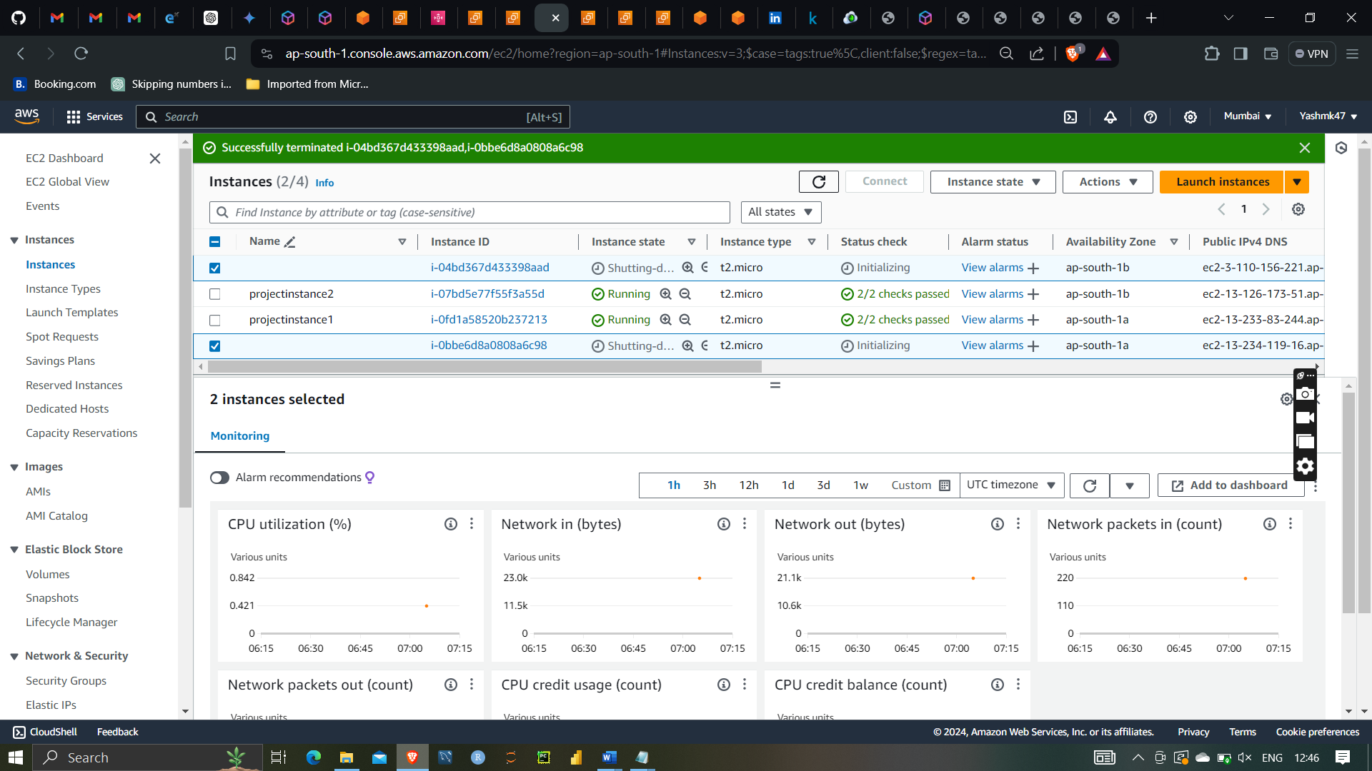



As you can see it try to launch new server with autoscaling

The orange arrow indicate that new server has been launch successfully by autoscaling groups

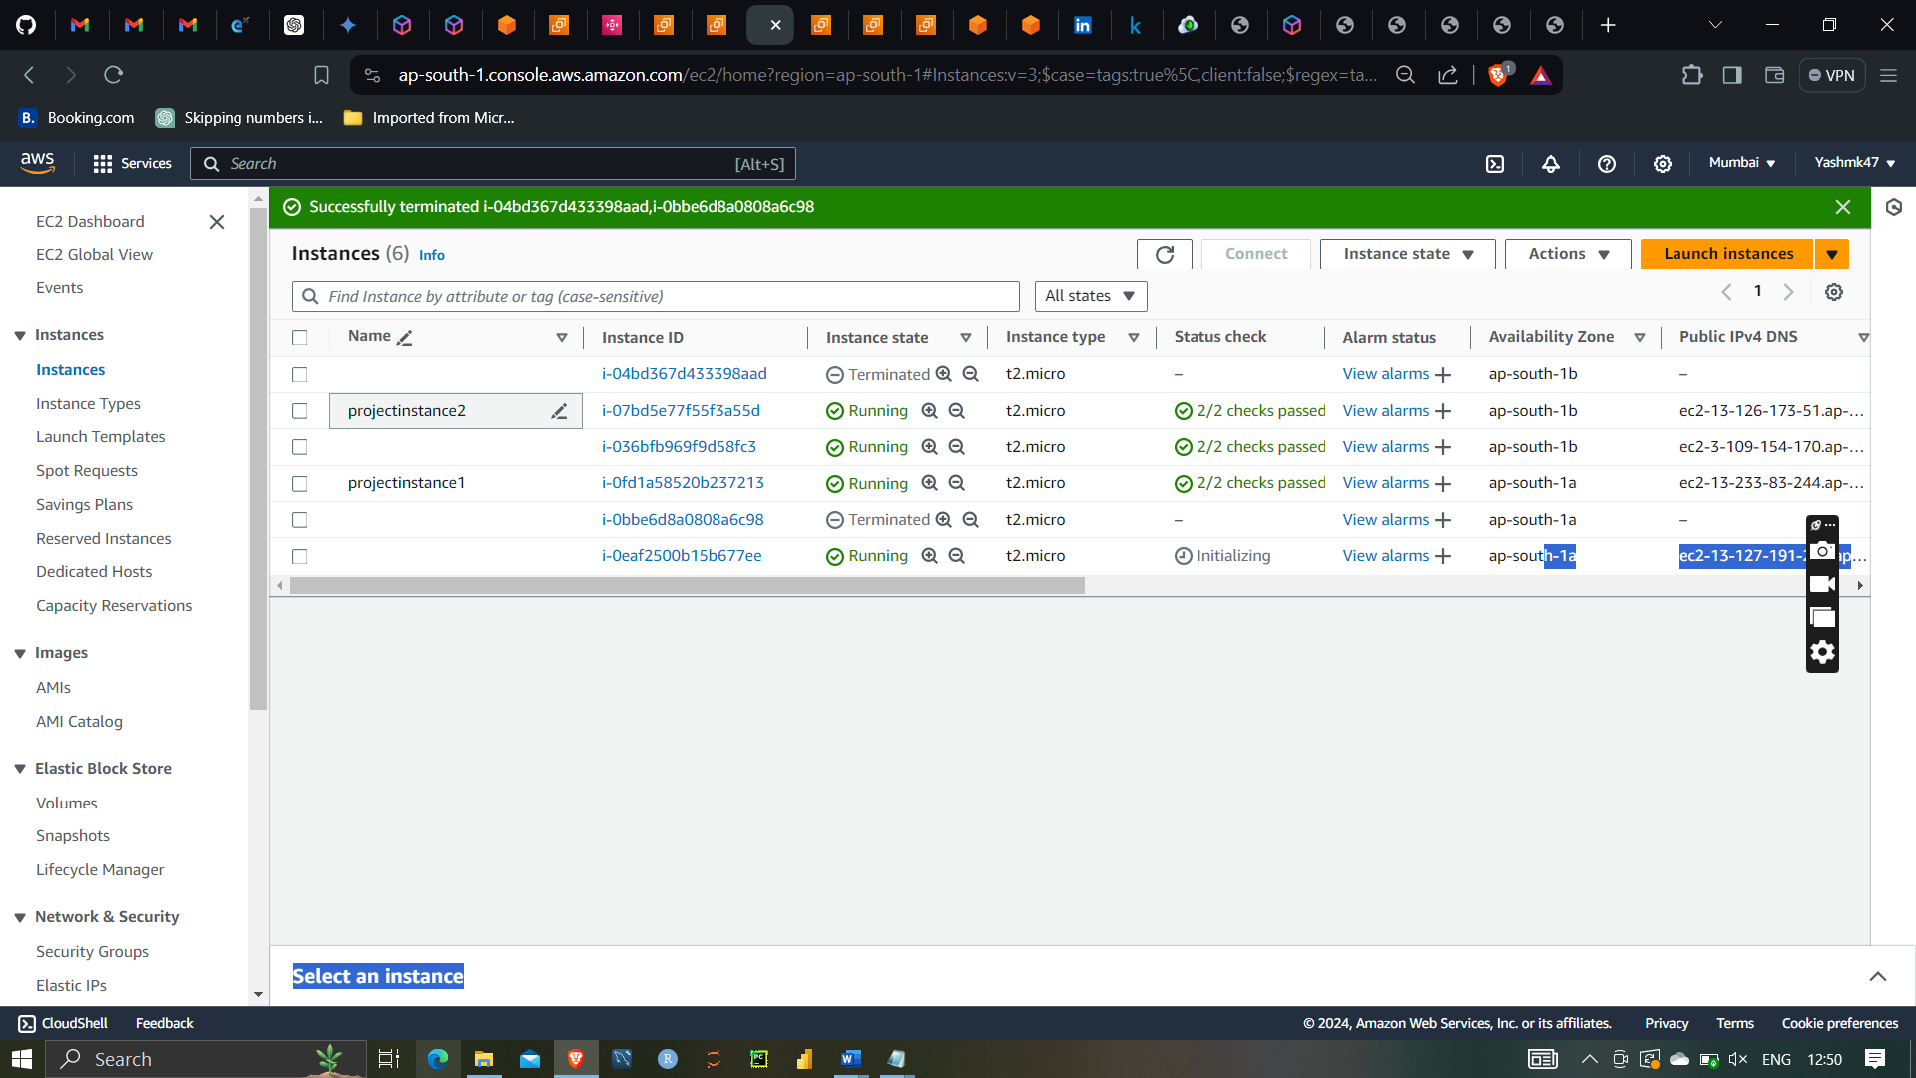

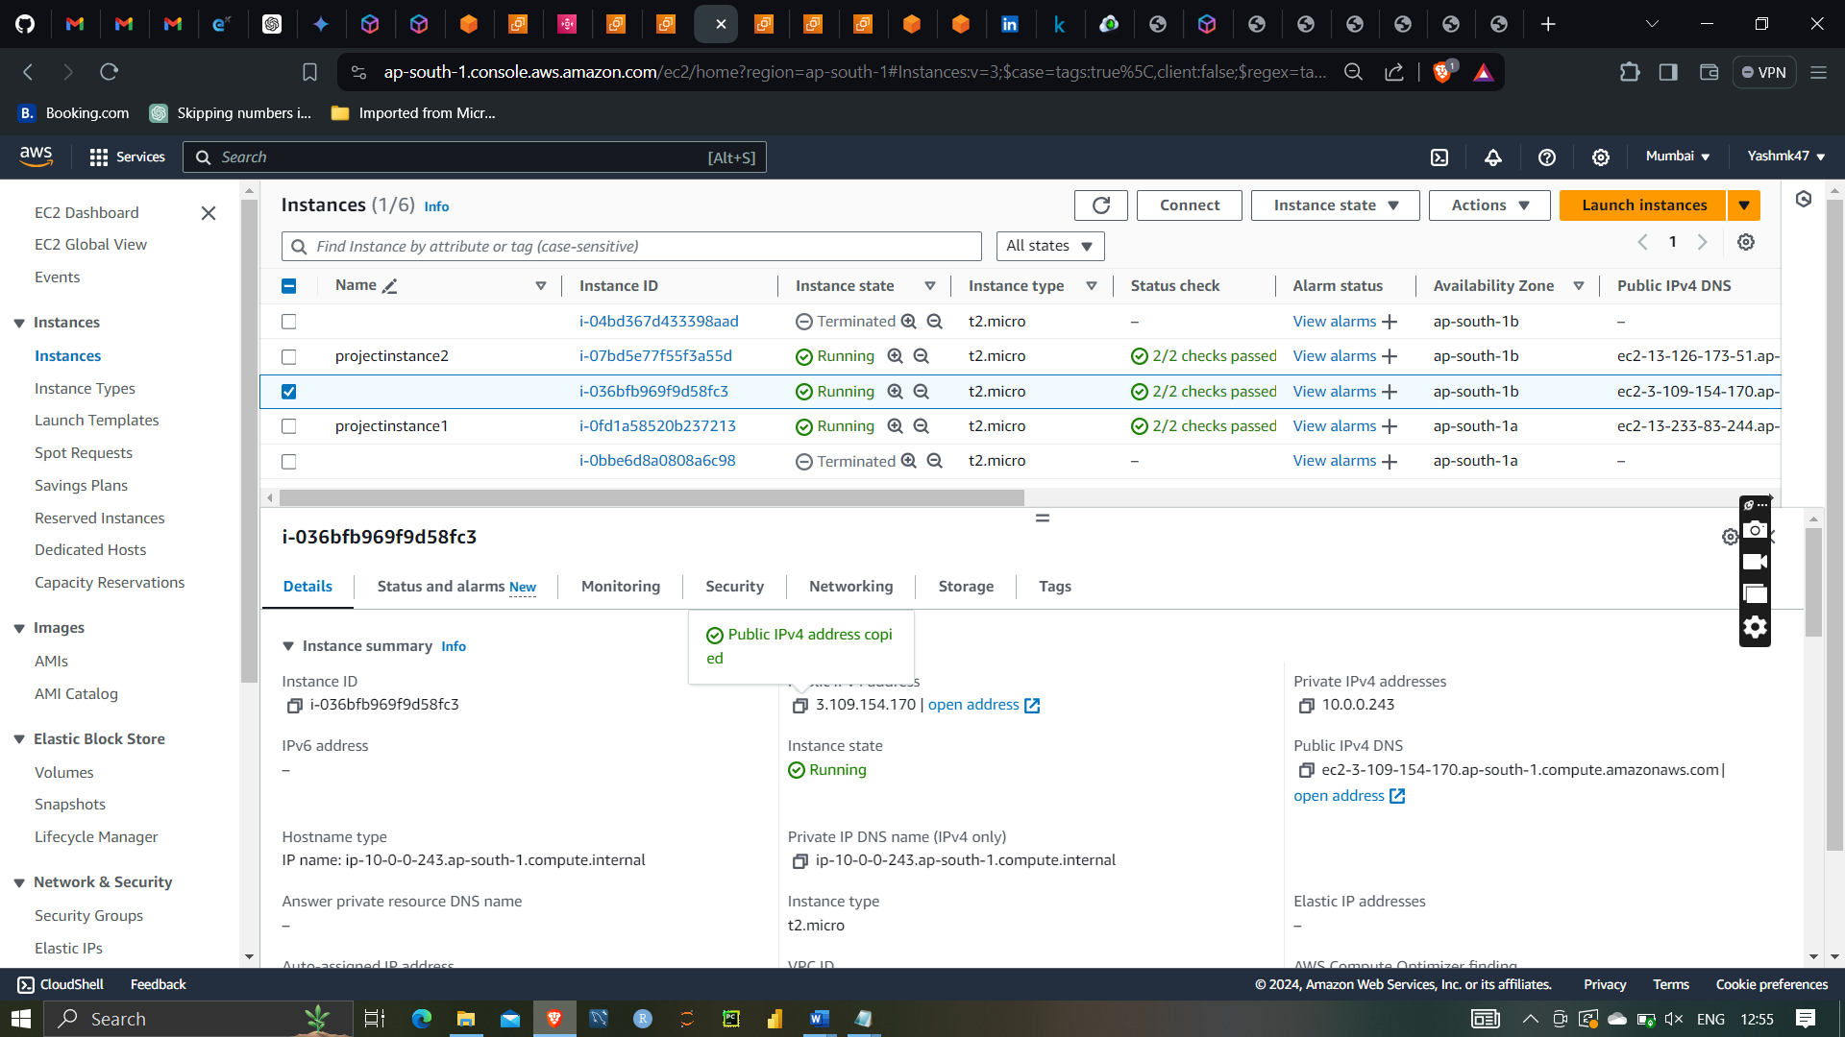

Instances launched by autoscaling behave same way as instances which have created

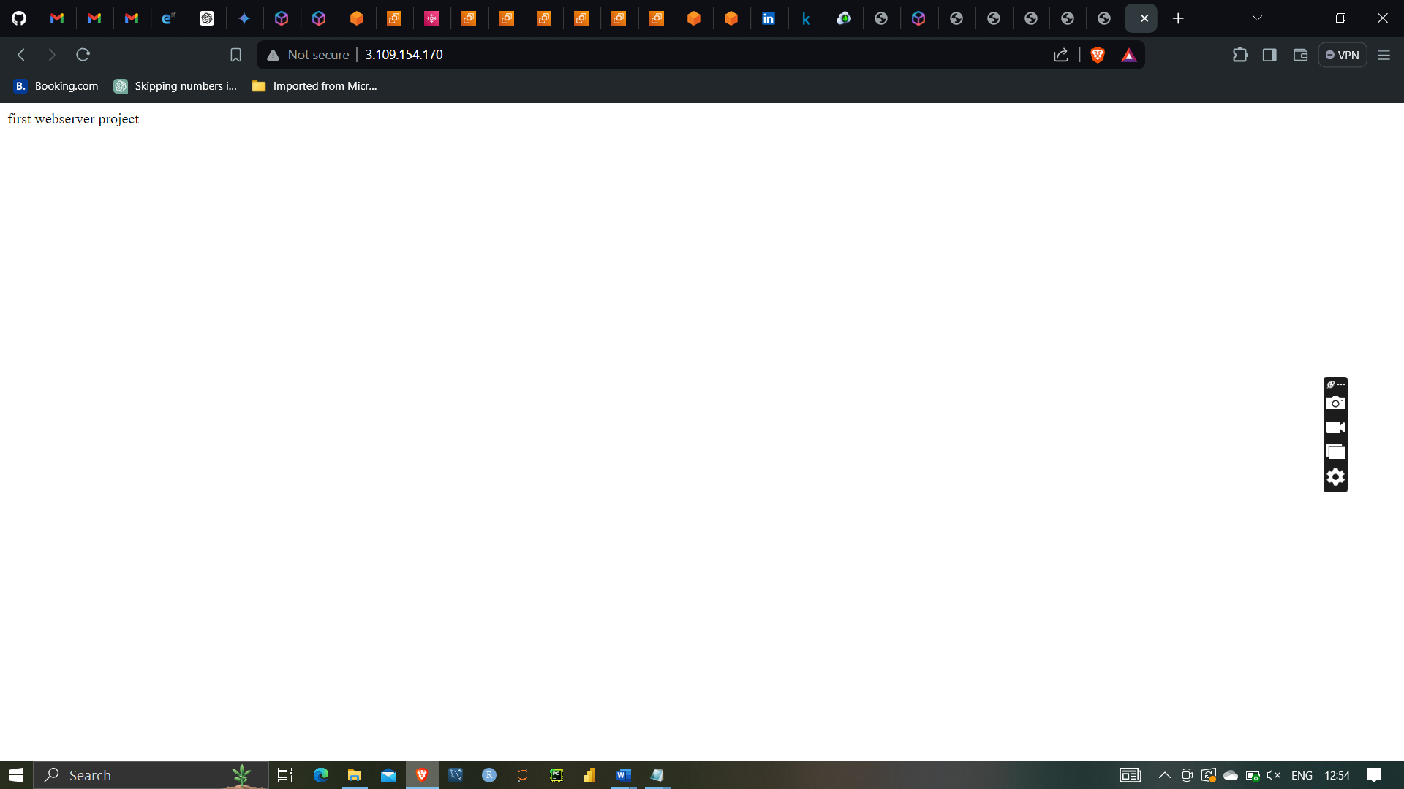

Hence creating privateVPC and subnets with different availability zones and launching instances with configuring load balancing and autoscaling concept has been done successfully